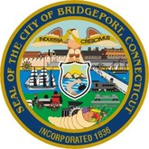

2020-2024 Consolidated Plan
2020 CDBG & HOME Allocation Correction

City of Bridgeport
Office of Planning and Economic Development
Housing and Community Development
Margaret E. Morton Government Center
999 Broad Street
Bridgeport, CT 06604

Table of Contents
Executive Summary 5
ES-05 Executive Summary - 24 CFR 91.200(c), 91.220(b) 5
The Process 9
PR-05 Lead & Responsible Agencies 24 CFR 91.200(b) 9
PR-10 Consultation – 91.100, 91.110, 91.200(b), 91.300(b), 91.215(I) and 91.315(I) 10
PR-15 Citizen Participation – 91.105, 91.115, 91.200(c) and 91.300(c) 25
Needs Assessment 31
NA-05 Overview 31
NA-10 Housing Needs Assessment - 24 CFR 91.205 (a,b,c) 32
NA-15 Disproportionately Greater Need: Housing Problems – 91.205 (b)(2) 47
NA-20 Disproportionately Greater Need: Severe Housing Problems – 91.205 (b)(2) 51
NA-25 Disproportionately Greater Need: Housing Cost Burdens – 91.205 (b)(2) 55
NA-30 Disproportionately Greater Need: Discussion – 91.205(b)(2) 56
NA-35 Public Housing – 91.205(b) 57
NA-40 Homeless Needs Assessment – 91.205(c) 62
NA-45 Non-Homeless Special Needs Assessment - 91.205 (b,d) 67
NA-50 Non-Housing Community Development Needs – 91.215 (f) 71
Housing Market Analysis 73
MA-05 Overview 73
MA-10 Number of Housing Units – 91.210(a)&(b)(2) 74
MA-15 Housing Market Analysis: Cost of Housing - 91.210(a) 80
MA-20 Housing Market Analysis: Condition of Housing – 91.210(a) 85
MA-25 Public and Assisted Housing – 91.210(b) 92
MA-30 Homeless Facilities and Services – 91.210(c) 98
MA-35 Special Needs Facilities and Services – 91.210(d) 103
MA-40 Barriers to Affordable Housing – 91.210(e) 106
MA-45 Non-Housing Community Development Assets – 91.215 (f) 107
MA-50 Needs and Market Analysis Discussion 116
MA-60 Broadband Needs of Housing occupied by Low- and Moderate-Income Households - 91.210(a)(4), 91.310(a)(2) 122
MA-65 Hazard Mitigation - 91.210(a)(5), 91.310(a)(3) 126
Strategic Plan 127
SP-05 Overview 127
SP-10 Geographic Priorities – 91.215 (a)(1) 128
SP-25 Priority Needs - 91.215(a)(2) 132
SP-30 Influence of Market Conditions – 91.215 (b) 136
SP-35 Anticipated Resources - 91.215(a)(4), 91.220(c)(1,2) 137
SP-40 Institutional Delivery Structure – 91.215(k) 141
SP-45 Goals Summary – 91.215(a)(4) 145
SP-50 Public Housing Accessibility and Involvement – 91.215(c) 151
SP-55 Barriers to affordable housing – 91.215(h) 153
SP-60 Homelessness Strategy – 91.215(d) 154
SP-65 Lead based paint Hazards – 91.215(i) 157
SP-70 Anti-Poverty Strategy – 91.215(j) 158
SP-80 Monitoring – 91.230 159
Expected Resources 160
AP-15 Expected Resources – 91.220(c)(1,2) 160
Annual Goals and Objectives 165
Projects 171
AP-35 Projects – 91.220(d) 171
AP-38 Project Summary 174
AP-50 Geographic Distribution – 91.220(f) 185
Affordable Housing 188
AP-55 Affordable Housing – 91.220(g) 188
AP-60 Public Housing – 91.220(h) 190
AP-65 Homeless and Other Special Needs Activities – 91.220(i) 193
AP-70 HOPWA Goals - 91.220 (l)(3) 197
AP-75 Barriers to affordable housing – 91.220(j) 198
AP-85 Other Actions – 91.220(k) 200
Program Specific Requirements 203

Minor Amendment to correct 2020 CDBG and HOME allocations.

Executive Summary

ES-05 Executive Summary - 24 CFR 91.200(c), 91.220(b)
1. Introduction
The City of Bridgeport Office of Planning and Economic Development’s Housing and Community Development (HCD) is committed to making Bridgeport and its neighborhoods a better place to live, work and enjoy life. The City strives to provide safe, decent and affordable housing, a suitable and stimulating living environment especially for low- to moderate-income individuals and the special needs population.
HCD administers federal HUD entitlement grant funds CDBG, HOME, ESG and HOPWA and ensures compliance, increases and stabilizes housing for residents, and builds neighborhood capacity. Partnerships with other vital City departments, nonprofit stakeholder organizations and citizens from the public allows HCD to accomplish its goals to address the needs of the community.
This 5-Year Consolidated Plan identifies the City’s priority needs through a community needs assessment and data analysis of the housing market, as well as an extensive citizen participation and stakeholder consultation process. The priority needs of the City are addressed through activities developed in the Annual Action Plans that work towards accomplishing the established goals that are associated with the identified needs. By addressing these priority needs, the City will improve the quality of life of residents in the Bridgeport.
2. Summary of the objectives and outcomes identified in the Plan Needs Assessment Overview
The City of Bridgeport has developed its strategic plan based on an analysis of the data presented in this plan and the community participation and stake holder consultation process. Through these efforts, the City has identified 5 priority needs and associated goals to address those needs. The priority needs include:
Expand/Improve Public Infrastructure & Facilities
1A Expand Public Infrastructure
1B Improve Public Infrastructure Capacity
1C Improve Access to Public Facilities
Preserve & Develop Affordable Housing
2A Increase Homeownership Opportunities
2B Increase Affordable Rental Hsg Opportunities
2C. Provide Code Enforcement in LMI Neighborhoods
2D. Provide Removal of Slum/Blight in Resident Area
2E. Provide for Owner Occupied Housing Rehab
Public Services & Quality of Life Improvements
3A Provide Supportive Services for Special Needs
3B Provide Vital Services for LMI Households
Homelessness Housing and Support Services
4A Provide Homeless Rapid Re-Housing Assistance
4B Provide Assistance to Homeless Shelters
4C. Provide for Street Outreach & Homeless Prevent
Housing/Supportive Services for Persons w HIV/AIDS
5A. Provide Hsg Opportunities Persons w HIV/AIDS
5B. Provide Medical & Supportive Services HIV/AIDS
3. Evaluation of past performance
The City of Bridgeport, with other public, private and non-profit community housing providers and non-housing service agencies have made significant contributions to provide safe, decent and affordable housing and a suitable living environment especially for low- to moderate-income (LMI) individuals and those with special needs in the community. However, affordable housing, public facilities and infrastructure and services for the LMI and persons with special needs remain some of the most prolific needs facing the City of Bridgeport, as documented by the current Consolidated Plan, the City’s previous Consolidated Plan, and the recent 2018 Consolidated Annual Performance and Evaluation Report (CAPER).
The CAPER provides an assessment of progress towards the five-year goals and the one-year goals of HUD entitlement grants CDBG, HOME, ESG and HOPWA. According to the most recent 2018 CAPER, the City accomplished its goals for assisting LMI persons with public facilities and infrastructure as well as providing vital public services for LMI and special needs persons, in particular for the elderly in the City. For affordable housing programs, only a few projects were completed, however these goals were accomplished in prior program years of that 5-Year Plan. Also affordable housing program that were not completed in the program year will be recorded in future program reporting years. In homeless programs the City exceeded homeless prevention goals.
The City worked towards accomplishing its goals for working with people living with HIV/AIDS in the HOWPA program. Short-term rent, mortgage, and utility assistance (STRMU) and tenant-based rental assistance (TBRA) fell short, but the City with its HOPWA partners exceeded goals for providing other housing options for families. The HOPWA program remain a valuable resource to organizations that provide necessary supportive services to people living with AIDS/HIV and their families and the City will continue to provide more support through housing for persons with HIV/AIDS and TBRA assistance.
4. Summary of citizen participation process and consultation process
The City of Bridgeport encourages participation by all citizens with special emphasis on persons of low- to moderate-incomes and those with special needs to participate in the Consolidated Planning process. The City follows its HUD approved Citizen Participation Plan and has developed a formal process for soliciting citizens' input into the Consolidated Plan process. A series of public meetings, online community and stakeholder survey, public hearings and public comment review periods allowed the public an opportunity to review the Plan. The Citizens Union held a meeting on May 11, 2020 and the Special Committee on May 12, 2020 to discuss and review the draft Plan. A public hearing was held at City Council on June 1, 2020 to approve the Consolidated Plan and first year of the Annual Action Plan.
Full details and results of the citizen process are located in PR-15 Citizen Participation in this Plan.
5. Summary of public comments
All comments were accepted. There were no comments rejected or not accepted. Public comments were uploaded as part of the community and stakeholder survey in the AD-25 Administration.
6. Summary of comments or views not accepted and the reasons for not accepting them
All comments were accepted. There were no comments rejected or not accepted.
7. Summary
Primary data sources for the Consolidated Plan include: 2013-2017 American Community Survey 5-Year Estimates, 2000 Census, 2012-2016 CHAS, Bureau of Labor Statistics, Longitudinal Employer-Household Dynamics (LEHD), HUD 2019 FMR and HOME Rents, Homeless Management Information System (HMIS), Inventory Management System/PIH Information Center (IMS/PIC), Connecticut Coalition to End Homelessness 2019 Point-in-Time Counts,HUD 2018 Housing Inventory Counts (HIC), Connecticut Department of Public Health HIV Surveillance Program 2018 and local data sources. A disparity exists between data tables throughout the plan in that tables which utilize ACS contain 2017 data and tables that utilize CHAS contain 2016 data. At the time of writing only 2016 CHAS data was available from HUD. However, 2017 ACS data was available and thus the City thought it best to utilize the most current data source where possible, and that incongruencies in the source years were outweighed by the more accurate demographic and housing picture painted by the 2017 ACS data.

The Process

PR-05 Lead & Responsible Agencies 24 CFR 91.200(b)
1. Describe agency/entity responsible for preparing the Consolidated Plan and those responsible for administration of each grant program and funding source
The following are the agencies/entities responsible for preparing the Consolidated Plan and those responsible for administration of each grant program and funding source.
Agency Role | Name | Department/Agency
Lead Agency | BRIDGEPORT

CDBG Administrator | BRIDGEPORT | Housing and Community Development
HOPWA Administrator | BRIDGEPORT | Housing and Community Development
HOME Administrator | BRIDGEPORT | Housing and Community Development
ESG Administrator | BRIDGEPORT | Housing and Community Development
Table 1 – Responsible Agencies

Narrative
The Office of Housing and Community Development is the lead office for the development of the City of Bridgeport's Consolidation Plan and the implementation of the subsequent Annual Action Plans, as well as the administrative office charged with oversite and disbursement of federal funds under the CDBG, HOME, ESG and HOPWA Programs.
Consolidated Plan Public Contact Information
Ginne-Rae Clay, Deputy Director
City of Bridgeport
Office of Planning and Economic Development
Housing and Community Development
Margaret E. Morton Government Center
999 Broad Street
Bridgeport, CT 06604

PR-10 Consultation – 91.100, 91.110, 91.200(b), 91.300(b), 91.215(I) and 91.315(I)
1. Introduction
The City uses diverse methods to encourage on-going participation from residents, community service providers, existing and potential community development partners. In developing its Consolidated Plan, the City sought input for its overall and annual priorities & goals through a series of community meetings, public notices, a non-profit organization forum, a public comment review period, public hearings, a community survey made available on the City’s website, and consultation with non-profits, City staff, elected officials and housing providers. In the end, the consolidated planning process yielded the active involvement and input of more than 30 governmental departments, non-profit organizations, and many citizens. Goals and strategies established during the consolidated planning process serve as a blueprint for future annual allocations of entitlement funds.
Provide a concise summary of the jurisdiction’s activities to enhance coordination between public and assisted housing providers and private and governmental health, mental health and service agencies (91.215(I)).
The City continues to reach out and participate with public and assisted living housing providers, and private and governmental health, mental health and other service agencies to ensure that the city’s most at risk population has access to services that are needed. During the City's consolidated planning process consultations with nonprofit organizations, service providers, housing advocacy organizations, developers, housing finance entities, and faith-based organizations are conducted to gather information, identify and prioritize community needs, identify community resources and initiatives, and to promote the coordination of resources and collaboration among agencies within the community.
Separate public meetings with Community Stakeholders and Community Residents were held during development of the Consolidated Plan, at which representatives from county and regional public and private agencies involved in assisted housing, health services, services for the homeless, historic preservation, employment, and social services participated. Attendees provided valuable information related to the mission and needs of their organizations. Additional reports, plans, and data from state, federal and local agencies were also used in the development of the Consolidated Plan.
The Community Development staff also consulted with multiple City of Bridgeport Department Heads and Staff, during the development of the Consolidated Planto discuss specifics of the City’s housing and community development needs and to identify and prioritize potential projects that align with the City's existing plans for each department. Existing Plans such as the CoC Plan, BGreen 2020 initiative and New York-Connecticut Sustainable Communities Consortium.
As an annual follow up to the initial Consolidated Plan consultation, the City works closely with its local Community Housing Development Organization (CHDO), Bridgeport Neighborhood Trust, and other local non-profit housing providers to gauge community need, projects in the pipeline, possible funding needs, etc. Because of the dire need for all the entitlement funding received by the City of Bridgeport, requests from non-profit community organizations far outnumber actual allocations. This disparity allows the City, the Citizen’s Union and the City Council to raise the bar for services provided when evaluating applications for funds in each program year through the public hearing process.
Describe coordination with the Continuum of Care and efforts to address the needs of homeless persons (particularly chronically homeless individuals and families, families with children, veterans, and unaccompanied youth) and persons at risk of homelessness
The City of Bridgeport works together with Opening Doors Fairfield County (ODFC) to meet the needs of the homeless population in the region. ODFC organizes and delivers housing and services in Bridgeport. The strategies to end homelessness include coordinated plans and activities listed below:
Point in Time Count: The annual Point in Time is a census of all sheltered and unsheltered individuals which takes place on the last Wednesday each January. The count gives an overview of homelessness to provide HUD with a snapshot of the subpopulations experiencing homeless so that funding is directed appropriately toward each and local resources can be directed appropriately.
Project Homeless Connect Committee: Strategizes to organize Project Homeless Connect - a one-day, one-stop event. The day is an opportunity to integrate homeless neighbors into the community. The Project Homeless Connect planning committee meets in advance of the event to focus on planning activities, donations, care packages, marketing, sponsors and refreshments for the event. Project Homeless Connect occurs annually each August.
Greater Bridgeport Consumer Advocacy Committee: Advocates for visibility with legislators to inform policy makers throughout the year on issues related to housing and homelessness. The committee also creates regular communications that keep legislators abreast of progress, barriers and gaps in resources, so that legislators remain informed. Efforts are focused in the following areas: protecting funding, funding the 211 systems, expanding the number-of state funded rental assistance certificates, increased resources for rapid rehousing, investing in new supportive housing, preservation and revitalization of the state public housing portfolio, and increasing economic security among the area’s poorest residents and advocating for child care.
Coordinated Access to Housing: A coordinated entry process to access housing makes it more likely that individuals and families will be served more equitably, rapidly and efficiently. Each entry point uses the same assessment tool. Targeted services and housing opportunities are centralized statewide through the 211 systems and 311 locally.
Rapid Re-housing (RRH): RRH provides short term stabilization support to help families and individuals exit homelessness and rapidly enter permanent housing through a short-term rental subsidy to each household coupled with case management, which helps to support participants in building skill sets around employment, continuing education and job training.
The following strategies continue to be successful in reducing homelessness: 1) Support the housing stability of vulnerable families, children and youth; 2) Strengthen the housing delivery system; create supportive and affordable housing; 3) Recalibrate the response to housing loss; 4) Foster housing retention through income growth and employment; 5) Reduce medical vulnerability and frequent use of health care systems; 6) Break the cycle of homelessness and re-incarceration.
The above strategies are carried out through the efforts of committees and workgroups which meet regularly.
Describe consultation with the Continuum(s) of Care that serves the jurisdiction's area in determining how to allocate ESG funds, develop performance standards and evaluate outcomes, and develop funding, policies and procedures for the administration of HMIS
Opening Doors of Fairfield County and the United Way of Coastal Fairfield County work in partnership with regional housing authorities, shelters, non-profits and landlords to review and assure that available resources are maximized for ending homelessness.
The Emergency Solutions Grant (ESG) allocation follows the policies and procedures described in the Citizen Participation Plan and as described the City’s grant awards procedures. The application review process and monitoring involve consultation with the CoC and the CoC goals and objectives, including the operation and administration of the HMIS.
2. Describe Agencies, groups, organizations and others who participated in the process and describe the jurisdictions consultations with housing, social service agencies and other entities

Table 2 – Agencies, groups, organizations who participated
1 | Agency/Group/Organization | Bridgeport Fire Department
 | Agency/Group/Organization Type | Other government - Local
 | What section of the Plan was addressed by Consultation? | Housing Need Assessment  Community Development
 | How was the Agency/Group/Organization consulted and what are the anticipated outcomes of the consultation or areas for improved coordination? | Bridgeport FD attended a meeting to discuss the Consolidated Plan and help assess affordable housing and community development needs. Bridgeport FD works to provide a safer community through our extensive participation in Fire Prevention, Code Enforcement and Education for the public and department members.
2 | Agency/Group/Organization | Bridgeport Youth Services
 | Agency/Group/Organization Type | Services-Children  Services-Youth
 | What section of the Plan was addressed by Consultation? | Housing Need Assessment  Non-Homeless Special Needs  Community Development
 | How was the Agency/Group/Organization consulted and what are the anticipated outcomes of the consultation or areas for improved coordination? | The City of Bridgeport Youth Service Department attended a meeting to discuss the Consolidated Plan and help assess affordable housing and community development needs. The department works in partnership with many local service providers to ensure youth have opportunities and experiences to learn and grow.
3 | Agency/Group/Organization | Bridgeport Library
 | Agency/Group/Organization Type | Other government - Local  Public Library
 | What section of the Plan was addressed by Consultation? | Housing Need Assessment  Community Development
 | How was the Agency/Group/Organization consulted and what are the anticipated outcomes of the consultation or areas for improved coordination? | The Bridgeport Public Library attended a meeting to discuss the Consolidated Plan and help assess affordable housing and community development needs. The Library serves as the principal public library for the City of Bridgeport.
4 | Agency/Group/Organization | Bridgeport Health and Social Services Department
 | Agency/Group/Organization Type | Services-Health  Other government - Local  Health Department
 | What section of the Plan was addressed by Consultation? | Housing Need Assessment  Non-Homeless Special Needs
 | How was the Agency/Group/Organization consulted and what are the anticipated outcomes of the consultation or areas for improved coordination? | The City of Bridgeport Department of Health & Social Services attended a meeting to discuss the Consolidated Plan and help assess affordable housing and community development needs. The department provides a wide range of services through programs that are designed to promote and protect the health of all Bridgeport residents and visitors.
5 | Agency/Group/Organization | Bridgeport Office of Planning & Economic Development
 | Agency/Group/Organization Type | Other government - Local
 | What section of the Plan was addressed by Consultation? | Housing Need Assessment  Economic Development  Community Development
 | How was the Agency/Group/Organization consulted and what are the anticipated outcomes of the consultation or areas for improved coordination? | The Office of Planning & Economic Development (OPED) attended a meeting to discuss the Consolidated Plan and help assess affordable housing and community development needs. OPED is a multi-disciplinary organization responsible for economic development, neighborhood revitalization, business development, planning and zoning, historic districts, local film & TV productions, land use, design review, building permits & inspections and related issues.
6 | Agency/Group/Organization | Bridgeport Chief Administrative Office
 | Agency/Group/Organization Type | Other government - Local
 | What section of the Plan was addressed by Consultation? | Housing Need Assessment  Community Development
 | How was the Agency/Group/Organization consulted and what are the anticipated outcomes of the consultation or areas for improved coordination? | The Office of the Chief Administrative Officer attended a meeting to discuss the Consolidated Plan and help assess affordable housing and community development needs. The mission of the Office of the Chief Administrative Officer is to coordinate all department management and operational policies and practices for the Mayor.
7 | Agency/Group/Organization | Mayors Initiative for Reentry Affairs
 | Agency/Group/Organization Type | Other government - Local
 | What section of the Plan was addressed by Consultation? | Housing Need Assessment  Community Development
 | How was the Agency/Group/Organization consulted and what are the anticipated outcomes of the consultation or areas for improved coordination? | The Mayor's Initiative for Reentry Affairs (MIRA) attended a meeting to discuss the Consolidated Plan and help assess affordable housing and community development needs. MIRA provides linkage to community resources and pertinent information for the empowerment of convicted persons and ex-offenders in the City of Bridgeport.
8 | Agency/Group/Organization | March for Education Foundation
 | Agency/Group/Organization Type | Services-Education  Foundation
 | What section of the Plan was addressed by Consultation? | Housing Need Assessment  Community Development
 | How was the Agency/Group/Organization consulted and what are the anticipated outcomes of the consultation or areas for improved coordination? | March for Education Foundation attended a meeting to discuss the Consolidated Plan and help assess affordable housing and community development needs. The Foundation is an advocate for youth education.
9 | Agency/Group/Organization | Catholic Charities
 | Agency/Group/Organization Type | Nonprofit organization
 | What section of the Plan was addressed by Consultation? | Housing Need Assessment  Homelessness Strategy  Community Development
 | How was the Agency/Group/Organization consulted and what are the anticipated outcomes of the consultation or areas for improved coordination? | Catholic Charities attended a meeting to discuss the Consolidated Plan and help assess affordable housing and community development needs. The organization serves all people with programs that feed the hungry and homebound, shelter the homeless, strengthen families, assist the physically and emotionally challenged, and deliver consultation and assistance to immigrants.
10 | Agency/Group/Organization | ABCD Inc.
 | Agency/Group/Organization Type | Anti-Poverty  Neighborhood Organization
 | What section of the Plan was addressed by Consultation? | Housing Need Assessment  Anti-poverty Strategy
 | How was the Agency/Group/Organization consulted and what are the anticipated outcomes of the consultation or areas for improved coordination? | ABCD Inc. attended a meeting to discuss the Consolidated Plan and help assess affordable housing and community development needs. ABCD Inc. concentrates its efforts and resources on identifying and eliminating the causes of poverty rather than only dealing with its effects.
11 | Agency/Group/Organization | Hall Neighborhood House
 | Agency/Group/Organization Type | Services-Education  Neighborhood Organization
 | What section of the Plan was addressed by Consultation? | Housing Need Assessment  Community Development
 | How was the Agency/Group/Organization consulted and what are the anticipated outcomes of the consultation or areas for improved coordination? | The Hall Neighborhood House attended a meeting to discuss the Consolidated Plan and help assess affordable housing and community development needs. The mission of Hall Neighborhood House is to provide services that will educate, enrich and empower the lives of residents of all ages of the East Side of Bridgeport and the surrounding community.
12 | Agency/Group/Organization | Kuchma Corporation
 | Agency/Group/Organization Type | Business Leaders  Construction
 | What section of the Plan was addressed by Consultation? | Housing Need Assessment  Economic Development  Community Development
 | How was the Agency/Group/Organization consulted and what are the anticipated outcomes of the consultation or areas for improved coordination? | Kuchma Corporation attended a meeting to discuss the Consolidated Plan and help assess affordable housing and community development needs. Kuchma Corporation is one of the areas foremost open shop commercial, industrial, & residential construction organizations.
13 | Agency/Group/Organization | Council of Churches of Greater Bridgeport
 | Agency/Group/Organization Type | Social Services  Neighborhood Organization
 | What section of the Plan was addressed by Consultation? | Housing Need Assessment  Anti-poverty Strategy  Community Development
 | How was the Agency/Group/Organization consulted and what are the anticipated outcomes of the consultation or areas for improved coordination? | The Council of Churches attended a meeting to discuss the Consolidated Plan and help assess affordable housing and community development needs. The Council is a faith-based, non-sectarian social services agency dedicated to meeting the needs of people at risk and breaking the cycle of poverty and crisis in the Greater Bridgeport area.
14 | Agency/Group/Organization | The Klein Memorial Auditorium
 | Agency/Group/Organization Type | Performing Arts Center
 | What section of the Plan was addressed by Consultation? | Housing Need Assessment  Community Development
 | How was the Agency/Group/Organization consulted and what are the anticipated outcomes of the consultation or areas for improved coordination? | The Klein Memorial Auditorium attended a meeting to discuss the Consolidated Plan and help assess affordable housing and community development needs. The Klein is a performing arts center that serves as a hub for Bridgeport and surrounding communities. The mission of The Klein is to enrich, educate and entertain through arts and ideas.
15 | Agency/Group/Organization | Sha Stokes Designs
 | Agency/Group/Organization Type | Business Leaders
 | What section of the Plan was addressed by Consultation? | Housing Need Assessment  Community Development
 | How was the Agency/Group/Organization consulted and what are the anticipated outcomes of the consultation or areas for improved coordination? | Sha Stokes Designs attended a meeting to discuss the Consolidated Plan and help assess affordable housing and community development needs. Sha Stokes Design is a local business that provides repair and alterations services for apparel and home decor in the City of Bridgeport.
16 | Agency/Group/Organization | City of Bridgeport Public Facilities
 | Agency/Group/Organization Type | Other government - Local  Public Facilities
 | What section of the Plan was addressed by Consultation? | Housing Need Assessment  Community Development
 | How was the Agency/Group/Organization consulted and what are the anticipated outcomes of the consultation or areas for improved coordination? | Bridgeport Public Facilities attended a meeting to discuss the Consolidated Plan and help assess affordable housing and community development needs. The department provides services that are required in order to ensure a clean, safe and healthy environment for the City of Bridgeport.
17 | Agency/Group/Organization | Sickle Cell Center of Southern CT
 | Agency/Group/Organization Type | Services-Health
 | What section of the Plan was addressed by Consultation? | Non-Homeless Special Needs  Community Development
 | How was the Agency/Group/Organization consulted and what are the anticipated outcomes of the consultation or areas for improved coordination? | SCDAA-SC attended a meeting to discuss the Consolidated Plan and help assess affordable housing and community development needs. SCDAA-SC embraces prevention strategies to enhance the quality of life and well-being of individuals affected by sickle cell disease and related conditions.
18 | Agency/Group/Organization | Central Connecticut Coast YMCA
 | Agency/Group/Organization Type | Services-Children  Services-Youth
 | What section of the Plan was addressed by Consultation? | Housing Need Assessment  Non-Homeless Special Needs  Community Development
 | How was the Agency/Group/Organization consulted and what are the anticipated outcomes of the consultation or areas for improved coordination? | CCC YMCA attended a meeting to discuss the Consolidated Plan and help assess affordable housing and community development needs. CCC YMCA is a community-focused nonprofit with recreational programs & services for all ages.
19 | Agency/Group/Organization | Chemical Abuse Services Agency Inc.
 | Agency/Group/Organization Type | Services-Health
 | What section of the Plan was addressed by Consultation? | Housing Need Assessment  Non-Homeless Special Needs
 | How was the Agency/Group/Organization consulted and what are the anticipated outcomes of the consultation or areas for improved coordination? | Chemical Abuse Services Agency Inc attended a meeting to discuss the Consolidated Plan and help assess affordable housing and community development needs. The mission of CASA, Inc. is to provide holistic and culturally competent community-based behavioral health services to individuals, families and communities.
20 | Agency/Group/Organization | Park City Harvest
 | Agency/Group/Organization Type | Community Garden  Neighborhood Organization
 | What section of the Plan was addressed by Consultation? | Housing Need Assessment  Community Development
 | How was the Agency/Group/Organization consulted and what are the anticipated outcomes of the consultation or areas for improved coordination? | Park City Harvest (PCH) attended a meeting to discuss the Consolidated Plan and help assess affordable housing and community development needs. PCH is a small scale urban farm in Bridgeport.
21 | Agency/Group/Organization | Green Village Initiative
 | Agency/Group/Organization Type | Community Garden  Neighborhood Organization
 | What section of the Plan was addressed by Consultation? | Housing Need Assessment  Community Development
 | How was the Agency/Group/Organization consulted and what are the anticipated outcomes of the consultation or areas for improved coordination? | Green Village Initiative (GVI) attended a meeting to discuss the Consolidated Plan and help assess affordable housing and community development needs. The mission of GVI is to grow food, knowledge, leadership and community through urban gardening and farming, to create a more just food system in Bridgeport. We have four programs: Reservoir Community Farm, School Gardens, Community Gardens, and a Youth Leadership Program.
22 | Agency/Group/Organization | PT Partners
 | Agency/Group/Organization Type | Housing  Services - Housing
 | What section of the Plan was addressed by Consultation? | Housing Need Assessment  Public Housing Needs  Community Development
 | How was the Agency/Group/Organization consulted and what are the anticipated outcomes of the consultation or areas for improved coordination? | PT Partners attended a meeting to discuss the Consolidated Plan and help assess affordable housing and community development needs. PT Partners is a program about creating change for public housing communities.
23 | Agency/Group/Organization | McGivney Community Center
 | Agency/Group/Organization Type | Services-Children  Services-Youth
 | What section of the Plan was addressed by Consultation? | Housing Need Assessment  Non-Homeless Special Needs  Community Development
 | How was the Agency/Group/Organization consulted and what are the anticipated outcomes of the consultation or areas for improved coordination? | The McGivney Community Center attended a meeting to discuss the Consolidated Plan and help assess affordable housing and community development needs. The Center is a youth organization in Bridgeport. The Center provides youth enrichment programs
24 | Agency/Group/Organization | Bridgeport Caribe Youth Leaders
 | Agency/Group/Organization Type | Services-Children  Services-Youth
 | What section of the Plan was addressed by Consultation? | Housing Need Assessment  Non-Homeless Special Needs  Community Development
 | How was the Agency/Group/Organization consulted and what are the anticipated outcomes of the consultation or areas for improved coordination? | Bridgeport Caribe Youth Leaders attended a meeting to discuss the Consolidated Plan and help assess affordable housing and community development needs. Bridgeport Caribe Youth Leaders is a grassroots youth development organization serving youth with enrichment programs and activities under sports, education and community platforms.
25 | Agency/Group/Organization | Bridgeport Downtown Special Services District
 | Agency/Group/Organization Type | Planning organization  Services-Preservation
 | What section of the Plan was addressed by Consultation? | Economic Development  Community Development
 | How was the Agency/Group/Organization consulted and what are the anticipated outcomes of the consultation or areas for improved coordination? | Bridgeport Downtown Special Services District (DSSD) attended a meeting to discuss the Consolidated Plan and help assess affordable housing and community development needs. DSSD works to promote the preservation and development of the downtown business district; make the area more attractive and accessible; and enhance the public perception of downtown Bridgeport through overseeing and managing its appearance, security, and cleanliness.
26 | Agency/Group/Organization | Supportive Housing Works
 | Agency/Group/Organization Type | Services-homeless
 | What section of the Plan was addressed by Consultation? | Homelessness Strategy
 | How was the Agency/Group/Organization consulted and what are the anticipated outcomes of the consultation or areas for improved coordination? | Supportive Housing Works attended a meeting to discuss the Consolidated Plan and help assess affordable housing and community development needs. The mission of Supportive Housing Works is to end homelessness in Fairfield County.
27 | Agency/Group/Organization | Neighborhood Studios of Fairfield County
 | Agency/Group/Organization Type | Services-Children  Services-Education  Nonprofit organization
 | What section of the Plan was addressed by Consultation? | Non-Homeless Special Needs  Community Development
 | How was the Agency/Group/Organization consulted and what are the anticipated outcomes of the consultation or areas for improved coordination? | Neighborhood Studios of Fairfield County is a nonprofit organization in Bridgeport. Neighborhood Studios works with children through arts education, and empowers them to make a difference in their community. The organization attended a meeting to discuss the Consolidated Plan and help assess affordable housing and community development needs.
28 | Agency/Group/Organization | Park City Communities
 | Agency/Group/Organization Type | PHA  Services - Housing
 | What section of the Plan was addressed by Consultation? | Housing Need Assessment  Public Housing Needs
 | How was the Agency/Group/Organization consulted and what are the anticipated outcomes of the consultation or areas for improved coordination? | Park City Communities is the local PHA. The PHA attended a meeting to discuss the Consolidated Plan and help assess affordable housing and community development needs.
29 | Agency/Group/Organization | Second Stone Ridge Co-Op
 | Agency/Group/Organization Type | Housing
 | What section of the Plan was addressed by Consultation? | Housing Need Assessment
 | How was the Agency/Group/Organization consulted and what are the anticipated outcomes of the consultation or areas for improved coordination? | Second Stone Ridge Co-Op is an apartment building in Bridgeport. Second Stone Ridge Co-Op attended a meeting to discuss the Consolidated Plan and help assess affordable housing and community development needs.
30 | Agency/Group/Organization | Led By Us
 | Agency/Group/Organization Type | Business Leaders  Neighborhood Organization
 | What section of the Plan was addressed by Consultation? | Housing Need Assessment  Economic Development  Community Development
 | How was the Agency/Group/Organization consulted and what are the anticipated outcomes of the consultation or areas for improved coordination? | Led By Us helps with community development. Led By Us attended a meeting to discuss the Consolidated Plan and help assess affordable housing and community development needs.
31 | Agency/Group/Organization | BroadbandNow
 | Agency/Group/Organization Type | Services - Broadband Internet Service Providers  Services - Narrowing the Digital Divide
 | What section of the Plan was addressed by Consultation? | Economic Development  Market Analysis  Community Development
 | How was the Agency/Group/Organization consulted and what are the anticipated outcomes of the consultation or areas for improved coordination? | BroadbandNow is a research organization which publishes data on the digital divide and impact of highspeed internet in society. It believes broadband internet should be available to all Americans and its mission is to help find and compare internet options with a goal to bring attention to underserved areas and help raise awareness of the importance of broadband access. The City consulted with the BroadbandNow website for broadband access and identified highspeed internet providers in the City.

Identify any Agency Types not consulted and provide rationale for not consulting
No agency types were intentionally not consulted. All comments were welcome.

Other local/regional/state/federal planning efforts considered when preparing the Plan
Name of Plan | Lead Organization | How do the goals of your Strategic Plan overlap with the goals of each plan?
Continuum of Care | Greater Bridgeport Opening Doors Fairfield County | The CoC Plan continues to be an integral part of the City's efforts to address homelessness and the prevention of homelessness. Through coordinated meetings, roundtables, etc., the City shapes its homeless strategies to be part of the CoC's broader anti-homelessness initiatives and objectives.
New York-Connecticut Sustainable Comm. Consortium | New York-Connecticut Sustainable Communities | The goal of the Strategic Plan/Annual Action Plan were developed to work in concert with the Sustainable Community Consortium. Activities and goals include transit-oriented development and sustainability projects along key nodes on the local railroad, as well as steps to address housing equity issues in Bridgeport and the region.
Plan Bridgeport | City of Bridgeport | Plan Bridgeport is the Citys plan of conservation and development over the next 10 years establishing a strategy of prioritization of resources towards the areas of waterfront, transit development, neighborhoods, and housing.
Table 3 – Other local / regional / federal planning efforts

Describe cooperation and coordination with other public entities, including the State and any adjacent units of general local government, in the implementation of the Consolidated Plan (91.215(l))
The City works closely with Opening Doors of Fairfield County in planning and coordination with homeless needs in the community when implementing the Consolidated Plan. Through coordinated meetings, and roundtable initiatives the City shapes its homeless strategies to be part of the those with the broader regional anti-homelessness initiatives and objectives. The City also works with the New York-Connecticut Sustainable Communities which coordinate and implement transit-oriented development and sustainability projects, as well as steps to address housing equity issues in Bridgeport and the region.
Narrative (optional):
N/A

PR-15 Citizen Participation – 91.105, 91.115, 91.200(c) and 91.300(c)
1. Summary of citizen participation process/Efforts made to broaden citizen participation
Summarize citizen participation process and how it impacted goal-setting

The City of Bridgeport encourages participation by all citizens with special emphasis on persons of low- to moderate-incomes and those with special needs to participate in the Consolidated Planning process. The City follows its HUD approved Citizen Participation Plan and has developed a formal process for soliciting citizens' input into the Consolidated Plan process. A series of public meetings, online community and stakeholder survey, public hearings and public comment review periods allowed the public an opportunity to review the Plan. The Citizens Union held a meeting on May 11, 2020 and the Special Committee on May 12, 2020 to discuss and review the draft Plan. A public hearing was held at City Council on June 1, 2020 to vote for approval on the Consolidated Plan and first year of the Annual Action Plan.
The table below shows details and results of the citizen participation outreach efforts made by the City.

Citizen Participation Outreach
Sort  Order | Mode of  Outreach | Target of  Outreach | Summary of  response/attendance | Summary of  comments received | Summary of comments not accepted and reasons | URL
1 | Public Meeting | Non-targeted/broad community  City of Bridgeport Department Heads/Staff | A public meeting was held for the City of Bridgeport Department Heads and staff to gather feedback and have a discussion on the upcoming Consolidated Plan. The meeting was held on December 5, 2019 at City Council Chambers, 45 Lyon Terrace at 9:30 AM to 11:30 AM. There were 12 in attendance. | All comments were accepted. There were no comments received. | There were no comments rejected or not accepted.
2 | Public Meeting | Non-targeted/broad community  Community Stakeholders | A public meeting was held for community stakeholders to gather feedback and have a discussion on the upcoming Consolidated Plan.. The meeting was held on December 5, 2019 at City Council Chambers, 45 Lyon Terrace at 3:00 PM to 5:00 PM. There were 27 in attendance. | All comments were accepted. There were no comments received. | There were no comments rejected or not accepted.
3 | Public Meeting | Non-targeted/broad community | A public meeting was held for community residents and stakeholders to gather feedback and have a discussion on the upcoming Consolidated Plan. The meeting was held on December 5, 2019 at City Council Chambers, 45 Lyon Terrace at 5:30 PM to 7:30 PM. There were 10 in attendance. | All comments were accepted. There were no comments received. | There were no comments rejected or not accepted.
4 | Internet Outreach | Non-targeted/broad community | An online community survey was provided for the public to participate in the Consolidated planning process. There were 45 responses to the survey. The survey link was: https://www.surveymonkey.com/r/  Bridgeport_Community2020 | In the community survey, members from the public ranked housing and community development priorities in this order (with specific needs):1. Affordable Housing: New affordable rental and homeownership housing, down payment assistance and owner-occupied rehab.2. Economic Development: Job creation/retention, small business assistance and workforce development.3. Public Services: Youth services, mental health services and crime prevention.4. Public Facilities: Community Centers and parks and rec facilities.5. Public Infrastructure: Street improvements, neighborhood cleanup, water/sewer and sidewalks. A full summary of responses is attached in the AD-25 citizen participation attachment. | There were no surveys rejected or not accepted.
5 | Internet Outreach | Community Stakeholders | An online stakeholder survey was provided for community organizations and agencies to participate in the Consolidated planning process. There were 14 stakeholder responses to the survey.The survey link was: https://www.surveymonkey.com/r/  Bridgeport_Stakeholder_2020 | In the stakeholder survey, community stakeholders ranked housing and community development priorities in this order (with specific needs):1. Safe, decent and affordable housing (new housing and rehab)2. Community development (public services, public facilities and infrastructure improvements)3. Crime prevention4. Economic development5. Employment training Community stakeholders also ranked in this order priorities for funding:1. Public services2. Economic development3. Public facilities and infrastructure improvements4. Creation of affordable housing or homebuyer assistance5. Removal of slum and blight. A full summary of responses is attached in the AD-25 citizen participation attachment. | There were no surveys rejected or not accepted.
6 | Public Hearing | Non-targeted/broad community | A public hearing was held on May 6, 2020 to discuss the Consolidated Plan and first year of the Annual Action Plan. | All comments were accepted. There were no comments received. | There were no comments rejected or not accepted.
7 | Public Hearing | Non-targeted/broad community | A public hearing was held on May 7, 2020 to discuss the Consolidated Plan and first year of the Annual Action Plan. | All comments were accepted. There were no comments received. | There were no comments rejected or not accepted.
8 | Public Meeting | Non-targeted/broad community  Citizens Union Deliberations | A public meeting with the Citizens Union Deliberations was held on May 11, 2020 to discuss the draft Consolidated Plan and first year of the Annual Action Plan. | All comments were accepted. There were no comments received. | There were no comments rejected or not accepted.
9 | Public Meeting | Non-targeted/broad community  Special Committee Deliberations | A public meeting with the Special Committee Deliberations was held on May 12, 2020 to discuss the draft Consolidated Plan and first year of the Annual Action Plan. | All comments were accepted. There were no comments received. | There were no comments rejected or not accepted.
10 | Public Comment Review Period | Non-targeted/broad community | The City held a public comment review period from July 13, 2020 to July 20, 2020 to allow for the public to review and make comments on the draft Consolidated Plan and first year of the Annual Action Plan. | All comments were accepted. There were no comments received. | There were no comments rejected or not accepted.
11 | Public Hearing | Non-targeted/broad community  City Council | A public hearing was held at City Council on August 3, 2020 to vote for approval on the Consolidated Plan and first year of the Annual Action Plan. | All comments were accepted. The Plan was approved by City Council. | There were no comments rejected or not accepted.
Table 4 – Citizen Participation Outreach

Needs Assessment

NA-05 Overview
Needs Assessment Overview
In order to ensure the most efficient and effective use of resources the City of Bridgeport must first assess the needs of the community. In this section, the City’s various demographic and economic indicators will be described and analyzed to provide the foundation needed for grant management.
Developing a picture of the current needs in the City begins by looking at broad trends in population, income, and household demographics. Once that data has been gathered, they can be examined with a more nuanced analysis of variables, such as how family and household dynamics relate to race and housing problems.
A key goal of the Needs Assessment section is to identify the nature and prevalence of housing problems experienced by the City’s residents. Per HUD’s definition, there are four housing problems that are assessed:
- Cost-Burden, which is defined as households who spend 30% or more of their income on housing costs
- Lack of Complete Plumbing
- Lack of Complete Kitchen Facilities
- Overcrowding
In addition to the demographics analyzed this section also looks at factors that impact or are impacted by the housing market. The City’s public housing needs of those facing homelessness, and non-homeless special needs are also discussed. Finally, non-housing development needs like public services and infrastructure are also analyzed to assist in determining where resources should be allocated.
Whenever possible, each of these issues is juxtaposed with economic and demographic indicators to determine if certain groups carry a disproportionate burden. Understanding the magnitude and prevalence of these issues in the City of Bridgeport is crucial in aiding in setting evidence-based priorities for entitlement programs.
Data Note: Many fields in this document are populated automatically by the IDIS system. In order to provide the most accurate and up-to-date analysis, additional data sources are often used.

NA-10 Housing Needs Assessment - 24 CFR 91.205 (a,b,c)
Summary of Housing Needs
The housing needs of a community are, like all items in the market economy, a product of supply and demand. However, determining the factors that impact supply and demand is much more complicated than building one house for one household. Changes in population, household size, availability of rental housing, income, and the condition of a property all work to shift the community’s housing needs.
Demographics | Base Year: 2000 | Most Recent Year: 2017 | % Change
Population | 139,529 | 147,586 | 6%
Households | 50,307 | 50,341 | 0%
Median Income | $34,658.00 | $44,841.00 | 29%
Table 5 - Housing Needs Assessment Demographics

Alternate Data Source Name:
2000 Census, 2013-2017 ACS

Since 2000, the population of Bridgeport has grown slightly. In nearly two decades it has grown by less than 10,000 people, which represents nearly 6% growth. The number of households has remained nearly the same, growing by only 34 households. This points to an increase in the average household size in the City.
Residents have a 29.4% higher median household income than they did in 2000. Unfortunately, due to inflation they have less buying power. In 2000, the median household income of $34,658 had a buying power of $49,860 in 2017 dollars. Financially, residents are worse off now then they were then which can lead to increases in poverty and substandard living.
Population
The following map displays the population density throughout the City. Overall, there is not a strong correlation between area of the City and high population census tracts. Many tracts have a relatively large population of over 5,000 people but they are scattered throughout the City. The low population tracts are also found throughout the City. Every ten years the US Census Bureau redraws the census tract boundaries with the intention of putting approximately 4,000 people in each tract. The high and low tracts may represent population shifts since 2000.
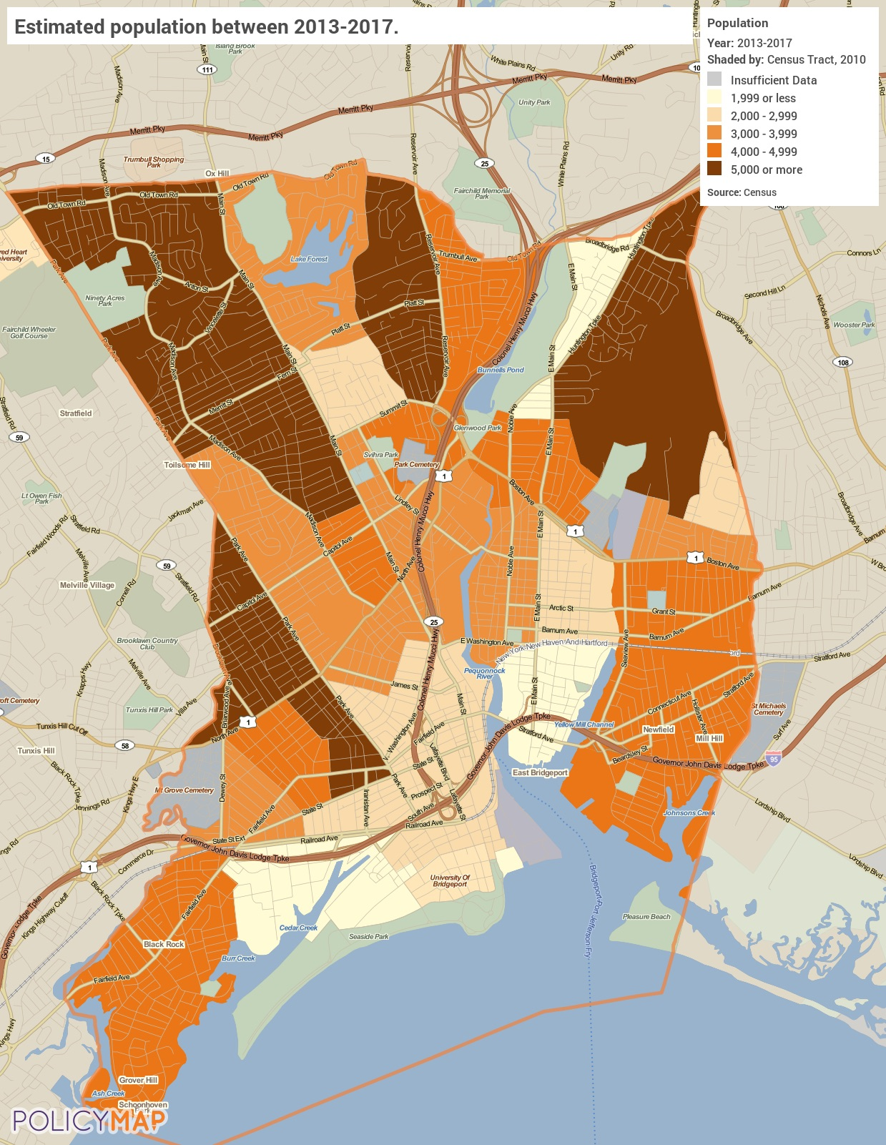
Population
Change in Population
As noted above, the City’s population grew by approximately 6% since 2000. That growth was not uniform throughout the City. Many tracts saw a population decline, sometimes over 10%. One tract in the center of the City had the largest growth where the population increased by more than 20%.
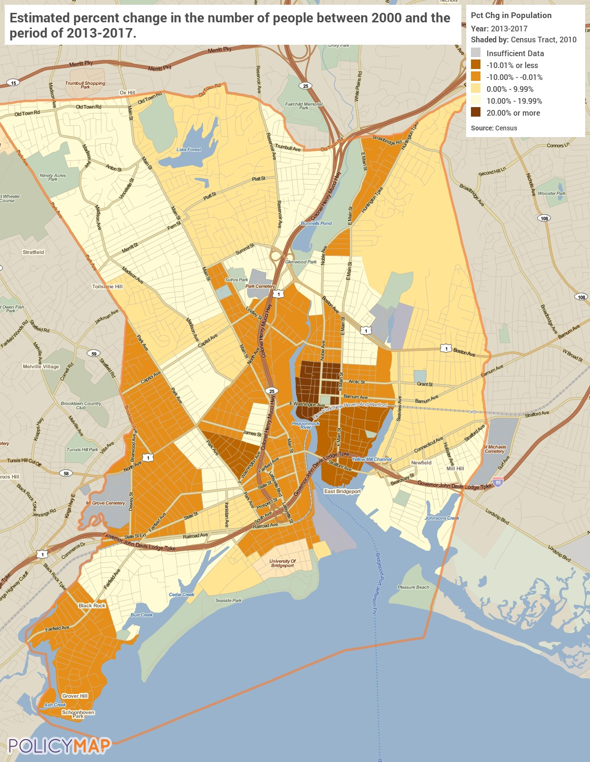
Change in Population
Median Household Income
In the City of Bridgeport, a household’s income appears to be linked to where that person lives. Tracts in the northern part of the City have a significantly higher median household income than those in the south and western parts. One exception being the far southeastern tract that has a high MHI, over $70,000. The low-income tracts have an MHI significantly lower than that, less than $40,000. When income is concentrated in certain areas it can lead to concentrated areas of poverty, which become of concern if income and geography are closely related to race or ethnicity in the community.
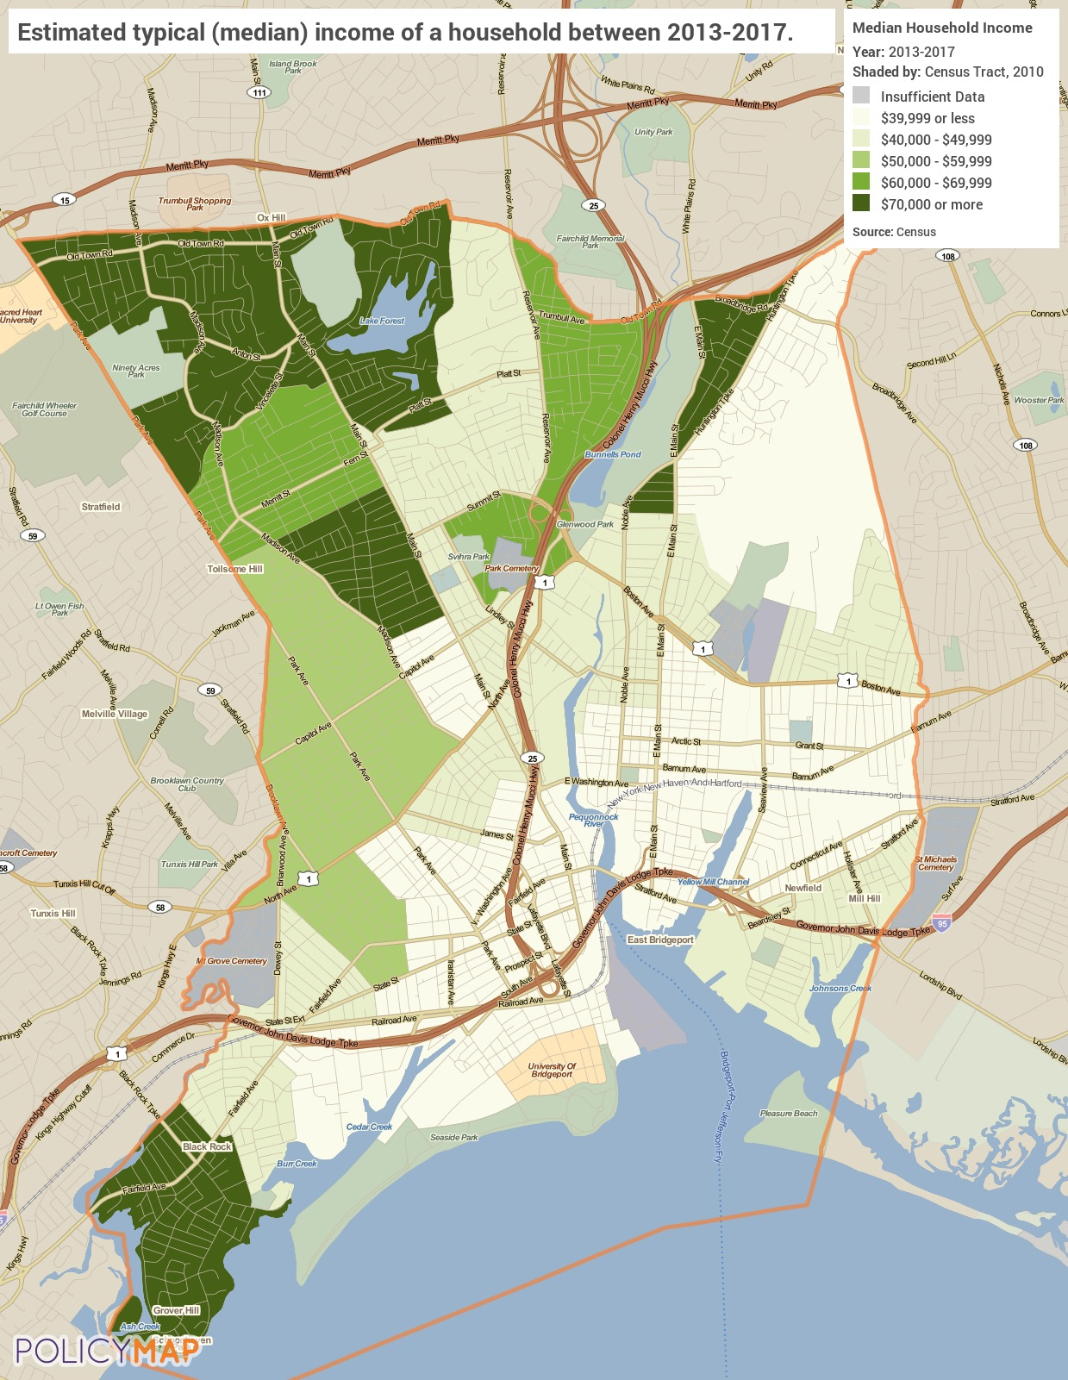
Median Household Income
Poverty
Unsurprisingly, the following map shows that the areas with high poverty are also those that were identified above as having a low median household income. The poverty rate in several lower MHI tracts is over 40%, which is significantly higher than the northern tracts where the poverty rate is less than 20%.
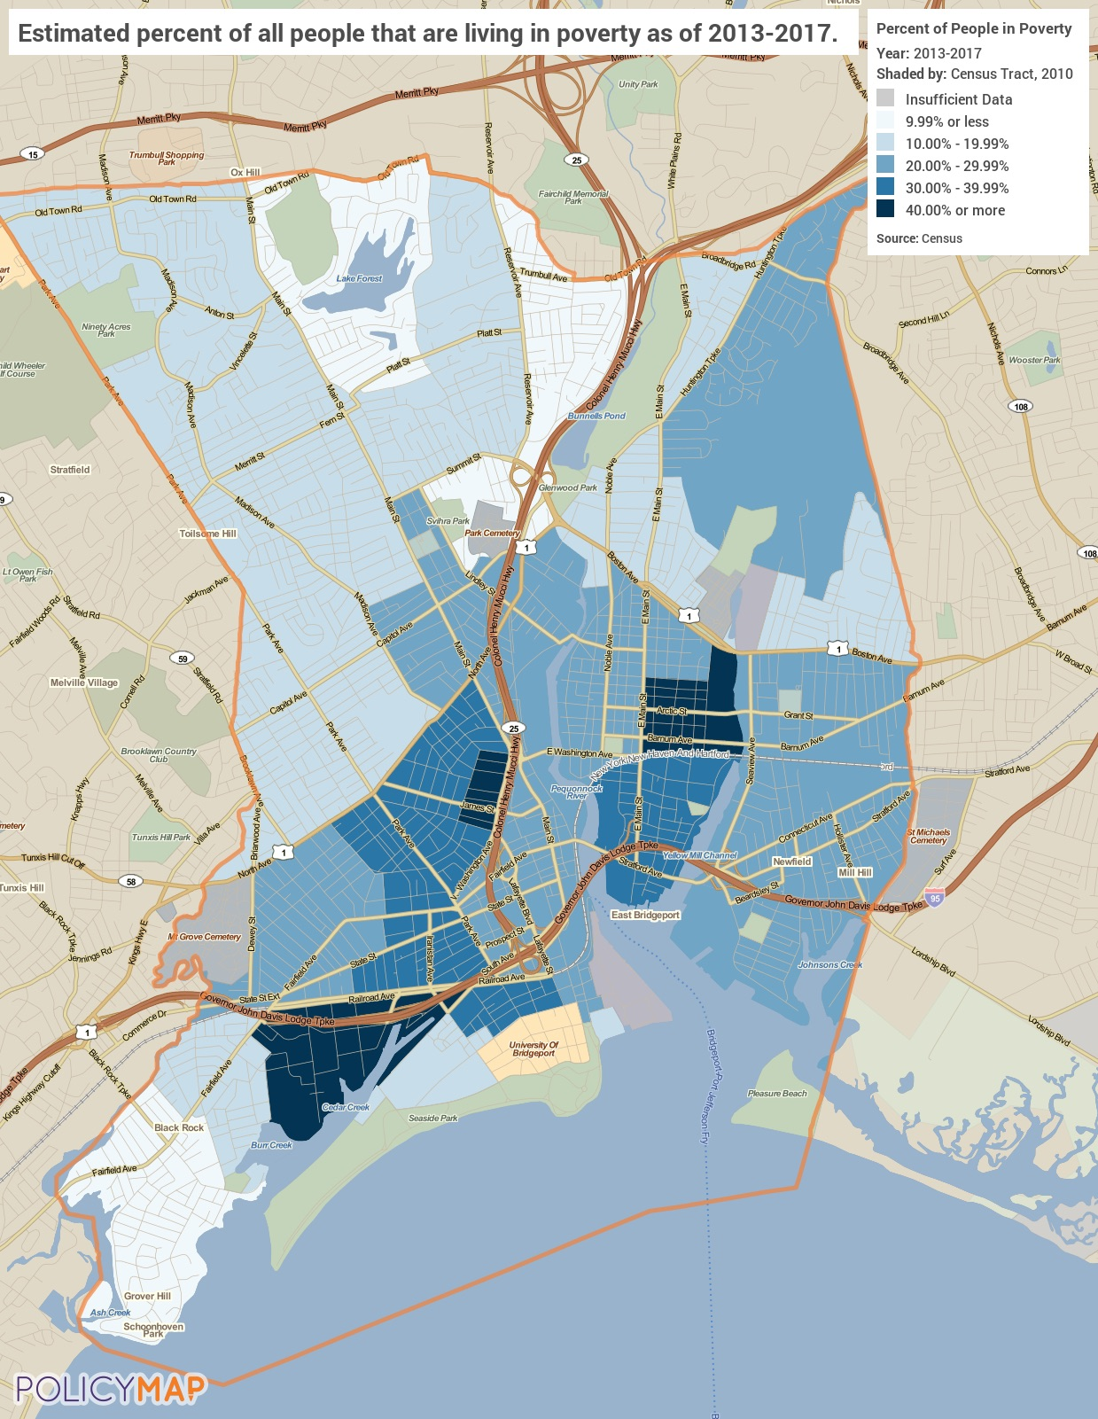
Poverty

Number of Households Table
 | 0-30% HAMFI | >30-50% HAMFI | >50-80% HAMFI | >80-100% HAMFI | >100% HAMFI
Total Households | 12,925 | 6,355 | 4,205 | 2,330 | 3,635
Small Family Households | 5,375 | 2,900 | 2,140 | 1,170 | 1,780
Large Family Households | 1,220 | 665 | 405 | 255 | 405
Household contains at least one person 62-74 years of age | 1,870 | 755 | 445 | 350 | 545
Household contains at least one person age 75 or older | 1,100 | 430 | 255 | 40 | 205
Households with one or more children 6 years old or younger | 3,360 | 1,605 | 960 | 515 | 660

Table 6 - Total Households Table

Alternate Data Source Name:
2012-2016 CHAS

Housing Needs Summary Tables
1. Housing Problems (Households with one of the listed needs)
 | Renter |  |  |  |  | Owner
 | 0-30% AMI | >30-50% AMI | >50-80% AMI | >80-100% AMI | Total | 0-30% AMI | >30-50% AMI | >50-80% AMI | >80-100% AMI | Total
NUMBER OF HOUSEHOLDS
Substandard Housing - Lacking complete plumbing or kitchen facilities | 190 | 155 | 40 | 15 | 400 | 30 | 10 | 0 | 10 | 50
Severely Overcrowded - With >1.51 people per room (and complete kitchen and plumbing) | 205 | 175 | 105 | 15 | 500 | 55 | 65 | 25 | 15 | 160
Overcrowded - With 1.01-1.5 people per room (and none of the above problems) | 550 | 235 | 405 | 155 | 1,345 | 20 | 65 | 150 | 80 | 315
Housing cost burden greater than 50% of income (and none of the above problems) | 8,260 | 1,580 | 85 | 20 | 9,945 | 1,665 | 1,515 | 745 | 150 | 4,075
Housing cost burden greater than 30% of income (and none of the above problems) | 1,935 | 2,995 | 1,490 | 230 | 6,650 | 295 | 950 | 1,195 | 1,085 | 3,525
Zero/negative Income (and none of the above problems) | 1,035 | 0 | 0 | 0 | 1,035 | 165 | 0 | 0 | 0 | 165
Table 7 – Housing Problems Table

Alternate Data Source Name:
2012-2016 CHAS

Housing Needs Summary
The table above gives an overview of housing problems in the City. Using 2016 CHAS data, it provides the numbers of households experiencing each category of housing problem broken down by income ranges (up to 100% AMI) and owner/renter status.
Cost burden is clearly the biggest housing problem in Bridgeport in terms of sheer numbers – a common trend in many communities across the state and nation today. According to the above data there were 16,595 renters and 7,600 homeowners in the 0% to 100% AMI range spending more than 30% of their income on housing costs (100% AMI is the area median income).
2. Housing Problems 2 (Households with one or more Severe Housing Problems: Lacks kitchen or complete plumbing, severe overcrowding, severe cost burden)
 | Renter |  |  |  |  | Owner
 | 0-30% AMI | >30-50% AMI | >50-80% AMI | >80-100% AMI | Total | 0-30% AMI | >30-50% AMI | >50-80% AMI | >80-100% AMI | Total
NUMBER OF HOUSEHOLDS
Having 1 or more of four housing problems | 8,515 | 2,060 | 635 | 205 | 11,415 | 1,730 | 1,545 | 910 | 250 | 4,435
Having none of four housing problems | 3,550 | 3,665 | 3,895 | 2,255 | 13,365 | 380 | 1,640 | 2,745 | 2,380 | 7,145
Household has negative income, but none of the other housing problems | 1,035 | 0 | 0 | 0 | 1,035 | 165 | 0 | 0 | 0 | 165
Table 8 – Housing Problems 2

Alternate Data Source Name:
2012-2016 CHAS

Severe Housing Problems
The above table shows households with at least one severe housing problem broken out by income and occupancy. The trend in the data is simply the lower the income in a household, the greater presence of severe housing problems.
3. Cost Burden > 30%
 | Renter |  |  |  | Owner
 | 0-30% AMI | >30-50% AMI | >50-80% AMI | Total | 0-30% AMI | >30-50% AMI | >50-80% AMI | Total
NUMBER OF HOUSEHOLDS
Small Related | 4,565 | 2,325 | 805 | 7,695 | 540 | 890 | 880 | 2,310
Large Related | 1,110 | 505 | 80 | 1,695 | 75 | 290 | 270 | 635
Elderly | 410 | 355 | 70 | 835 | 235 | 430 | 255 | 920
Other | 2,715 | 990 | 475 | 4,180 | 350 | 300 | 370 | 1,020
Total need by income | 8,800 | 4,175 | 1,430 | 14,405 | 1,200 | 1,910 | 1,775 | 4,885
Table 9 – Cost Burden > 30%

Alternate Data Source Name:
2012-2016 CHAS

Housing Cost-Burdened
The table above displays 2016 CHAS data on cost-burdened households in the Bridgeport for the 0% to 80% AMI cohorts.
The following maps and data show that income and poverty appear to be closely tied to geography, which includes clear concentrations in certain areas. For cost burden, the picture is less clear. Tracts with high homeowner cost burden rates (60% or more) are found only in two places and only one tract has a low-cost burden (under 30%). A more moderate cost burden rate is found throughout the City.
The following map does not include the 0%-15% range for clarity. There are no tracts in Bridgeport where less than 15% of the homeowners are cost burdened.
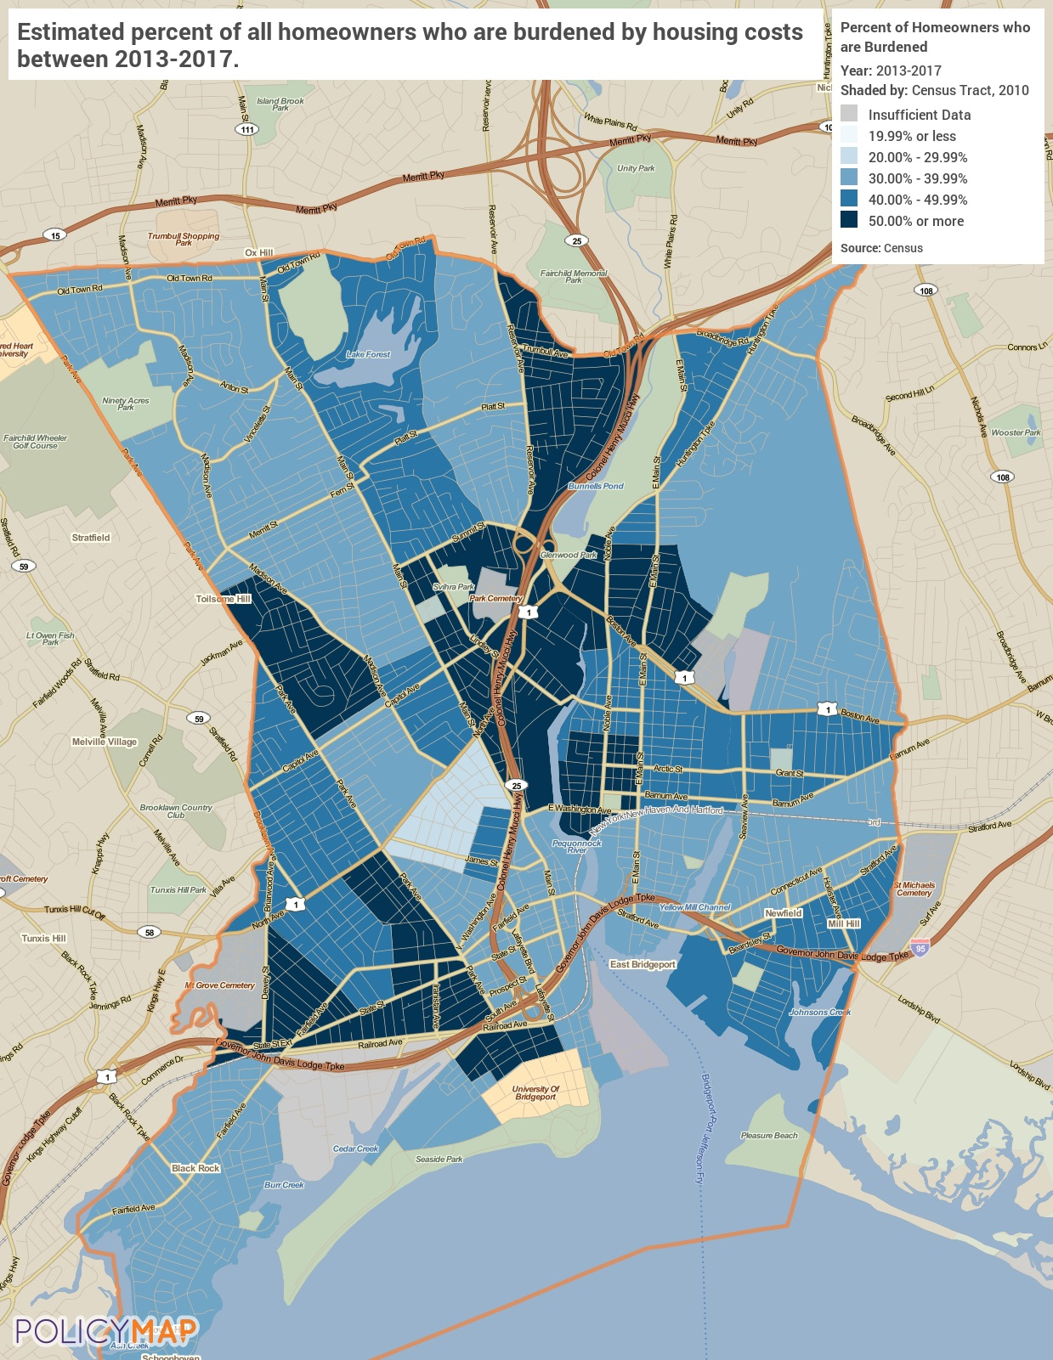
Cost-Burdened Homeowners
Cost-Burdened Renters
Cost burdened renters are found throughout the City, however there does appear to be some geographic relationship between cost burden and location. Renter cost burdened appears to be more concentrated on the eastern side of the City where several tracts have a renter cost burden rate of over 70%. In general, lower cost burdened tracts (less than 40%) are more common on the western and northern parts of the City.
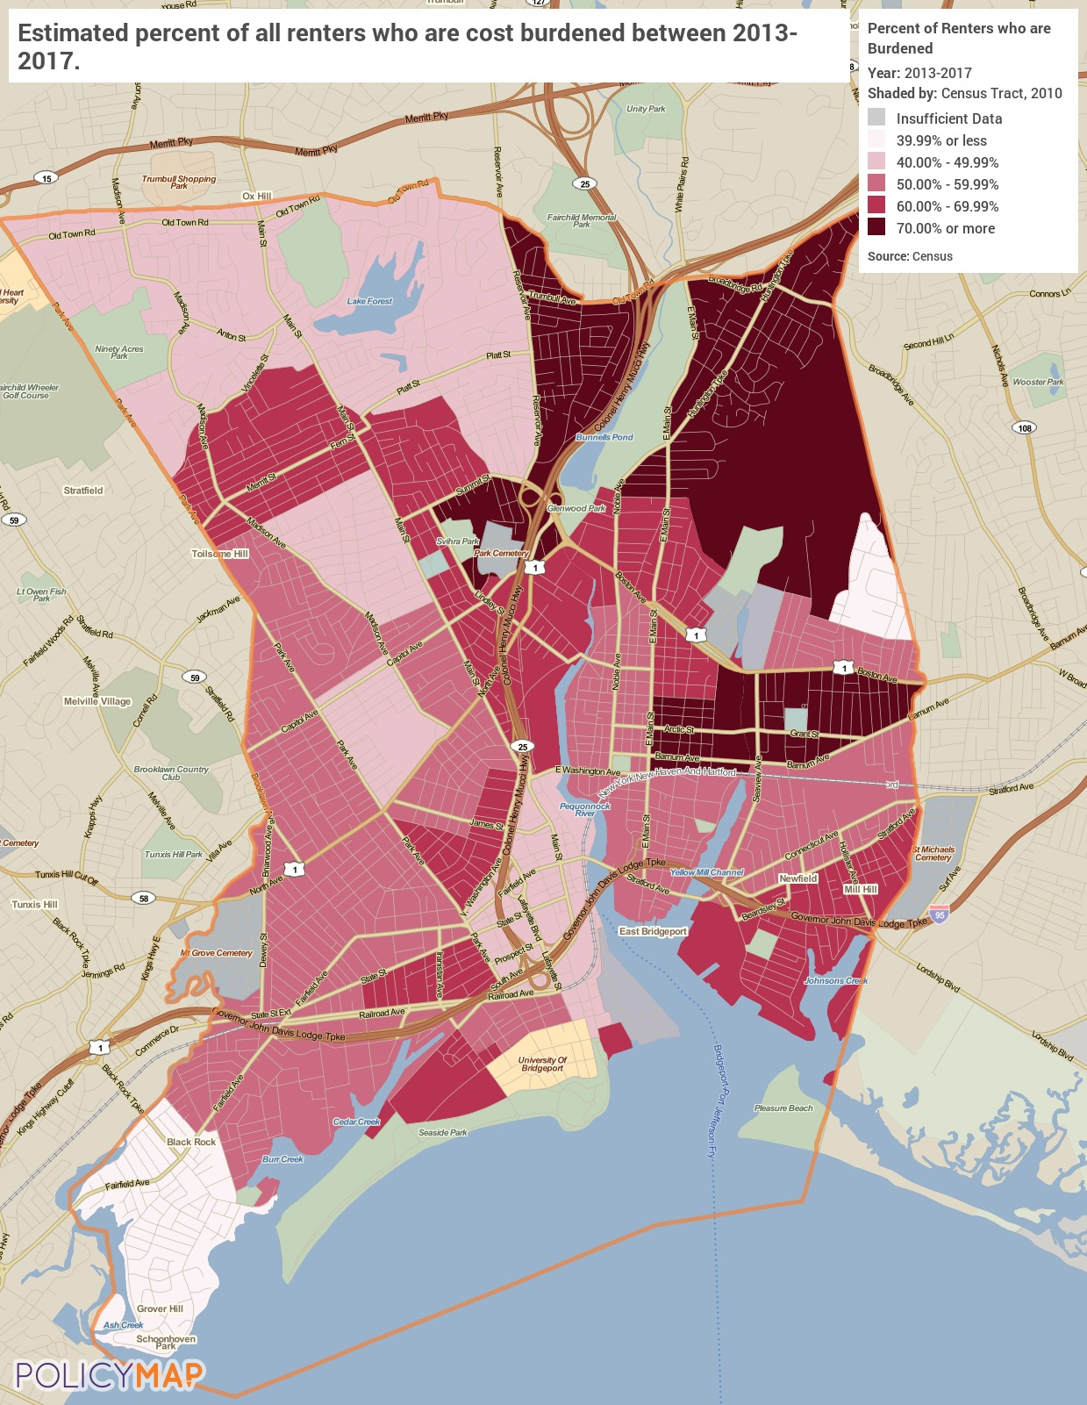
Cost-Burdened Renters

4. Cost Burden > 50%
 | Renter |  |  |  | Owner
 | 0-30% AMI | >30-50% AMI | >50-80% AMI | Total | 0-30% AMI | >30-50% AMI | >50-80% AMI | Total
NUMBER OF HOUSEHOLDS
Small Related | 3,795 | 680 | 20 | 4,495 | 475 | 645 | 375 | 1,495
Large Related | 925 | 165 | 0 | 1,090 | 75 | 190 | 40 | 305
Elderly | 350 | 115 | 10 | 475 | 200 | 190 | 85 | 475
Other | 2,375 | 445 | 10 | 2,830 | 335 | 170 | 165 | 670
Total need by income | 7,445 | 1,405 | 40 | 8,890 | 1,085 | 1,195 | 665 | 2,945
Table 10 – Cost Burden > 50%

Alternate Data Source Name:
2012-2016 CHAS

Severe Cost Burden
The data presented above show the severe cost burden in the City, which is defined as paying more than 50% of household income on housing cost. While it is less likely that a household would be severely cost burdened, there are still nearly 12,000 residents who pay over half their income to housing costs alone.
5. Crowding (More than one person per room)
 | Renter |  |  |  |  | Owner
 | 0-30% AMI | >30-50% AMI | >50-80% AMI | >80-100% AMI | Total | 0-30% AMI | >30-50% AMI | >50-80% AMI | >80-100% AMI | Total
NUMBER OF HOUSEHOLDS
Single family households | 625 | 295 | 365 | 130 | 1,415 | 65 | 39 | 115 | 60 | 279
Multiple, unrelated family households | 105 | 120 | 55 | 40 | 320 | 10 | 90 | 60 | 35 | 195
Other, non-family households | 50 | 0 | 95 | 95 | 240 | 0 | 0 | 0 | 65 | 65
Total need by income | 780 | 415 | 515 | 265 | 1,975 | 75 | 129 | 175 | 160 | 539
Table 11 – Crowding Information – 1/2

Alternate Data Source Name:
2012-2016 CHAS

Overcrowding
HUD defines an overcrowded household as one having from 1.01 to 1.50 occupants per room and a severely overcrowded household as one with more than 1.50 occupants per room. This type of condition can be seen in both renter and homeowner households, but it is much more prevalent in renter households. There are over 2,300 renters, mostly single-family households, that are overcrowded.
 | Renter |  |  |  | Owner
 | 0-30% AMI | >30-50% AMI | >50-80% AMI | Total | 0-30% AMI | >30-50% AMI | >50-80% AMI | Total
Households with Children Present | 3,360 | 1,605 | 960 | 5,925 | 230 | 470 | 550 | 1,250
Table 12 – Crowding Information – 2/2

Alternate Data Source Name:
2012-2016 CHAS

Describe the number and type of single person households in need of housing assistance.
According to the 2013-2017 ACS 5 Year Estimates 27.6% of occupied housing units in Bridgeport are single person households. This equates to approximately 13,900 households. Renters are more likely to be single-person households than homeowners. Approximately 31% of renters live alone and 2.3.3% of homeowners live alone. Residents in this group who are most at risk of needing housing assistance are elderly residents. Elderly residents are often on a fixed income and any increase in housing costs puts them at risk of becoming cost burdened or severely cost burdened. In Bridgeport, there are nearly 4,900 residents that are 65 years old or older and live alone, making up 41.3% of the population 65 years and older.
Estimate the number and type of families in need of housing assistance who are disabled or victims of domestic violence, dating violence, sexual assault and stalking.
Disability
Based on ACS 2013-2017 data it is estimated that 18,689 people, or 12.8%, in Bridgeport has a disability. Unsurprisingly age is closely related to the presence of a disability. Over 52% of residents over the age of 75 report dealing with a disability while only 15.3% of residents aged 35-64 years old do. It is likely that all or nearly all the approximately 2,500 residents over the age of 65 with a disability need housing assistance.
According to the FBI Uniform Crime Report of 2017 there were a number of violent crimes in Bridgeport that may have victims in need of housing support. In particular, there were 77 reported rapes and 652 aggravated assaults. These crimes are likely severely underreported and it is likely that significantly more survivors need support, particularly if children are present.
What are the most common housing problems?
Housing Cost Burden is the most common housing problem throughout the City of Bridgeport. According to the 2013-2017 American Community Survey 5-Year Estimates, there are 25,615 households that are cost burdened in the City, representing 52.8% of the households. This issue is more prevalent among renters than homeowners with 61.1% of renters cost burdened. Additionally, 52.6% of all renters paly over 35% of their income to housing costs.
The other three housing problems are significantly less common. Only 5.6% of households are overcrowded, less than 1% lack complete plumbing and less than 1% lack completed kitchen facilities.
Are any populations/household types more affected than others by these problems?
Renters are much more likely to be affected by housing problems than homeowners, particularly cost burden.
The relationship between race, ethnicity, and low-income households with housing problems is discussed later in this document in section MA-45.
Describe the characteristics and needs of Low-income individuals and families with children (especially extremely low-income) who are currently housed but are at imminent risk of either residing in shelters or becoming unsheltered 91.205(c)/91.305(c)). Also discuss the needs of formerly homeless families and individuals who are receiving rapid re-housing assistance and are nearing the termination of that assistance
Over sixty percent of the renters in City have rental obligations that consume more than 30% of their household income. This presents an unreasonably large burden on such households; one for which increasing income is the most likely cure. Rents will continue to raise across the country, including in Bridgeport. Homelessness prevention programs that assist at-risk renters before they reach an unresolvable impasse with their landlords needs sufficient support.
If a jurisdiction provides estimates of the at-risk population(s), it should also include a description of the operational definition of the at-risk group and the methodology used to generate the estimates:
No at-risk populations data available.
Specify particular housing characteristics that have been linked with instability and an increased risk of homelessness
The factors that contribute to an increased risk of homelessness are as varied as the populations served by the programs available to address them. Lack of sufficient income or the employment stability needed to generate adequate income is a key element. Health issues (both mental and physical) and the lack of education or having job skills that aren't valued or needed by employers can heavily influence the amount of income available to pay for a family's housing. Substance abuse, criminal background, prior evictions, high levels of debt and the loss of benefits (such as housing vouchers or Temporary Assistance for Needy Families (TANF)) can adversely impact the stability of a family's housing situation. Incidences of domestic violence or human trafficking can also greatly diminish one's ability to afford housing, especially when children are involved.
Discussion
N/A

NA-15 Disproportionately Greater Need: Housing Problems – 91.205 (b)(2)
Assess the need of any racial or ethnic group that has disproportionately greater need in comparison to the needs of that category of need as a whole.
Introduction
This section compares the existence of housing problems amongst racial groups against that of the jurisdiction as a whole in an effort to determine if any group(s) share a disproportionate burden of the area’s housing problems.
For this section, the definition of disproportionately greater need from "Using IDIS to Prepare the Consolidated Plan, Annual Action Plan and CAPER/PER" published May 2018 is used. It states "A disproportionately greater need exists within the members of racial or ethnic group at a given income level experience housing problems at a greater rate (10 percentage points or more) than the income level as a whole.
The following series of tables looks at the existence of housing problems amongst different racial and ethnic groups across the 0%-30%, 30%-50%, 50%-80%, and 80%-100% AMI cohorts.
0%-30% of Area Median Income
Housing Problems | Has one or more of four housing problems | Has none of the four housing problems | Household has no/negative income, but none of the other housing problems
Jurisdiction as a whole | 11,959 | 1,895 | 1,145
White | 2,515 | 220 | 320
Black / African American | 4,325 | 655 | 385
Asian | 225 | 15 | 135
American Indian, Alaska Native | 4 | 0 | 0
Pacific Islander | 0 | 0 | 0
Hispanic | 4,890 | 1,005 | 305
Table 13 - Disproportionally Greater Need 0 - 30% AMI

Alternate Data Source Name:
2012-2016 CHAS

*The four housing problems are:
1. Lacks complete kitchen facilities, 2. Lacks complete plumbing facilities, 3. More than one person per room, 4.Cost Burden greater than 30%

30%-50% of Area Median Income
Housing Problems | Has one or more of four housing problems | Has none of the four housing problems | Household has no/negative income, but none of the other housing problems
Jurisdiction as a whole | 7,045 | 3,075 | 0
White | 1,865 | 1,360 | 0
Black / African American | 2,300 | 95 | 0
Asian | 210 | 1,045 | 0
American Indian, Alaska Native | 0 | 85 | 0
Pacific Islander | 0 | 310 | 0
Hispanic | 2,670 | 180 | 0
Table 14 - Disproportionally Greater Need 30 - 50% AMI

Alternate Data Source Name:
2012-2016 CHAS

*The four housing problems are:
1. Lacks complete kitchen facilities, 2. Lacks complete plumbing facilities, 3. More than one person per room, 4.Cost Burden greater than 30%

50%-80% of Area Median Income
Housing Problems | Has one or more of four housing problems | Has none of the four housing problems | Household has no/negative income, but none of the other housing problems
Jurisdiction as a whole | 3,940 | 4,035 | 0
White | 925 | 1,165 | 0
Black / African American | 1,525 | 1,205 | 0
Asian | 130 | 105 | 0
American Indian, Alaska Native | 0 | 0 | 0
Pacific Islander | 25 | 0 | 0
Hispanic | 1,335 | 1,560 | 0
Table 15 - Disproportionally Greater Need 50 - 80% AMI

Alternate Data Source Name:
2012-2016 CHAS

*The four housing problems are:
1. Lacks complete kitchen facilities, 2. Lacks complete plumbing facilities, 3. More than one person per room, 4.Cost Burden greater than 30%
80%-100% of Area Median Income
Housing Problems | Has one or more of four housing problems | Has none of the four housing problems | Household has no/negative income, but none of the other housing problems
Jurisdiction as a whole | 1,725 | 3,285 | 0
White | 440 | 1,110 | 0
Black / African American | 490 | 985 | 0
Asian | 35 | 150 | 0
American Indian, Alaska Native | 0 | 20 | 0
Pacific Islander | 0 | 0 | 0
Hispanic | 760 | 1,020 | 0
Table 16 - Disproportionally Greater Need 80 - 100% AMI

Alternate Data Source Name:
2012-2016 CHAS

*The four housing problems are:
1. Lacks complete kitchen facilities, 2. Lacks complete plumbing facilities, 3. More than one person per room, 4.Cost Burden greater than 30%
Discussion
Extremely Low-Income Households
Residents of the City of Bridgeport who earn 30% HAMFI or less are considered extremely low income. Housing problems for this demographic are incredibly common. Citywide, approximately 79.7% of all extremely low-income households have at least one housing problem, the most common being cost burden.
According to the available data there is one racial group that disproportionately has a housing problem. One hundred percent of American Indian or Alaska Native households have a housing problem. However, due to the incredibly small sample size of only four households it is difficult to draw significant conclusions.
Very Low-Income Households
A household that earns between 30% and 50% HAMFI is classified as very low income. Housing problems are slightly less common for this group than extremely low-income households with 69.6% of the population with a problem.
For this population there are two groups that present disproportionate housing problems. Both Black and Hispanic households are disproportionately impacted with 96% of the former and 93.7% of the latter impacted.
Low Income Households
Housing problems are significantly less common in households that earn between 50% and 80% HAMFI. Citywide, nearly 50% of households in this group have a housing problem. There is one racial group that is disproportionately affected by housing problems. One hundred percent of Pacific Islander households experience housing problems in this group. However, this is another very small sample size (25 households) and drawing conclusions is difficult.
Moderate Income Households
Housing problem rates decline further for this group with only 34.4% of households who earn 80% to 100% HAMFI having a housing problem. There are no racial or ethnic groups that are disproportionately affected by housing problems for this income group.

NA-20 Disproportionately Greater Need: Severe Housing Problems – 91.205 (b)(2)
Assess the need of any racial or ethnic group that has disproportionately greater need in comparison to the needs of that category of need as a whole.
Introduction
This section compares the existence of severe housing problems amongst racial groups against that of the jurisdiction as a whole in an effort to determine if any group(s) share a disproportionate burden of the area’s housing problems.
For this section, the definition of disproportionately greater need from "Using IDIS to Prepare the Consolidated Plan, Annual Action Plan and CAPER/PER" published May 2018 is used. It states "A disproportionately greater need exists within the members of racial or ethnic group at a given income level experience housing problems at a greater rate (10 percentage points or more) than the income level as a whole.
The following series of tables looks at the existence of housing problems amongst different racial and ethnic groups across the 0%-30%, 30%-50%, 50%-80%, and 80%-100% AMI cohorts.
0%-30% of Area Median Income
Severe Housing Problems* | Has one or more of four housing problems | Has none of the four housing problems | Household has no/negative income, but none of the other housing problems
Jurisdiction as a whole | 9,974 | 3,880 | 1,145
White | 2,040 | 695 | 320
Black / African American | 3,610 | 1,375 | 385
Asian | 225 | 15 | 135
American Indian, Alaska Native | 4 | 0 | 0
Pacific Islander | 0 | 0 | 0
Hispanic | 4,095 | 1,795 | 305
Table 17 – Severe Housing Problems 0 - 30% AMI

Alternate Data Source Name:
2012-2016 CHAS

*The four severe housing problems are:
1. Lacks complete kitchen facilities, 2. Lacks complete plumbing facilities, 3. More than 1.5 persons per room, 4.Cost Burden over 50%

30%-50% of Area Median Income
Severe Housing Problems* | Has one or more of four housing problems | Has none of the four housing problems | Household has no/negative income, but none of the other housing problems
Jurisdiction as a whole | 3,535 | 5,185 | 0
White | 930 | 1,390 | 0
Black / African American | 1,060 | 1,640 | 0
Asian | 170 | 100 | 0
American Indian, Alaska Native | 0 | 0 | 0
Pacific Islander | 0 | 0 | 0
Hispanic | 1,375 | 2,055 | 0
Table 18 – Severe Housing Problems 30 - 50% AMI

Alternate Data Source Name:
2012-2016 CHAS

*The four severe housing problems are:
1. Lacks complete kitchen facilities, 2. Lacks complete plumbing facilities, 3. More than 1.5 persons per room, 4.Cost Burden over 50%

50%-80% of Area Median Income
Severe Housing Problems* | Has one or more of four housing problems | Has none of the four housing problems | Household has no/negative income, but none of the other housing problems
Jurisdiction as a whole | 1,480 | 6,495 | 0
White | 310 | 1,785 | 0
Black / African American | 485 | 2,240 | 0
Asian | 110 | 120 | 0
American Indian, Alaska Native | 0 | 0 | 0
Pacific Islander | 0 | 25 | 0
Hispanic | 575 | 2,325 | 0
Table 19 – Severe Housing Problems 50 - 80% AMI

Alternate Data Source Name:
2012-2016 CHAS

*The four severe housing problems are:
1. Lacks complete kitchen facilities, 2. Lacks complete plumbing facilities, 3. More than 1.5 persons per room, 4.Cost Burden over 50%

80%-100% of Area Median Income
Severe Housing Problems* | Has one or more of four housing problems | Has none of the four housing problems | Household has no/negative income, but none of the other housing problems
Jurisdiction as a whole | 449 | 4,560 | 0
White | 75 | 1,475 | 0
Black / African American | 155 | 1,320 | 0
Asian | 4 | 175 | 0
American Indian, Alaska Native | 0 | 20 | 0
Pacific Islander | 0 | 0 | 0
Hispanic | 215 | 1,570 | 0
Table 20 – Severe Housing Problems 80 - 100% AMI

Alternate Data Source Name:
2012-2016 CHAS

*The four severe housing problems are:
1. Lacks complete kitchen facilities, 2. Lacks complete plumbing facilities, 3. More than 1.5 persons per room, 4.Cost Burden over 50%

Discussion
Extremely Low-Income Households
Residents of the City of Bridgeport who earn 30% HAMFI or less are considered extremely low income. Severe housing problems for this demographic are common Citywide, approximately 66.5% of all extremely low-income households have at least one severe housing problem, the most common being cost burden.
Similar to the previous section that analyzed housing problems there is one racial group in this income group that is disproportionately impacted by severe housing problems. One hundred percent of American Indian and Alaska Native households have a severe cost housing problem but again, this group is very small, only 4 households.
Very Low-Income Households
Severe housing problems are less common for very low-income households than extremely low-income households with 40.5% of the population with a problem. Asian households face severe housing problems at a disproportionate rate, 63.0%. This population is relatively small, though. There are only approximately 270 Asian households in this income group.
Low Income Households
For low income households having a severe housing problem is relatively rare. Only 18.6% of households in the City have a severe housing problem. Again, Asian households appear to have severe housing problems at a disproportionately high rate, 47.8%, and are a relatively small population, 230 households.
Moderate Income Households
Severe housing problems are very rare for moderate income households. Approximately 9.0% of the households in this group have a severe housing problem. There are no racial or ethnic groups that are disproportionately affected by housing problems for this income group.

NA-25 Disproportionately Greater Need: Housing Cost Burdens – 91.205 (b)(2)
Assess the need of any racial or ethnic group that has disproportionately greater need in comparison to the needs of that category of need as a whole.
Introduction:
HUD defines a disproportionately greater need - housing cost burden when the members of a racial or ethnic group at a given income level experience a housing cost burdens at a greater rate (10% or more) than the income level as a whole. Households who pay more than 30% of their income for housing are considered cost burdened. Households paying more than 50% of their income are considered severely cost burdened.
Housing Cost Burden
Housing Cost Burden | <=30% | 30-50% | >50% | No / negative income (not computed)
Jurisdiction as a whole | 23,260 | 11,105 | 13,724 | 23,260
White | 7,615 | 2,880 | 3,100 | 7,615
Black / African American | 7,330 | 3,955 | 4,930 | 7,330
Asian | 725 | 185 | 395 | 725
American Indian, Alaska Native | 35 | 0 | 4 | 35
Pacific Islander | 0 | 25 | 0 | 0
Hispanic | 7,555 | 4,060 | 5,295 | 7,555
Table 21 – Greater Need: Housing Cost Burdens AMI

Alternate Data Source Name:
2012-2016 CHAS

Discussion:
Housing cost burden is a significant problem in the City of Bridgeport. According to the CHAS data, there are nearly 25,000 households that are cost burdened, over half of which pay 50% or more of their income to housing cost. Approximately 23.1% of all households in the City pay between 30% and 50% of their income to household costs. Only one racial group appears to have a disproportionately high cost burden, 100% of Pacific Islander households are cost burdened. However, there are only 25 households estimated to fall in this group, a very small population. Approximately 28.5% of the City’s households pay 50% or more of their income to housing costs, but no racial or ethnic groups are disproportionately affected.

NA-30 Disproportionately Greater Need: Discussion – 91.205(b)(2)
Are there any Income categories in which a racial or ethnic group has disproportionately greater need than the needs of that income category as a whole?
Overall, there is not a significant disproportionate need based on race or ethnicity by income category. There are a few groups that reported a disproportionate impact but often these groups were very small and there is a concern about the accuracy with such a small sample size. These groups should not be ignored but the data should be considered with the rest of the research considered.
Disproportionate Housing Problems:
- Extremely Low Income: American Indian or Alaskan Native
- Very Low Income: Black or African American, Hispanic
- Low Income: Pacific Islander
- Moderate Income: None
Disproportionate Severe Housing Problems:
- Extremely Low Income: American Indian or Alaskan Native
- Very Low Income: Asian
- Low Income: Asian
- Moderate Income: None
Cost Burden: Pacific Islander
Extreme Cost Burden: None
If they have needs not identified above, what are those needs?
No additional needs have been identified.
Are any of those racial or ethnic groups located in specific areas or neighborhoods in your community?
Race and ethnicity are often linked to economic opportunities and the area of a jurisdiction where people live. Economic issues are discussed in detail in Section MA-45 and where people live by race and ethnicity in MA-50.

NA-35 Public Housing – 91.205(b)
Introduction
Park Cities Communities (PCC) is the local public housing authority in the City of Bridgeport. PCC’s mission is to provide quality housing of choice, empower residents to their highest level of self-sufficiency, and form public and private partnerships to help revitalize the neighborhood.
PCC administers Public Housing and the Housing Choice Vouchers (HCV) program in the city. There are currently over 2,300 families in public housing managed by PCC and over 3,000 participants of the HCV program, also called Section 8.
Public housing was established to provide decent and safe rental housing for eligible low-income families, the elderly and persons with disabilities. Public housing comes in all types and sizes from scattered single-family homes to high-rise apartment developments for elderly families. The US Department of Housing and Urban Development (HUD) administered Federal aid to PCC to manage public housing for low-income families at affordable rates.
The Housing Choice Voucher Program (HCV) provides "tenant-based" rental assistance for assisting low-income families, the elderly, and the disabled to afford decent, safe, and sanitary housing in the private market. A housing subsidy is paid to the landlord/management directly by the housing authority on behalf of the participating voucher holder family, then the family pays the difference between the actual rent charged by the landlord and the amount subsidized by the program. HCV also authorizes a variety of "project-based" rental assistance programs, under which the owner reserves some or all of the units in a building for low-income tenants. A tenant who leaves a subsidized project will lose access to the project-based subsidy.
The following tables show the program activity and the characteristics of the housing community served by PCC.
Totals in Use
Program Type
 | Certificate | Mod-Rehab | Public Housing | Vouchers
 |  |  |  | Total | Project -based | Tenant -based | Special Purpose Voucher
 |  |  |  |  |  |  | Veterans Affairs Supportive Housing | Family Unification Program | Disabled  *
# of units vouchers in use | 0 | 0 | 2,342 | 3,370 | 307 | 3,063 | 14 | 0 | 0

Table 22 - Public Housing by Program Type
*includes Non-Elderly Disabled, Mainstream One-Year, Mainstream Five-year, and Nursing Home Transition

Alternate Data Source Name:
PIC (PIH Information Center)

Characteristics of Residents

Program Type
 | Certificate | Mod-Rehab | Public Housing | Vouchers
 |  |  |  | Total | Project -based | Tenant -based | Special Purpose Voucher
 |  |  |  |  |  |  | Veterans Affairs Supportive Housing | Family Unification Program
Average Annual Income | 0 | 0 | 13,398 | 14,260 | 8,088 | 14,265 | 7,801 | 0
Average length of stay | 0 | 0 | 7 | 8 | 1 | 8 | 2 | 0
Average Household size | 0 | 0 | 2 | 2 | 1 | 2 | 1 | 0
# Homeless at admission | 0 | 0 | 0 | 0 | 0 | 0 | 0 | 0
# of Elderly Program Participants (>62) | 0 | 0 | 514 | 429 | 0 | 429 | 0 | 0
# of Disabled Families | 0 | 0 | 453 | 561 | 1 | 560 | 0 | 0
# of Families requesting accessibility features | 0 | 0 | 2,472 | 2,462 | 1 | 2,460 | 1 | 0
# of HIV/AIDS program participants | 0 | 0 | 0 | 0 | 0 | 0 | 0 | 0
# of DV victims | 0 | 0 | 0 | 0 | 0 | 0 | 0 | 0
Table 24 – Characteristics of Public Housing Residents by Program Type
Data Source: | PIC (PIH Information Center)

Race of Residents
Program Type
Race | Certificate | Mod-Rehab | Public Housing | Vouchers
 |  |  |  | Total | Project -based | Tenant -based | Special Purpose Voucher
 |  |  |  |  |  |  | Veterans Affairs Supportive Housing | Family Unification Program | Disabled  *
White | 0 | 0 | 1,334 | 1,436 | 0 | 1,436 | 0 | 0 | 0
Black/African American | 0 | 0 | 1,125 | 1,013 | 1 | 1,011 | 1 | 0 | 0
Asian | 0 | 0 | 6 | 9 | 0 | 9 | 0 | 0 | 0
American Indian/Alaska Native | 0 | 0 | 3 | 1 | 0 | 1 | 0 | 0 | 0
Pacific Islander | 0 | 0 | 4 | 3 | 0 | 3 | 0 | 0 | 0
Other | 0 | 0 | 0 | 0 | 0 | 0 | 0 | 0 | 0

*includes Non-Elderly Disabled, Mainstream One-Year, Mainstream Five-year, and Nursing Home Transition
Table 25 – Race of Public Housing Residents by Program Type
Data Source: | PIC (PIH Information Center)

Ethnicity of Residents
Program Type
Ethnicity | Certificate | Mod-Rehab | Public Housing | Vouchers
 |  |  |  | Total | Project -based | Tenant -based | Special Purpose Voucher
 |  |  |  |  |  |  | Veterans Affairs Supportive Housing | Family Unification Program | Disabled  *
Hispanic | 0 | 0 | 1,258 | 1,331 | 0 | 1,331 | 0 | 0 | 0
Not Hispanic | 0 | 0 | 1,214 | 1,131 | 1 | 1,129 | 1 | 0 | 0

*includes Non-Elderly Disabled, Mainstream One-Year, Mainstream Five-year, and Nursing Home Transition
Table 26 – Ethnicity of Public Housing Residents by Program Type
Data Source: | PIC (PIH Information Center)

Section 504 Needs Assessment: Describe the needs of public housing tenants and applicants on the waiting list for accessible units:
As a PHA receiving federal funding by HUD, PCC is by law, obligated to protect the rights of persons with disabilities. PCC is compliant with federal and state laws that provide protection to persons with disabilities, including Section 504 of the Rehabilitation Act of 1973 and in particular, 24 CFR Part 8 implementing Section 504, and 24 CFR Part 100 implementing the Fair Housing Act. Further, PCC will make any reasonable accommodation to its public housing apartments when it is necessary to allow for a person with any disability to live and enjoy housing through PCC. PCC will also make reasonable accommodations to its policies, programs and services, when they are necessary to allow persons with a disability to enjoy, participate or have access to the housing authority’s programs and services.
For public housing, PCC uses a point system and preference for its waiting list. For HCV the waiting list is purged approximately every three years by a mailing to all applicants to ensure that the waiting list remains current. The mailings ask for confirmation of continued interest in the HCV program. Admissions preferences include persons with disabilities, however as of now both waiting lists are closed. As of 3/17/2016 the waiting list for each program was:
Public Housing: 1723 with 93 individuals or families with a disability (5%).
HCV: 369 with 26 individuals or families with a disability (7%)
Most immediate needs of residents of Public Housing and Housing Choice voucher holders
The most immediate need of residents of public housing and HCV holders is additional affordable housing and incomes that can support self-sustainability. According to HUD PIH Information Center data, provided by the PHA, the average income of residents in publicly assisted housing in Bridgeport is roughly around $13,000 to $14,000. Without the help of subsidized housing, they would not be able to afford housing at market rates. The need for affordability is indicated by the long waiting lists for the affordable housing programs.
How do these needs compare to the housing needs of the population at large
There is a much greater and ongoing need for affordable housing for residents in public housing than in the general population. Residents in public housing are more likely to be very low-income and therefore more severely cost burden than the general population.
The elderly may require housing accommodations due to the nature of elderly persons being more likely to be disabled than the general population. Elderly are also more likely to be living on fixed incomes, which means any change in housing costs effects affordability to them more than the general population.

NA-40 Homeless Needs Assessment – 91.205(c)
Introduction:
Homelessness is a particularly troublesome and complex issue that most communities across the United States must address. A major reason that homelessness is difficult to address is that it has many causes with overlapping and interrelated variables. The cause of any single person’s homelessness often lies, not in a single factor, but at the convergence of many events and conditions. From one perspective, homelessness is an economic problem caused by unemployment, lack of affordable housing options, or poverty. From another perspective, homelessness is a health issue because many homeless persons struggle with mental illness, physical disabilities, HIV/AIDS, substance abuse, or a combination of those health factors. A third perspective is to view homelessness as a social problem with factors such as domestic violence, educational attainment, and race lying at the root. In reality, homelessness can be caused by all of these issues and they are often interrelated. Due to this complexity, addressing homelessness requires a collaborative and community-based approach.
The Stewart B. McKinney Homeless Assistance Act defines the “homeless” or “homeless individual” or “homeless person” as an individual who lacks a fixed, regular, and adequate night-time residence; and who has a primary night-time residence that is:
- A supervised publicly or privately-operated shelter designed to provide temporary living accommodations (including welfare hotels, congregate shelters, and transitional housing for the mentally ill);
- An institution that provides a temporary residence for individuals intended to be institutionalized; or
- A public or private place not designed for, or ordinarily used as, a regular sleeping accommodation for human beings.
The City of Bridgeport partners with the Connecticut Coalition to End Homelessness (CCEH) which is the local Continuum of Care (CoC) in the region. CCEH’s collective mission is to prevent and end homelessness in Connecticut. The data below is from the 2019 Point-in-Time (PIT) Count, which was taken on the night of January 22, 2019. The PIT count shows a snapshot of people experiencing homelessness on any given night in the City of Bridgeport, of which on that night was 278 people. In the table below, the first three rows categorize the sheltered and unsheltered homeless count, and the rest of the rows are sub-categories of the homeless count.
Homeless Needs Assessment
Population | Estimate the # of persons experiencing homelessness on a given night |  | Estimate the # experiencing homelessness each year | Estimate the # becoming homeless each year | Estimate the # exiting homelessness each year | Estimate the # of days persons experience homelessness
 | Sheltered | Unsheltered
Persons in Households with Adult(s) and Child(ren) | 108 | 0 | 0 | 0 | 0 | 0
Persons in Households with Only Children | 0 | 1 | 0 | 0 | 0 | 0
Persons in Households with Only Adults | 146 | 23 | 0 | 0 | 0 | 0
Chronically Homeless Individuals | 16 | 10 | 0 | 0 | 0 | 0
Chronically Homeless Families | 7 | 0 | 0 | 0 | 0 | 0
Veterans | 41 | 0 | 0 | 0 | 0 | 0
Unaccompanied Child | 0 | 1 | 0 | 0 | 0 | 0
Persons with HIV | 13 | 2 | 0 | 0 | 0 | 0
Table 27 - Homeless Needs Assessment

Data Source Comments: | 2019 Point-in-Time (PIT) Count, January 22, 2019.

Indicate if the homeless population is: | Has No Rural Homeless

If data is not available for the categories "number of persons becoming and exiting homelessness each year," and "number of days that persons experience homelessness," describe these categories for each homeless population type (including chronically homeless individuals and families, families with children, veterans and their families, and unaccompanied youth):
Below is a summary of each homeless population category type. This data is from the 2019 Point-in-Time (PIT) Count, which was taken on the night of January 22, 2019.
Chronically Homeless Individuals and Families:
The chronically homeless are more likely to be those experiencing a disability (physical and cognitive), have a history of substance abuse, and be unsheltered. According to the 2019 PIT Count, there were 26 total persons that were reported as chronically homeless, with 7 being chronically homeless families. Approximately 38% of the chronically homeless were unsheltered – much higher than any other subcategory of persons experiencing homelessness.
Households with Adults and Children:
There were 33 households with adults and children comprising of a total of 108 persons. Working to get children out of homelessness will greatly improve the future success of the children in Bridgeport. Increased exposure to homelessness will cause harm to the development of children due to the lack of housing stability and the increased risk of living in poverty which include hunger and the lack of access to healthcare.
Veterans and Their Families:
Veterans are more likely to have a disability than non-veterans and this is also true for homeless veterans. There were 41 veterans in shelters, and none had families.
Unaccompanied Youth:
Youth that are alone and experiencing homelessness may be caused from any issue such as a death in the family or fleeing from a crisis. Similar to households with adults and children, increased exposure to homelessness will cause harm to the development of children due to the lack of housing stability and the increased risk of living in poverty which include hunger and the lack of access to healthcare. According to the 2019 PIT Count, there was only one “child only” household.

Nature and Extent of Homelessness: (Optional)
Race: | Sheltered: | Unsheltered (optional)
White | 101 | 9
Black or African American | 155 | 14
Asian | 4 | 0
American Indian or Alaska Native | 0 | 0
Pacific Islander | 0 | 0
Ethnicity: | Sheltered: | Unsheltered (optional)
Hispanic | 94 | 3
Not Hispanic | 184 | 21

Data Source Comments: | 2019 Point-in-Time (PIT) Count, January 22, 2019.

Estimate the number and type of families in need of housing assistance for families with children and the families of veterans.
There were 33 households with adults and children comprising of a total of 108 persons. As mentioned in this section, an increased exposure to homelessness will cause harm to the development of children due to the lack of housing stability and the increased risk of living in poverty which includes hunger and the lack of access to healthcare.
There were 41 veterans in shelters, and none had families. Veterans are more likely to have a disability than non-veterans and this is also true for homeless veterans. Housing for homeless veterans may require any reasonable accommodations that will meet their unique needs especially if they have a disability.
Describe the Nature and Extent of Homelessness by Racial and Ethnic Group.
Black or African Americans make up a disproportionate amount of the homeless population by race in the City of Bridgeport. Approximately 35.3% of the total population in Bridgeport is from the race group, however they represent over half of the homeless population (60.8%). All other race/ethnic groups experiencing homelessness fall relatively in line with the general population or are not experiencing a disproportionate percentage as homeless.
Describe the Nature and Extent of Unsheltered and Sheltered Homelessness.
Sheltered homeless are persons who are residing in emergency shelter units or transitional housing. The vast majority of the 2019 PIT Count was sheltered homeless persons.
Unsheltered homeless are much more difficult to count, and it’s probably that this group has been under reported. Unsheltered homeless reside in places not meant for human habitat. These places include cars, abandoned buildings and on the streets.
Discussion:
N/A

NA-45 Non-Homeless Special Needs Assessment - 91.205 (b,d)
Introduction:
There are four primary groups with non-homeless special needs in the jurisdiction. They are the elderly and frail elderly, those with HIV/AIDS and their families, those with alcohol and/or drug addiction, and the mentally or physically disabled. This section will explain who they are, what their needs are, and how the City is accommodating or should accommodate these needs.
HOPWA
Current HOPWA formula use:
Cumulative cases of AIDS reported | 1,234
Area incidence of AIDS | 836
Rate per population | 1
Number of new cases prior year (3 years of data) | 92
Rate per population (3 years of data) | 0

Current HIV surveillance data:
Number of Persons living with HIV (PLWH) | 1,234
Area Prevalence (PLWH per population) | 836
Number of new HIV cases reported last year | 26
Table 29 – HOPWA Data

Data Source Comments: | Connecticut Department of Public Health (CDPH) HIV Surveillance Program 2018. Area Prevalence (PLWH per population) is 836 per 100,000 persons. CDPH refers to HIV infected as three diagnoses collectively, which are: 1.) persons with a diagnosis of HIV (not AIDS), 2.) a diagnosis of HIV infection and a later diagnosis of AIDS, and 3.) concurrent diagnosis of HIV and AIDS. Due to this, data in the above table for Current HOPWA formula use, and data for Current HIV surveillance data both have the total estimated HIV/AIDs population in Bridgeport, CT.

HIV Housing Need (HOPWA Grantees Only)
Type of HOPWA Assistance | Estimates of Unmet Need
Tenant based rental assistance | 120
Short-term Rent, Mortgage, and Utility | 60
Facility Based Housing (Permanent, short-term or transitional) | 35
Table 30 – HIV Housing Need

Alternate Data Source Name:
2018 HOPWA CAPER

Data Source Comments: | Estimates of unmet need for persons living with HIV were taken from the One-Year Goals of the 2018 HOPWA CAPER, however according to the CT Dept. of Health HIV Surveillance Program, there were 1,234 persons living with HIV in Bridgeport - far more than the one-year goals. The true housing needs of persons living with HIV fall somewhere in between the proposed housing goals of the City and the reported number of persons living with HIV in the City.

 | 2017 | Total
Male | 53.8% | 62.0%
Female | 46.2% | 38.0%
Black or African American | 57.7% | 49.0%
Hispanic or Latino | 23.1% | 35.0%
White | 19.2% | 14.8%
Other/Multiple Races | 0.0% | 1.2%
Male and Male Sexual Contact | 30.8% | 26.3%
PWID | 3.8% | 18.7%
MSM and IDU | 0.0% | 0.9%
Heterosexual Contact | 46.2% | 34.2%
Perinatal | 0.0% | 0.1%
Presumed Heterosexual Contact | 3.8% | 4.6%
Unknown | 15.4% | 15.3%
Table 1 - 2017 HIV Surveillance Program for the State of Connecticut
Describe the characteristics of special needs populations in your community:
Elderly: The elderly population faces increased challenges and providing decent, affordable housing is incredibly important. It is medically beneficial and emotionally comforting for this population to remain in a familiar setting and, as a result, strong emphasis is placed on the elderly maintaining a lifestyle that is as independent as possible. Unfortunately, the elderly population is often on a limited income and/or has a disability, which puts financial pressure on them that reduces independence. As prices throughout the community inflate, the elderly population generally lacks the ability to increase their income to match.
According to the most recent data available, there are approximately 23,624 residents over the age of 60 in the City, making up approximately 16% of the population. Approximately 34% of the residents over the age of 60 have a disability and 14.3% are below the poverty level. Elderly residents are less likely to live in renter-occupied residences than owner-occupied residences, 43% and 57%, respectively. However, many elderly residents are still cost burdened. Approximately 58.9% of elderly renters and 41.7% of owners are cost burdened.
HIV/AIDS: See discussion below.
Alcohol and Drug Addiction: Gathering accurate data about alcohol and drug addiction within a community is difficult. Addiction often goes unrecognized because people don’t seek help due to fear of criminal charges and/or the social stigma associated with addiction and other medical issues. Often only when someone overdoses, gets arrested, or seeks treatment.
According to the Connecticut Department of Public Health, in Quarter 4 of 2018 there were 204 visits for “suspected opioid overdose” in Fairfield County. Fairfield County had the lowest rate with 21.5 per 100,000 people.
The Substance Abuse and Mental Health Services of Administration provides a number of key statistics related to alcohol consumption in the state. According to their 2014 report, alcohol use and binge drinking is higher in the southwest part of the state than elsewhere despite residents in the southwest having a greater perception of risk associated with alcohol. Research published in XXXX found that White residents are more likely to consume alcohol than other racial or ethnic groups. However, Black and Native American residents were the most vulnerable to alcohol related health consequences. Men were at higher risk of alcohol abuse and health consequences than women and young adults ages 18-20 were at particularly high risk of alcohol use disorder.
Disability: Based on ACS 2013-2017 data it is estimated that 18,689 people, or 12.8%, in Bridgeport has a disability. Unsurprisingly age is closely related to the presence of a disability. Over 52% of residents over the age of 75 report dealing with a disability while only 15.3% of residents aged 35-64 years old do. It is likely that all or nearly all of the approximately 2,500 residents over the age of 65 with a disability need housing assistance.
What are the housing and supportive service needs of these populations and how are these needs determined?
Elderly: Providing secure, safe, affordable, and stable housing for the elderly population is vitally important for this population. There are many factors that contribute to a healthy environment for the elderly including, but not limited to, access to health care, shopping, and social networks. A robust public transportation network is incredibly beneficial to assisting the elderly remain active and independent. Additionally, elderly resident’s homes may need modifications to assist with any disabilities that may develop as a result of aging.
HIV/AIDS: See discussion below.
Alcohol and Drug Addiction: Individuals with substance abuse problems need a strong network in order to stay healthy and sober. Their housing needs include sober living environments, support for employment, access to health facilities, and easy access to family and friend networks. Additionally, detoxification facilities are necessary when addiction is first recognized.
Disability: Individuals with disabilities encompass a wide range of skill levels and abilities. Therefore, they have many of the same issues as the general population with the added needs that are unique to their capabilities. Individuals with disabilities usually have a fixed income and have limited housing options. The individuals who have more independent skills tend to utilize subsidized housing options. Individuals requiring more support find residences in the public welfare funded community homes either sharing settings or privately-owned personal care settings. Many individuals continue to reside with parents and families throughout adulthood. Regardless of the housing situation, a common thread is the need for continuous support services dependent of the level of capabilities.
Discuss the size and characteristics of the population with HIV/AIDS and their families within the Eligible Metropolitan Statistical Area:
The Connecticut Department of Public Health conducts the annual HIV Surveillance Program for the State of Connecticut. According to the 2017 report, there were 26 reported cases in that year. This brings the citywide total to 857 cases since 2002. The overall infection rate has also come down considerably, in 2003 the number of reported cases of HIV was 87. The following table shows both the overall demographics and the 2017 demographics of reported HIV infection cases
In general, non-White males continue to have the highest rates of infections and heterosexual contact is the most common form of transmission. Infection through intravenous drug use continues to be less common, dropping from 36.4% of cases in 2002 to 3.8% in 2017.
See table above: 2017 HIV Surveillance Program for the State of Connecticut
Discussion:
Estimates of unmet need for persons living with HIV were taken from the One-Year Goals of the 2018 CAPER HOPWA report, however according to the CT Dept. of Health HIV Surveillance Program, there were 1,234 persons living with HIV in Bridgeport - far more than the one-year goals in the CAPER. The true housing needs of persons living with HIV fall somewhere in between the proposed one-year housing goals of the City and the reported number of persons living with HIV in the City.

NA-50 Non-Housing Community Development Needs – 91.215 (f)
Describe the jurisdiction’s need for Public Facilities:
The City of Bridgeport has identified the need for improved access to public facilities and has included a goal in the Strategic Plan:
1C Improve Access to Public Facilities
In this goal, the City will expand and improve access to public facilities through development activities for LMI persons and households and for special needs population (elderly, persons with a disability, victims of domestic abuse, etc.). Public facilities may include neighborhood facilities, community centers and parks and recreation facilities.
How were these needs determined?
The City of Bridgeport worked with key stakeholders, consulted the public, conducted an analysis of past successes, and forecast future needs to determine the Public Facility needs of the jurisdiction.
Describe the jurisdiction’s need for Public Improvements:
The City of Bridgeport has identified the need for the expansion and improvements of public infrastructure and has included two goals in the Strategic Plan:
1A Expand Public Infrastructure
1B Improve Public Infrastructure Capacity
For these goals, the City will expand and improve public infrastructure through development activities for LMI persons and households. Activities can include adding ADA compliance for curb ramps and sidewalks and roadway expansion projects.
How were these needs determined?
The City of Bridgeport worked with key stakeholders, consulted the public, conducted an analysis of past successes, and forecast future needs to determine the Public Improvement needs of the jurisdiction.
Describe the jurisdiction’s need for Public Services:
The City of Bridgeport has identified the need for public services for the special needs population and has included two goals in the Strategic Plan:
3A Provide Supportive Services for Special Needs Populations
3B Provide Vital Services for Low-to-Mod Income Households
For these goals, the City will provide supportive services for low income and special needs populations. Public services will target LMI citizens and may include services to address homelessness, persons with physical and mental health disabilities, the elderly, and the youth. Services may also include recreational programs for special needs populations, and education and health programs for special needs households.
How were these needs determined?
The City of Bridgeport worked with key stakeholders, consulted the public, conducted an analysis of past successes, and forecast future needs to determine the Public Service needs of the jurisdiction.

Housing Market Analysis

MA-05 Overview
Housing Market Analysis Overview:
The previous section provided the demographic information that is necessary to complete a comprehensive Market Analysis. Using the previously gathered data this section will begin looking closely at the housing market. A number of important indicators including trends in available types of housing, prices, age, and tenure will be analyzed to help determine the best use of grant funds by the City of Bridgeport.
Additionally, this section includes factors that are not directly related to the supply and demand for housing in the City. These factors include:
- Public Housing
- Homeless Services
- Special Needs Facilities
- Community Development
- Employment
Finally, this section will conclude with a discussion of the overall needs for the community and transition into the 5-Year Strategic Plan.

MA-10 Number of Housing Units – 91.210(a)&(b)(2)
Introduction
This section examines the composition of the City’s housing stock in terms of housing type and tenure. As noted in the Needs Assessment, simply having enough units for each household is not sufficient to meet demand. A variety of housing units must be available in a range of sizes and prices, for both homeowners and renters, in order to provide housing for all the City’s residents.
All residential properties by number of units
Property Type | Number | %
1-unit detached structure | 15,349 | 26%
1-unit, attached structure | 3,501 | 6%
2-4 units | 23,140 | 40%
5-19 units | 7,481 | 13%
20 or more units | 8,607 | 15%
Mobile Home, boat, RV, van, etc | 46 | 0%
Total | 58,124 | 100%
Table 31 – Residential Properties by Unit Number

Alternate Data Source Name:
2013-2017 ACS 5-Yr Estimates

Residential Properties by Number of Units
The table above breaks down the City’s housing stock by the number of units in each structure and by structure type. Small multi-unit properties with 2-4 units is the most common type in the City with 39%. Single unit detached structures are the second most common with 25%.
Source: 2013-2017 American Community Survey 5-Year Estimates
Multifamily Development Distribution
The maps below display the distribution of small, medium and large multifamily developments in the jurisdiction. In this section, small multifamily units are buildings with 3-19 units. There are several tracts where more than 50% of the population lives in one of these developments.
Source: 2013-2017 American Community Survey 5-Year Estimates
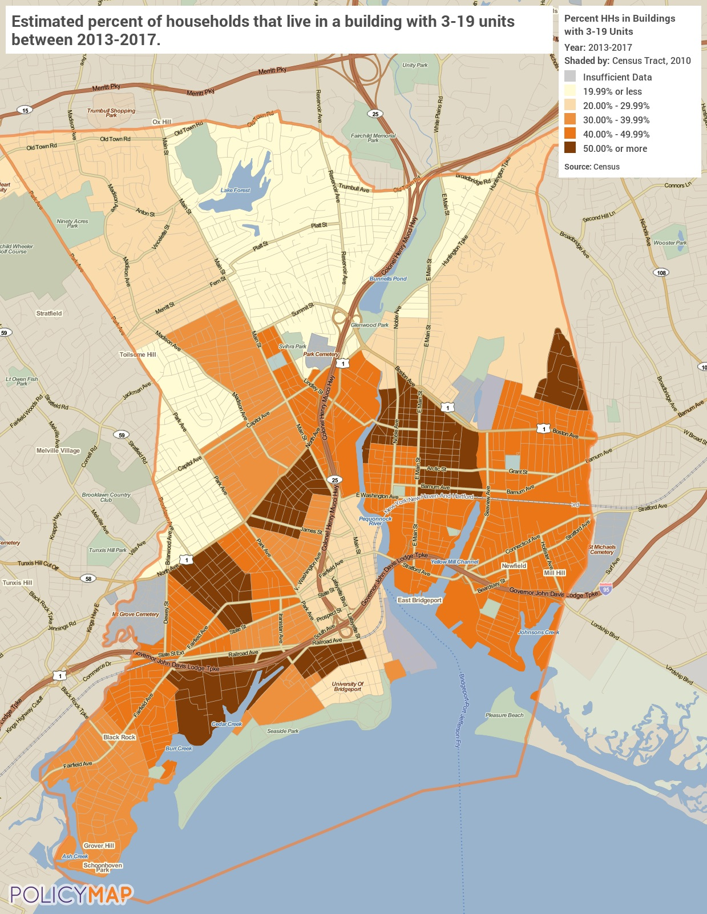
Small Multifamily Developments
Medium Multifamily Developments
Medium multifamily developments are less common than small but still have some significant concentrations, particularly in the southern part of the City where 10% or more of the housing stock is made up of these developments.
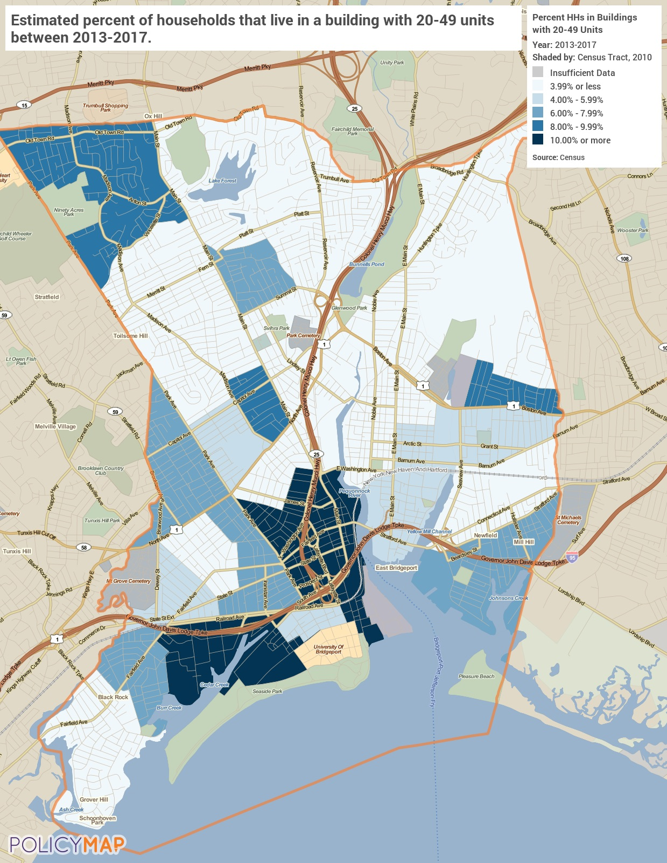
Medium Multifamily Developments
Large Multifamily Developments
Large multifamily developments are more common than medium but less common that small. Several tracts in the City have a relatively large housing stock of large buildings with 20% or more.
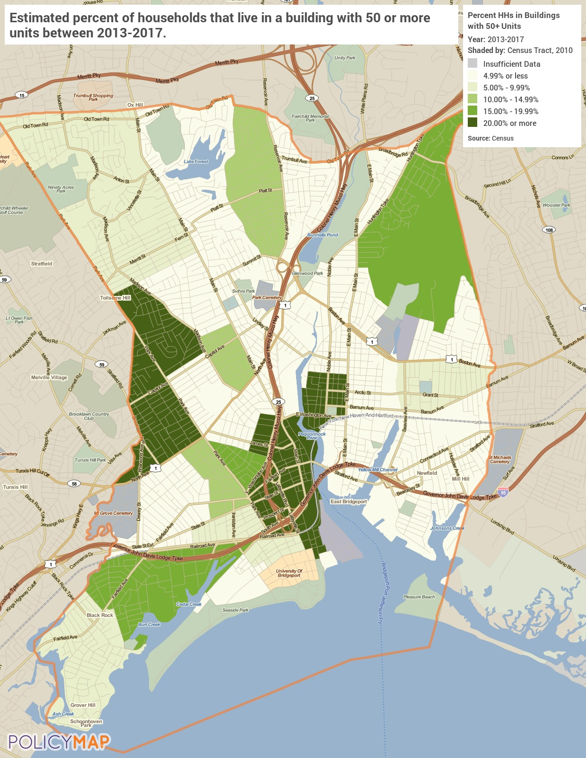
Large Multifamily Developments

Unit Size by Tenure
 | Owners |  | Renters
 | Number | % | Number | %
No bedroom | 125 | 1 | 1690 | 6
1 bedroom | 118 | 6 | 7283 | 25
2 bedrooms | 6625 | 31 | 11334 | 39
3 or more bedrooms | 13070 | 62 | 8896 | 30
Total | 21138 | 100 | 29203 | 100
Table 32 – Unit Size by Tenure

Alternate Data Source Name:
2013-2017 ACS 5-Yr Estimates

Unit Size by Tenure
The size of available units in the City differs considerably for owners and renters. Renter occupied units are much more likely to be smaller, nearly 70% of the units have 2 bedrooms or less. Owner-occupied units, on the other hand, are considerably larger. Over 60% of the units have 3 or more bedrooms.
Source: 2013-2017 American Community Survey 5-Year Estimates
Describe the number and targeting (income level/type of family served) of units assisted with federal, state, and local programs.
Over the next 5-Year Plan, the City will target LMI and special needs persons and families with programs:
HOME:
Homeowner Housing Added: 10 Household Housing Unit
Rental units constructed: 25 Household Housing Unit
Rental units rehabilitated: 50 Household Housing Unit
CDBG & HOME:
Homeowner Housing Rehabilitated: 50 Household Housing Unit
ESG:
Tenant-based rental assistance / Rapid Rehousing: 250 Households Assisted
HOPWA:
Tenant-based rental assistance / Rapid Rehousing: 600 Households Assisted
Housing for People with HIV/AIDS added: 180 Household Housing Unit
For a detailed description, see the SP-40 Goals for the number and targeting of units assisted in this five-year Consolidated Plan.
Provide an assessment of units expected to be lost from the affordable housing inventory for any reason, such as expiration of Section 8 contracts.
There are currently 18 properties with Section 8 contracts in the City of Bridgeport. Prior to the end of the time period covered by this plan there are eight contracts that may expire. These developments include 635 units. The vast majority of the units (601) are one bedroom. There are no units with 3 or more bedrooms in these contracts.
Does the availability of housing units meet the needs of the population?
No, there is a lack of decent affordable units throughout the jurisdiction. From a quantitative standpoint, there may be ample units in to house the population. However, high home values and rents result in much of the housing stock being out of the affordable range for large portions of the population.
Describe the need for specific types of housing:
Currently, the City has a need for affordable housing options and housing variety within the owner-occupied and renter-occupied market. In particular, there is a lack of smaller units available for residents who may not need 3 or more bedrooms in a starter home and renters who may need larger units with more than 2 bedrooms.
Discussion
N/A

MA-15 Housing Market Analysis: Cost of Housing - 91.210(a)
Introduction
The following section examines the cost of housing for both homeowners and renters within the City of Bridgeport. A review is made of current home values and rents as well as the recent changes in home values and rents. Finally, a closer look is given to the affordability of the existing housing stock for the residents of the jurisdiction.
Cost of Housing
 | Base Year: 2010 | Most Recent Year: 2017 | % Change
Median Home Value | 117,500 | 170,300 | 45%
Median Contract Rent | 671 | 1,142 | 70%
Table 33 – Cost of Housing

Alternate Data Source Name:
2000 Census, 2013-2017 ACS

Rent Paid | Number | %
Less than $500 | 3,422 | 12
$500-999 | 7,018 | 25
$1,000-1,499 | 11,921 | 42
$1,500-1,999 | 4,757 | 17
$2,000 or more | 1,233 | 4
Total | 28,351 | 100
Table 34 - Rent Paid

Alternate Data Source Name:
2013-2017 ACS 5-Yr Estimates

Housing Costs
Housing value and rents have increased substantially in the City since 2000. The reported average home value has increased by nearly 45%. However, this is not necessarily representative of what a potential homeowner in the City would actually pay for the property. Residents who are interested in purchasing a home will likely pay more than the average home value because the average sale price is generally higher than the reported value.
Rents have increased in the City by over 70%. The table above breaks out the rent paid by price cohorts in the City. Later in this section, the report examines rental rates as a percentage of household income to determine the affordability of rental housing.
The map below shows the median home value by census tract throughout the City. In general, home values appear to be higher outside of the downtown area. Three tracts have a relatively high median home value listed at over $225,000
Source: 2013-2017 American Community Survey 5-Year Estimates
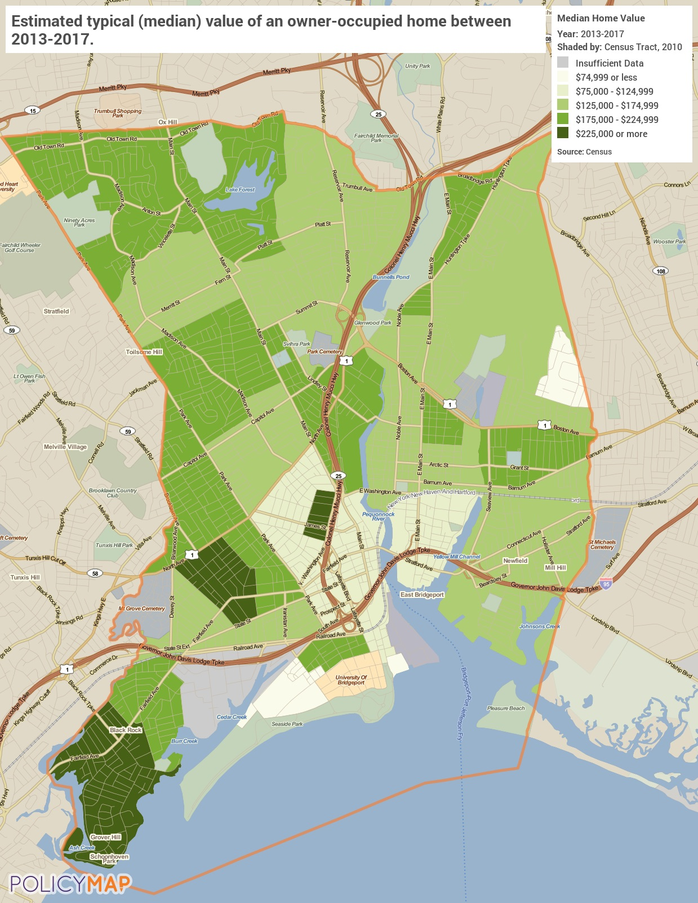
Median Home Value
Median Rent
The map below displays the median rent by census tract. The highest median rents are found in the southwest and north tracts of the City where the rent is, on average, more than $1,400. The tracts with the lowest median rent report less than $800 per unit.
Source: 2013-2017 American Community Survey 5-Year Estimates
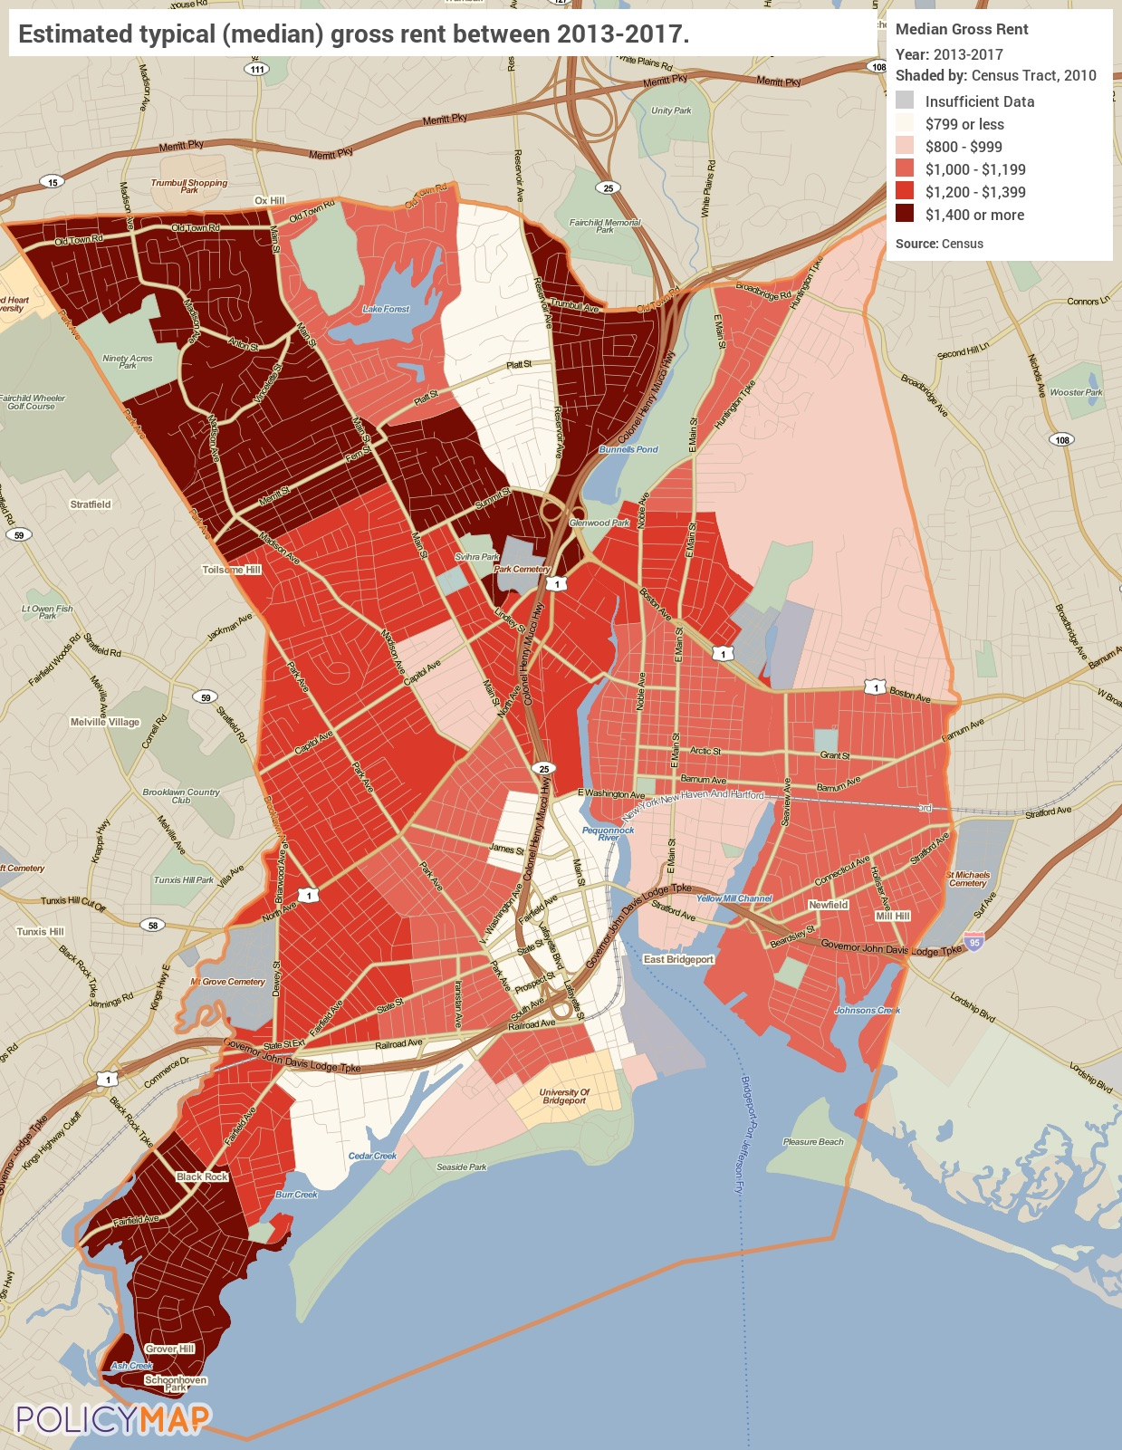
Median Rent

Housing Affordability
% Units affordable to Households earning | Renter | Owner
30% HAMFI | 4,225 | No Data
50% HAMFI | 10,995 | 3,145
80% HAMFI | 23,380 | 7,885
100% HAMFI | No Data | 11,405
Total | 38,600 | 22,435
Table 35 – Housing Affordability
Data Source: | 2011-2015 CHAS

Housing Affordability
Lower income groups have a significant need for affordable housing. Very low-income residents (30%-50% HAMFI) have only 3,145 owner units available. This relatively low number makes it difficult for residents in this income group to become homeowners.

Monthly Rent
Monthly Rent ($) | Efficiency (no bedroom) | 1 Bedroom | 2 Bedroom | 3 Bedroom | 4 Bedroom
Fair Market Rent | 853 | 1,032 | 1,293 | 1,631 | 2,028
High HOME Rent | 858 | 1,032 | 1,293 | 1,631 | 1,878
Low HOME Rent | 858 | 962 | 1,155 | 1,334 | 1,488
Table 36 – Monthly Rent

Alternate Data Source Name:
HUD 2019 FMR and HOME Rents

HUD FMR and HOME Rent Limit
Fair Market Rents (FMRs) are set by HUD and used to determine payment standard amounts for HUD Programs. HUD annually estimates FMRs for the Office of Management and Budget (OMB) defined metropolitan areas, some HUD defined subdivisions of OMB metropolitan areas and each nonmetropolitan county.
HOME Rents Limits are based on FMRs published by HUD. HOME Rent Limits are the maximum amount that may be charged for rent in HOME-assisted rental units and are applicable to new HOME leases.
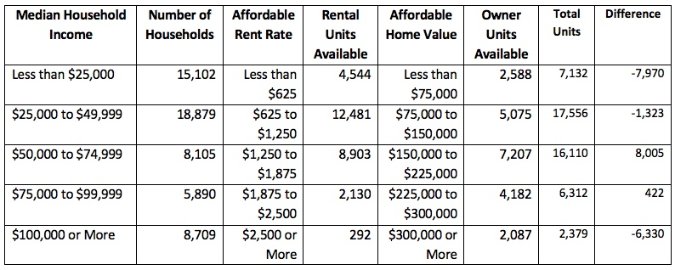
Units Affordable by Income Category

Is there sufficient housing for households at all income levels?
No, there is not. In the City of Bridgeport, the FMR for a two-bedroom apartment is $1,293. In order to afford this level of rent and utilities without paying more than 30% of income on housing, a household must earn approximately $4,310 monthly or $51,720 annually. Assuming a 40-hour work week, 52 weeks per year, this translates into a minimum “Affordable Housing Wage” of $24.87/hour.
Residents who make less than $25,000 annually have the greatest difficulty finding affordable housing. According to the data there are 7,970 fewer units available than needed. However, the situation is worse than that. When possible, households will work to minimize their costs and those with higher incomes can acquire units that are below their maximum affordability.
See table above: Units Affordable by Income Category
How is affordability of housing likely to change considering changes to home values and/or rents?
As noted in the above analysis, from 2000 to 2017, median home values and rents both increased. The continued high price of both owner-occupied and rental housing reduces the ability of low-income households to find affordable housing. In addition, there are a high number of owner-occupied and renter-occupied households that are cost burdened. If housing unit construction and rehabilitation cannot keep up with those that go off the market, then the affordable housing issue will continue to worsen.
How do HOME rents / Fair Market Rent compare to Area Median Rent? How might this impact your strategy to produce or preserve affordable housing?
The median contract rent in Bridgeport is $1,142. That level of rent is below the Fair Market Rent and High HOME Rent for a 2-bedroom unit and between the Low HOME Rent for 1-bedroom and 2-bedroom units. Being aware of the fair market rents and available housing will help inform which projects are supported by grant funds.
Discussion
N/A

MA-20 Housing Market Analysis: Condition of Housing – 91.210(a)
Introduction
The tables and maps in this section provide details on the condition of housing units throughout the region by looking at factors such as age, vacancy, and the prevalence of housing problems.
As defined by HUD, the four housing problems are:
1) a home which lacks complete or adequate kitchen facilities
2) a home which lacks complete or adequate plumbing facilities
3) a home which is overcrowded (having more than one person per room)
4) a household that is cost burdened (paying 30% or more of their income towards housing costs)
Definitions
For the purposes of this plan, units are considered to be in “standard condition” when the unit is in compliance with the local building code, which is based on the International Building Code.
The definition of substandard housing is a housing unit with one or more serious code violations. For the purposes of this analysis the lack of a complete plumbing or a complete kitchen will also serve as an indicator of substandard housing.
Units are considered to be in “substandard condition but suitable for rehabilitation” when the unit is out of compliance with one or more code violations and it is both financially and structurally feasible to rehabilitate the unit.
Condition of Units
Condition of Units | Owner-Occupied |  | Renter-Occupied
 | Number | % | Number | %
With one selected Condition | 8,692 | 41% | 16,085 | 55%
With two selected Conditions | 348 | 2% | 1,434 | 5%
With three selected Conditions | 0 | 0% | 77 | 0%
With four selected Conditions | 0 | 0% | 11 | 0%
No selected Conditions | 12,098 | 57% | 11,596 | 40%
Total | 21,138 | 100% | 29,203 | 100%
Table 37 - Condition of Units

Alternate Data Source Name:
2013-2017 ACS 5-Yr Estimates

Housing Conditions
The table above details the number of owner and renter households that have at least one housing condition. As stated previously, HUD describes four housing conditions as being problems: 1) the home lacks complete or adequate kitchen facilities, 2) the home lacks complete or adequate plumbing facilities 3) the home is overcrowded - defined as more than one person per room, 4) the household is cost burdened by paying more than 30% of their income towards housing costs.
Over 41% percent of all owner-occupied housing units face at least one housing condition while 55% of all renters have at least one housing condition. Generally speaking, there are relatively few households with multiple housing problems and when compared to the affordability statistics provided earlier in this section, it is clear that the overwhelming majority of housing problems are housing cost burden.

Year Unit Built
Year Unit Built | Owner-Occupied |  | Renter-Occupied
 | Number | % | Number | %
2000 or later | 621 | 3% | 1,331 | 5%
1980-1999 | 2,141 | 10% | 3,102 | 11%
1950-1979 | 8,083 | 38% | 8,796 | 30%
Before 1950 | 10,293 | 49% | 15,974 | 55%
Total | 21,138 | 100% | 29,203 | 101%
Table 38 – Year Unit Built

Alternate Data Source Name:
2013-2017 ACS 5-Yr Estimates

Data Source Comments:

Year Unit Built
Only a relatively small percentage of the housing stock was built since 1980, approximately 13% of owner households and 16% of renter households. There are currently over 43,000 housing units that were built before 1980 making over 85% of the housing stock. These homes are at an increased risk of Lead-Based Paint Hazard and may need significant remediation during any rehabilitation that may occur as they age.
Source: 2013-2017 American Community Survey 5-Year Estimates
Age of Housing
The maps below depict the prevalence of older housing units in the City. The first map identifies the percentage of units built prior to 1940 while the second map depicts units built prior to 1980. The darker shaded areas have higher concentrations of the older housing stock. The overall trend is that older homes are in the center part of the City.
Source: 2013-2017 American Community Survey 5-Year Estimates
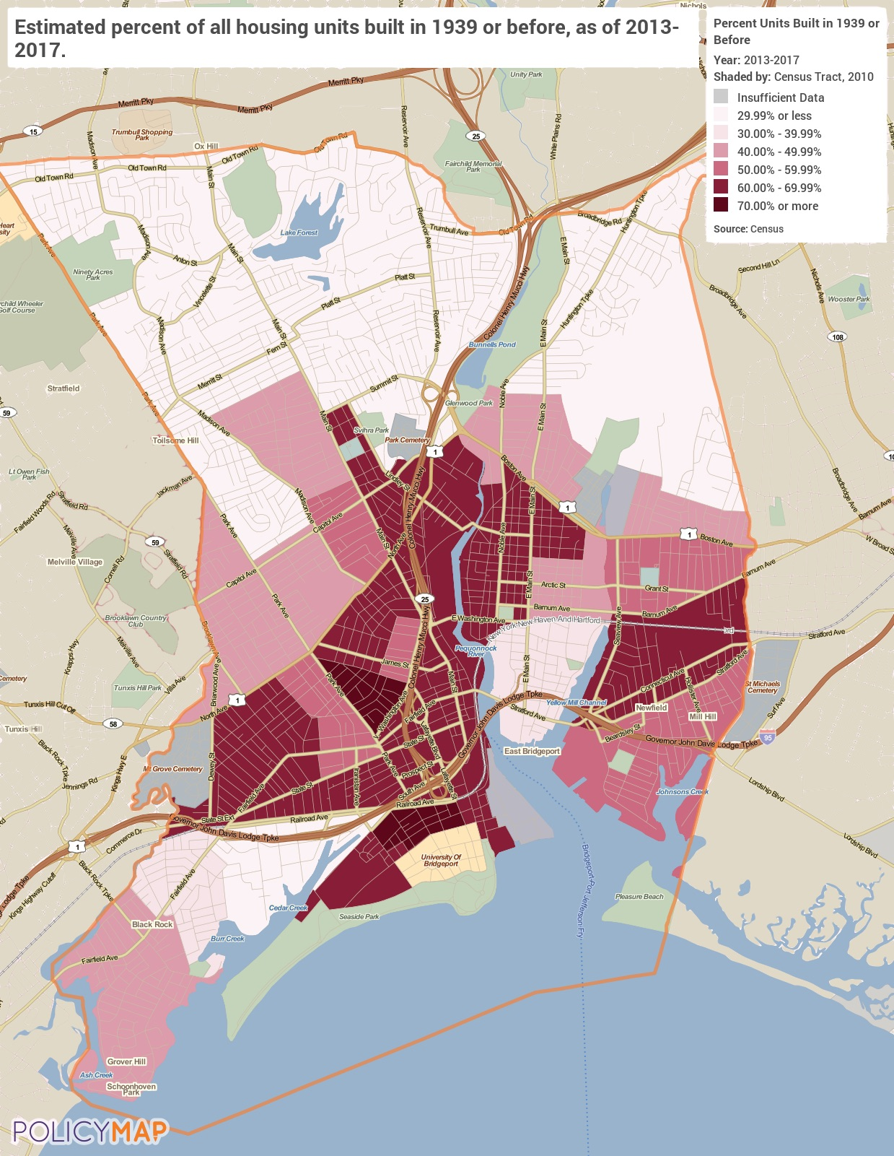
Housing Units Built Before 1940
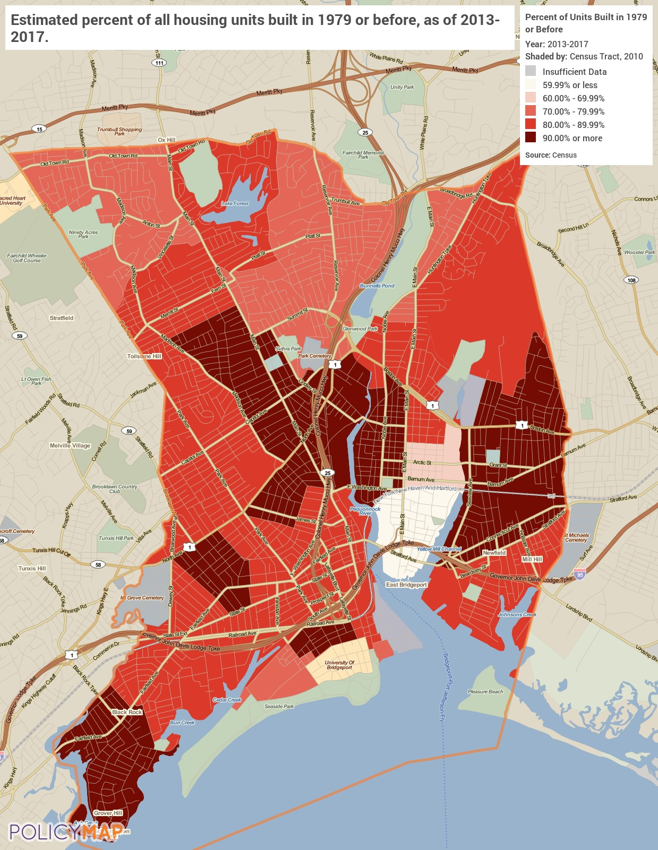
Housing Units Built Before 1980

Risk of Lead-Based Paint Hazard
Risk of Lead-Based Paint Hazard | Owner-Occupied |  | Renter-Occupied
 | Number | % | Number | %
Total Number of Units Built Before 1980 | 18,376 | 87% | 24,770 | 85%

Housing Units build before 1980 with children present | 1,485 | 7% | 495 | 2%
Table 39 – Risk of Lead-Based Paint
Data Source: | 2011-2015 ACS (Total Units) 2011-2015 CHAS (Units with Children present)

Lead-Based Paint Hazard
As mentioned previously, any housing unit built prior to 1980 may contain lead-based paint in portions of the home. The most common locations are window and door frames, walls, and ceilings, and in some cases throughout the entire home. Thus, it is generally accepted that these homes at least have a risk of lead-based paint hazards and should be tested in accordance with HUD standards. The greatest potential for lead-based paint and other environmental and safety hazards is in homes built before 1980. Within the City there are over 43,000 housing units built before 1980.

Vacancy Rate
The map below shows the average housing vacancy rates throughout the City. The darker shaded areas have higher vacancy rates, while the lighter shaded areas have lower vacancy rates. Vacancy is relatively common throughout the City.
Source: 2013-2017 American Community Survey 5-Year Estimates
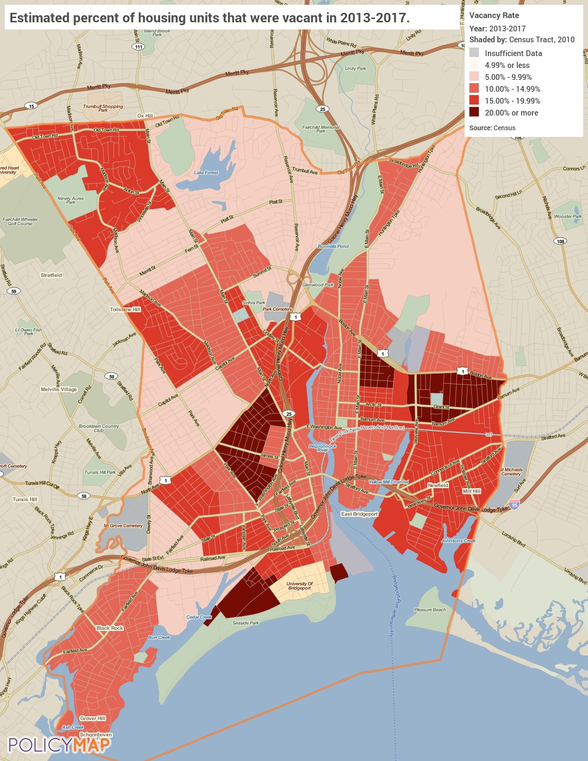
Vacancy Rate

Need for Owner and Rental Rehabilitation
Based on the analysis of data, the City’s need for owner and rental rehabilitation are based on the older age of a significant portion of both the rental and owner housing stock, the high number of owner and renter units at risk for lead exposure and occupied by families with children, and the high number of renter and owner units identified as having one or more substandard conditions.
Estimated Number of Housing Units Occupied by Low or Moderate Income Families with LBP Hazards
To estimate the number of housing units in the City by low- or moderate-income families that may contain lead-based paint hazards, this report assumes that homes by year built are distributed evenly across income categories, as no local data exists to describe otherwise. However, considering LMI families are more likely to live in older homes than higher income families, it is a reasonable estimate that approximately 65% of the 43,146 homes built before 1980 are occupied by LMI families. That means an estimated 28,045 LMI families may live in a home with LBP hazards.
Discussion
N/A

MA-25 Public and Assisted Housing – 91.210(b)
Introduction
Park Cities Communities (PCC) administers public housing and the Housing Choice Vouchers (HCV) program in the city. There are currently over 2,300 public housing residents living in properties owned and managed by PCC and over 3,000 participants in the HCV program. An indicator of market conditions and demand for affordable housing is the number of households on the waiting lists for publicly supported housing. PCC has provided the following information:
As of 3/17/2016 the Public Housing Wait List was 1,723 families and for the HCV program is was 369 families.
Totals Number of Units
Program Type
 | Certificate | Mod-Rehab | Public Housing | Vouchers
 |  |  |  | Total | Project -based | Tenant -based | Special Purpose Voucher
 |  |  |  |  |  |  | Veterans Affairs Supportive Housing | Family Unification Program | Disabled  *
# of units vouchers available | 0 | 0 | 2,342 | 3,370 | 307 | 3,063 | 15 | 0 | 0
# of accessible units

*includes Non-Elderly Disabled, Mainstream One-Year, Mainstream Five-year, and Nursing Home Transition
Table 41 – Total Number of Units by Program Type

Alternate Data Source Name:
PIC (PIH Information Center)

Data Source Comments:

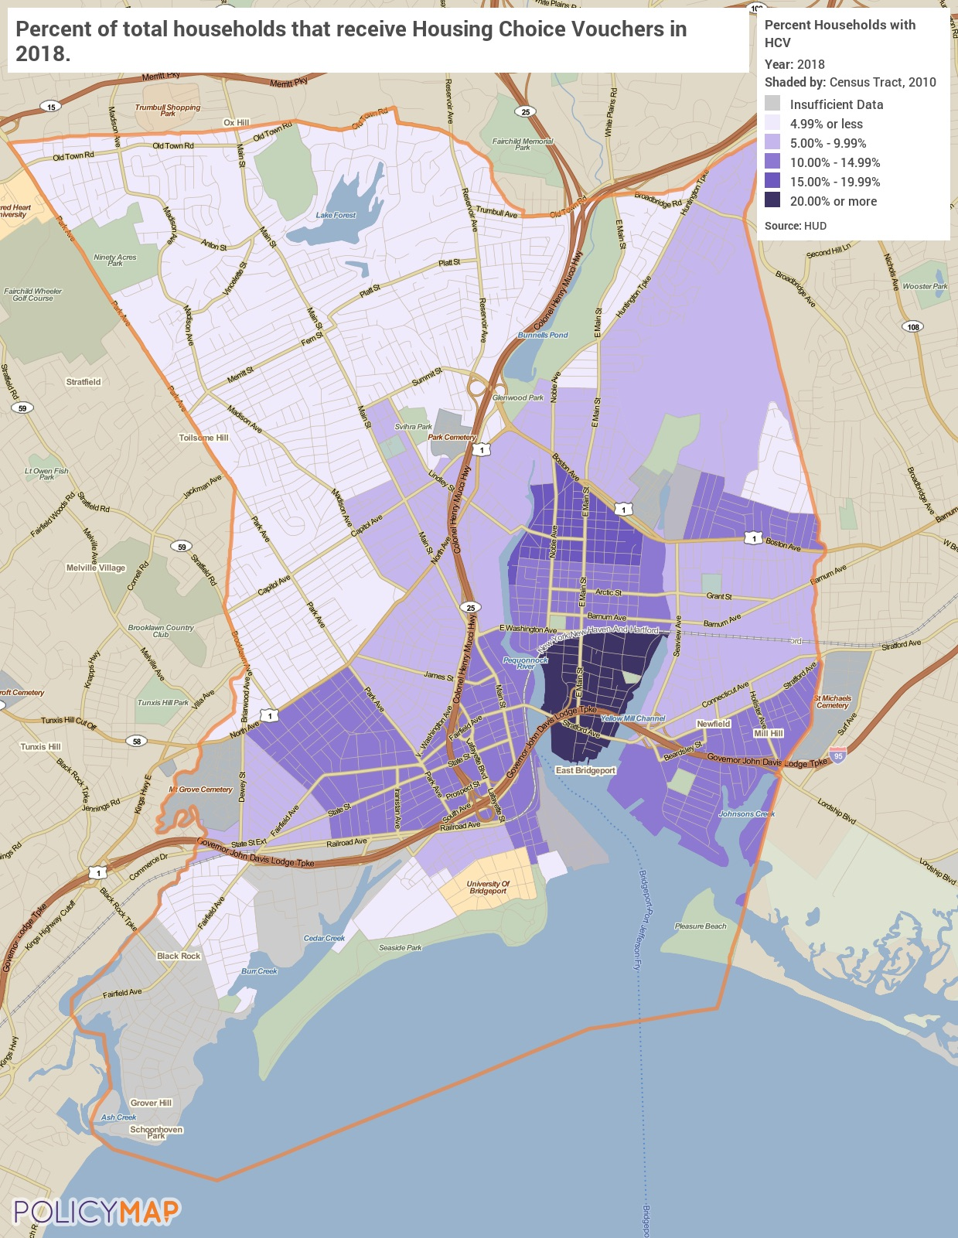
HCV Distribution
Describe the supply of public housing developments:
Describe the number and physical condition of public housing units in the jurisdiction, including those that are participating in an approved Public Housing Agency Plan:
HUD provides physical inspection scores for PHA developments across the country. The physical condition scoring process is based on three elements within the property, which are:
1. Inspectable areas: site, building exterior, building system, common areas and dwelling units;
2. Inspectable items: walls, kitchens, bathrooms and other things to be inspected in the inspectable area;
3. Observed deficiencies.
A score of 55 or below means that the property is in poor condition, and properties in excellent condition have a score of 90 and over.
Development Name / PHA score / Inspection Date
(note these are names used by HUD to identify the housing developments and may not be the commonly used name of the development)
PARK CITY – SUPPORTIVE / 96 / Last inspected on 2/10/2017
PARK CITY – ELDERLY / 96 / Last inspected on 10/13/2017
FIRESIDE APTS. EXT 2 / 89 / Last inspected on 11/28/2017
ALBION STREET / 80 / Last inspected on 11/3/2017
HARBOR VIEW TOWERS / 79 / Last inspected on 11/17/2017
P.T. BARNUM APTS. / 71 / Last inspected on 10/20/2017
TRUMBULL GARDENS TOWNHOUSES / 62 / Last inspected on 11/29/2017
MARINA VILLAGE / 62 / Last inspected on 2/21/2018
BOSTON COMMONS / 57 / Last inspected on 10/25/2017
PRESIDENTIAL VILLAGE / 49 / Last inspected on 11/3/2017
MAPLEWOOD SCHOOL MIXED FINANCE / 45 / Last inspected on 10/13/2017
MASTER CONTRACT - CREATIVE CHOICE / 38 / Last inspected on 2/13/2018
CHARLES F. GREENE HOMES / 23 / Last inspected on 2/12/2018

Public Housing Condition
Public Housing Development | Average Inspection Score
PARK CITY - SUPPORTIVE | 96
PARK CITY - ELDERLY | 96
FIRESIDE APTS. EXT 2 | 89
ALBION STREET | 80
HARBOR VIEW TOWERS | 79
P.T. BARNUM APARTMENTS | 71
TRUMBULL GARDENS TOWNHOUSES | 62
MARINA VILLAGE | 62
BOSTON COMMONS | 57
PRESIDENTIAL VILLAGE | 49
MAPLEWOOD SCHOOL MIXED FINANCE | 45
MASTER CONTRACT - CREATIVE CHOICE | 38
CHARLES F. GREENE HOMES | 23
Table 42 - Public Housing Condition

Describe the restoration and revitalization needs of public housing units in the jurisdiction:
As of their last inspections in 2017, both Park City developments are in excellent condition. There are currently four developments that are in poor condition and another that scored very closely to poor condition. These units will require significant rehab and restoration to remain useful. The units are (note these are names used by HUD to identify the housing developments and may not be the commonly used name of the development):
Presidential Village located at 627 Hallet Street with a score of 49.
Maplewood School Mixed Finance at 434 Maplewood Ave with a score of 45.
Master Contract – Creative Choice at 1810 Stratford Ave with a score of 38.
Charles F. Greene Homes at 508 Harral Ave with a score of 23.
Boston Commons at 1260 Boston Ave scored just above poor condition with 57.
Describe the public housing agency's strategy for improving the living environment of low- and moderate-income families residing in public housing:
As evidenced by four public housing developments in poor condition, maintaining quality standards continues to be a challenge. Efforts to improve the living environment for PCC residents consist of routine maintenance and continuing revitalization and rehabilitation efforts on development units with the most need. Large investments in public housing developments include recent projects such as roof replacement and repair at Albion Apartments and 408 Popular Street, and a children’s splash pad at Trumbull Gardens.
Resident associations, resident advisory boards (RAB), are also a way for residents to have a say in improving their own quality of life in their public housing communities. Associations plan and host social and recreational activities and programs for residents and give them an opportunity to voice their concerns to PCC. The associations represent the residents' views and interests in the operation of their community and can have a say in policies, how the community spends money, modernization of their buildings, and other issues as they arise. By addressing issues pertaining to the community, the associations promote public safety, self-sufficiency, and help create a more positive living environment for families.
Discussion:
N/A

MA-30 Homeless Facilities and Services – 91.210(c)
Introduction
The City of Bridgeport relies on its partners with the Connecticut Coalition to End Homelessness (CCEH), which is the local Continuum of Care (CoC), to meet the needs of the homeless with shelter facilities and homeless services. CCEH’s collective mission is to prevent and end homelessness in Connecticut.
The data below is the summary of all beds reported in Fairfield County by the Continuum of Care for 2018, as reported by HUD’s Housing Inventory Count Report.
Facilities and Housing Targeted to Homeless Households
 | Emergency Shelter Beds |  | Transitional Housing Beds | Permanent Supportive Housing Beds
 | Year Round Beds (Current & New) | Voucher / Seasonal / Overflow Beds | Current & New | Current & New | Under Development
Households with Adult(s) and Child(ren) | 271 | 80 | 110 | 717 | 0
Households with Only Adults | 268 | 0 | 95 | 1,167 | 0
Chronically Homeless Households | 0 | 0 | 0 | 1,657 | 0
Veterans | 0 | 0 | 57 | 100 | 0
Unaccompanied Youth | 16 | 0 | 71 | 49 | 0
Table 43 - Facilities and Housing Targeted to Homeless Households

Alternate Data Source Name:
2018 Housing Inventory Count

Data Source Comments: | Connecticut Coalition to End Homelessness (CCEH) Continuum of Care (CoC)

Describe mainstream services, such as health, mental health, and employment services to the extent those services are use to complement services targeted to homeless persons
There is a wealth of services and programs available for both public and private institutions, nonprofits and local government agencies that serve the homeless through the members of the CoC. All have the goal of providing these programs in the hopes that it will end homelessness. These member organizations are:
BCD
Access Community Action Agency
Alliance For Living
Always Home
Applied Behavioral Rehab Institute/Homes for the Brave
Association of Religious Communities
Bank of America
Beth-El Center
BHcare
Bridge House
Career Resources
CaseWorthy
Catholic Charities of Fairfield County
Central Connecticut Coast YMCA
Chemical Abuse Services Agency
CHR
Christian Community Action
Chrysalis Center
City of New Haven- Community Service Admin
City of Norwich Human Services
City of Waterbury, Finance Dept, Community Dev Program
Columbus House
Community Health Center Assoc of Connecticut
Community Health Center
Community Partners in Action
Community Renewal Team
Connecticut Dept of Labor
Connecticut Dept of Veterans’ Affairs
Connecticut Housing Coalition
Connecticut Housing Finance Authority
Connecticut Legal Services
Connecticut Natural Gas Company
Connecticut State Dept of Education
Cornerstone Church, Clinton
Corporation for Supportive Housing
Covenant Shelter of New London
CT Coalition Against Domestic Violence
David Fay
Dept of Housing
Dept of Mental Health and Addiction Services
Dept of Social Services
Family & Children’s Agency
Friendship Service Center
Hands On Hartford
Heritage Printers
Homes with Hope
House of Bread
Human Resource Agency of New Britain
ImmaCare
Inspirica
Jewish Family Services of Greater New Haven
Journey Home
Laurel House
Liberty Bank Foundation
Leeway
Liberty Community Services
Local Initiatives Support Corp
Marrakech
Melville Charitable Trust
Mercy Housing & Shelter Corp
Mutual Housing Assoc of Greater Hartford
My Sister’s Place
New London Homeless Hospitality Center
New Opportunities
New Reach
Noank Community Support Services
Nutmeg Consulting LLC
Office of Early Childhood
Open Door Shelter
Operation Fuel
Operation Hope of Fairfield
Pacific House
Partnership for Strong Communities
Perception Programs
Prudence Crandall Center
Recovery Network of Programs
Reliance Health
Safe Futures
Safe Haven of Greater Waterbury
Salvation Army Divisional Headquarters
South Park Inn
St John’s Episcopal Church – Essex
St. Vincent de Paul
St. Vincent’s Behavioral Health Services
Stonington Human Services
Supportive Housing Works
Team, Inc.
Terri Fleming
Thames River Community Service/Martin House
Thames Valley Council for Community Action
The Connection
The Open Hearth Assoc
The Salvation Army, Waterbury Corps
Trinity Church on the Green
United Services
UW of Coastal Fairfield County
UW of Connecticut
UW of Greater New Haven
UW of Greater Waterbury
UW of Southeastern Connecticut
Waterbury Youth Services
Windham Region No Freeze Project
Windham Reg Community Council
Women and Families Center
Women’s Institute for Housing & Economic Dev
Youth Continuum
YWCA of the Hartford

List and describe services and facilities that meet the needs of homeless persons, particularly chronically homeless individuals and families, families with children, veterans and their families, and unaccompanied youth. If the services and facilities are listed on screen SP-40 Institutional Delivery Structure or screen MA-35 Special Needs Facilities and Services, describe how these facilities and services specifically address the needs of these populations.
Families with Children
Families with children have several options that meet their emergency and transitional housing needs in the CoC. There are emergency shelter facilities specifically for families operated by Alpha Community Services YMCA in two locations (110 total beds), Bridgeport Rescue Mission (11 total beds), Homes with Hope (16 total beds), and Inspirica with two shelter locations (42 total beds). For transitional housing, Alpha Community Services YMCA with its Jean Wallace Transitional Housing facility has 26 beds, Inspirica has a facility with 63 beds and The Center for Family Justice has a facility with 12 beds. Inspirica also helps families with children with rapid re-housing services.
Unaccompanied Youth
For youth under 18 yrs. old that are homeless, there are two emergency shelters. The Council of Churches of Greater Bridgeport has 4 child-only beds and Kids in Crisis has a facility with 12 child-only beds.
Chronically Homeless
The chronically homeless in the CoC have are serviced by permanent supportive housing providers which work to serve this group with several programs designed to end homelessness. These providers are Alpha Community Services YMCA, Bridgeport Housing First Collaborative, Catholic Charities of Fairfield County, Family and Children’s Agency, Homes with Hope, Inspirica, Laurel House, Mid-Fairfield AIDS project, Open Door Shelter, Operation Home, Pacific House, Recovery Network of programs, South Western CT, St. Vincent CRS and The Connection Milestone. Through these providers, over 1,600 permanent supportive housing beds are available.
Veterans
Veterans in the CoC are served with transitional housing and permanent supportive housing. ABRI Homes for the Brave has three facilities with a total of 66 beds reserved for veterans. The Veterans Administration (VA) uses VASH to help house 81 veterans with permanent supportive housing. The Connection’s Milestone facility has 10 permanent supportive housing beds reserved for veterans.

MA-35 Special Needs Facilities and Services – 91.210(d)
Introduction
There are four primary groups with non-homeless special needs in the jurisdiction. They are the elderly and frail elderly, those with HIV/AIDS and their families, those with alcohol and/or drug addiction, and the mentally or physically disabled. This section will explain who they are, what their needs are, and how the jurisdiction is accommodating (or should accommodate) those needs.
HOPWA Assistance Baseline Table
Type of HOWA Assistance | Number of Units Designated or Available for People with HIV/AIDS and their families
TBRA | 120
PH in facilities | 0
STRMU | 60
ST or TH facilities | 0
PH placement | 35
Table 44– HOPWA Assistance Baseline

Alternate Data Source Name:
2018 HOPWA CAPER

Data Source Comments: | Estimates of unmet need for persons living with HIV were taken from the One-Year Goals of the 2018 HOPWA CAPER, however according to the CT Dept. of Health HIV Surveillance Program, there were 1,234 persons living with HIV in Bridgeport - far more than the one-year goals. The true housing needs of persons living with HIV fall somewhere in between the proposed housing goals of the City and the reported number of persons living with HIV in the City.

Including the elderly, frail elderly, persons with disabilities (mental, physical, developmental), persons with alcohol or other drug addictions, persons with HIV/AIDS and their families, public housing residents and any other categories the jurisdiction may specify, and describe their supportive housing needs
Elderly: The supportive housing needs for this population can vary widely depending on the health and fitness of the individuals. In general, with aging disabilities and other health issues become more common. Because of this, supportive housing must include access to health professionals and housing modifications to assist the resident. It is important to help residents stay independent and in their own homes for as long as possible if they prefer that.
HIV/AIDS: Medical and social support is important for residents living with HIV/AIDS. While there have been great advances in the medical treatment of HIV/AIDS, it is still important to provide specialized support. Family and friends must be accessible and medical facilities should be nearby.
Alcohol and/or Drug Addiction: Individuals dealing with addiction often require housing options that will provide a safe, sober place for recovery. A strong network is necessary to maximize the chance they will stay healthy and sober. It is important that these persons have access to health services, support groups, employment assistance, and access to family and friends. Additionally, detoxification facilities are necessary when addiction is first recognized.
Mental and Physical Disabilities: Individuals with disabilities encompass a wide range of skill levels and abilities. Therefore, the have many of the same issues as the general population with the added needs that are unique to their situation. Often times, individuals with disabilities have a fixed income and limited housing options. Individuals with more independent skills can utilize subsidized housing but individuals that need more support or specialized housing have fewer options. Many individuals continue to reside with parents and families throughout adulthood, which can put additional financial burden on the family. Regardless of the housing situation, a common thread is the need to continuous support services dependent on the level of capabilities.
The specific needs of local special needs subpopulations are described in NA-45, Non-Homeless Special Needs Assessment.
Describe programs for ensuring that persons returning from mental and physical health institutions receive appropriate supportive housing
The Connecticut Department of Social Services designed and developed “My Community Choices” a public information service that provides options for nursing home residents about returning to the community. The program funded by an $800,000 grant over three years from the federal Centers for Medicare and Medicaid Services is administered by DSS which has subcontracted the project to Connecticut Association of Centers for Independent Living. Independent living centers are organizations and operated within a local community by individuals with disabilities.
The Section 8 Mainstream Housing Opportunities Program for Persons with Disabilities enhances the State of Connecticut’s efforts to provide safe, affordable, decent and sanitary housing to persons with disabilities. Persons with disabilities may apply when Section 8 waiting list is open. The Section 8 waiting list identifies applicants who meet mainstream eligibility requirements. Since 2003, DSS has made available up to 50 housing vouchers per year for persons living in licensed nursing facilities in the state of Connecticut who wish to live in private rental units in the community. Interested persons call a transition coordinator working in the center for independent living which serves the region in which they live. When a person has developed a service plan to live in the community, he or she will be referred to the contract administrator and placed on the waiting list.
The Connecticut State Department of Mental Health and Addiction Services has developed and implemented a policy required as a condition of receipt of McKinney Funds. This policy specifies that each patient treated in a Department of Mental Health facility shall have a specialized treatment plan suited to his/her disorder, which shall include a discharge plan for appropriate aftercare of the patient. The treatment team or clinician responsible for the inpatient care should plan the aftercare services needed by the patient, in conjunction with the community case manager who is responsible to ensure linkages in the community. This collaborative planning process should commence at the point of the inpatient admission and should identify all of the services and service providers in the local community support system whose efforts will assist the individuals to maintain him/her in the community in the least restrictive environment possible. Continuity of care is of primary importance. Every attempt shall be made to verify discharge-housing arrangements. Under no circumstances shall an emergency shelter be considered appropriate housing disposition and patients shall not be directly discharged by the inpatient facility to an emergency shelter. No patient shall be discharged from a DMH facility without documented evidence that discharge aftercare plans have been an integral part of the treatment plan, with documentation indicating that the patient and the community-based case manager have been actively involved in the discharge planning
Specify the activities that the jurisdiction plans to undertake during the next year to address the housing and supportive services needs identified in accordance with 91.215(e) with respect to persons who are not homeless but have other special needs. Link to one-year goals. 91.315(e)
The City of Bridgeport has identified the need for public services for the special needs population and has included a goal in the Action Plan:
3A Provide Supportive Services for Special Needs Populations
For this goal, the City will provide supportive services for low income and special needs populations. Public services will target LMI citizens and may include services to address homelessness, persons with physical and mental health disabilities, the elderly, and the youth. Services may also include recreational programs for special needs populations, and education and health programs for special needs households.
The City will also target supportive services for individuals and families living with HIV/AIDS. A goal has been included in the Action Plan:
5A. Provide Hsg Opportunities Persons w HIV/AIDS
5B. Provide Medical & Supportive Services HIV/AIDS
Through these goals, the City will provide for housing & supportive services for persons with HIV/AIDS such as permanent housing placement, tenant-based rental assistance (TBRA) and short-term rent, mortgage and utility assistance (STRMU).

MA-40 Barriers to Affordable Housing – 91.210(e)
Negative Effects of Public Policies on Affordable Housing and Residential Investment
In 2019 the City of Bridgeport released, Plan Bridgeport, the City’s plan of conservation and development over the next 10 years. Plan Bridgeport provides an outline of the current realities of resources and constraints of the City and establishes a strategy for policy and funding decisions that will work to improve the quality of life for the City’s citizens through prioritization of resources towards the areas of waterfront, transit development, neighborhoods, and housing.
As documented in Plan Bridgeport, the housing situation is complex as there are contradicting policy problems. Housing is too expensive and not affordable for a large segment of the population. At the same time, housing is not expensive enough to generate a profit for real estate developers. The lack of profit incentive has led to an aging housing stock and overall shortage of housing in the City, which in turn is increasing demand for housing at all price points.
Plan Bridgeport also reports that older housing stock is more likely to have lead and asbestos hazards, more expensive to heat and cool and more prone to require costly repairs. Older housing is also generally less expensive to buy than newer housing, meaning that households with lower incomes tend to live in housing that has an increased risk of causing health problems and is more costly than newer housing to properly maintain. According to the ACS data in the MA-20 Year Unit Built table, 87% of homeowners and 85% of renters live in housing built before 1980 making it pertinent that the City address this issue. A full detailed strategy of the City is outlined in Plan Bridgeport.

MA-45 Non-Housing Community Development Assets – 91.215 (f)
Introduction
This section provides insight into the economic development landscape of the City. Included in this section is a look at the specific industries that are prevalent within the City, as well as indicators such as commute times, unemployment, and educational attainment.
Economic Development Market Analysis
Business Activity
Business by Sector | Number of Workers | Number of Jobs | Share of Workers  % | Share of Jobs  % | Jobs less workers  %
Agriculture, Mining, Oil & Gas Extraction | 80 | 30 | 0 | 0 | 0
Arts, Entertainment, Accommodations | 7,531 | 3,232 | 11 | 7 | -4
Construction | 5,469 | 1,431 | 8 | 3 | -5
Education and Health Care Services | 17,927 | 18,735 | 26 | 43 | 17
Finance, Insurance, and Real Estate | 3,145 | 2,590 | 5 | 6 | 1
Information | 1,321 | 782 | 2 | 2 | 0
Manufacturing | 6,011 | 3,531 | 9 | 8 | -1
Other Services | 4,197 | 1,659 | 6 | 4 | -2
Professional, Scientific, Management Services | 6,995 | 3,569 | 10 | 8 | -2
Public Administration | 1,895 | 2,175 | 3 | 5 | 2
Retail Trade | 8,842 | 3,220 | 13 | 7 | -6
Transportation and Warehousing | 3,464 | 1,282 | 5 | 3 | -2
Wholesale Trade | 1,110 | 1,522 | 2 | 3 | 1
Total | 67,987 | 43,758 | -- | -- | --
Table 45 - Business Activity

Alternate Data Source Name:
2013-2017 ACS (Workers), 2017 LEHD (Jobs)

Data Source Comments:

Labor Force
Total Population in the Civilian Labor Force | 78,853
Civilian Employed Population 16 years and over | 68,987
Unemployment Rate | 13.80
Unemployment Rate for Ages 16-24 | 29.20
Unemployment Rate for Ages 25-65 | 11.40
Table 46 - Labor Force

Alternate Data Source Name:
2013-2017 ACS 5-Yr Estimates

Unemployment
Using the unemployment methodology from the US Census Bureau, Citywide the unemployment rate is 13.8% for all persons in the civilian workforce. This is nearly double the national unemployment rate of 7.4%. Approximately 29.2% of persons between the ages of 16 and 24 are unemployed. The map below shows the distribution of unemployed persons throughout the City. Tracts closer to the water tend to have higher unemployment rates (over 20%).
Source: 2013-2017 American Community Survey 5-Year Estimates
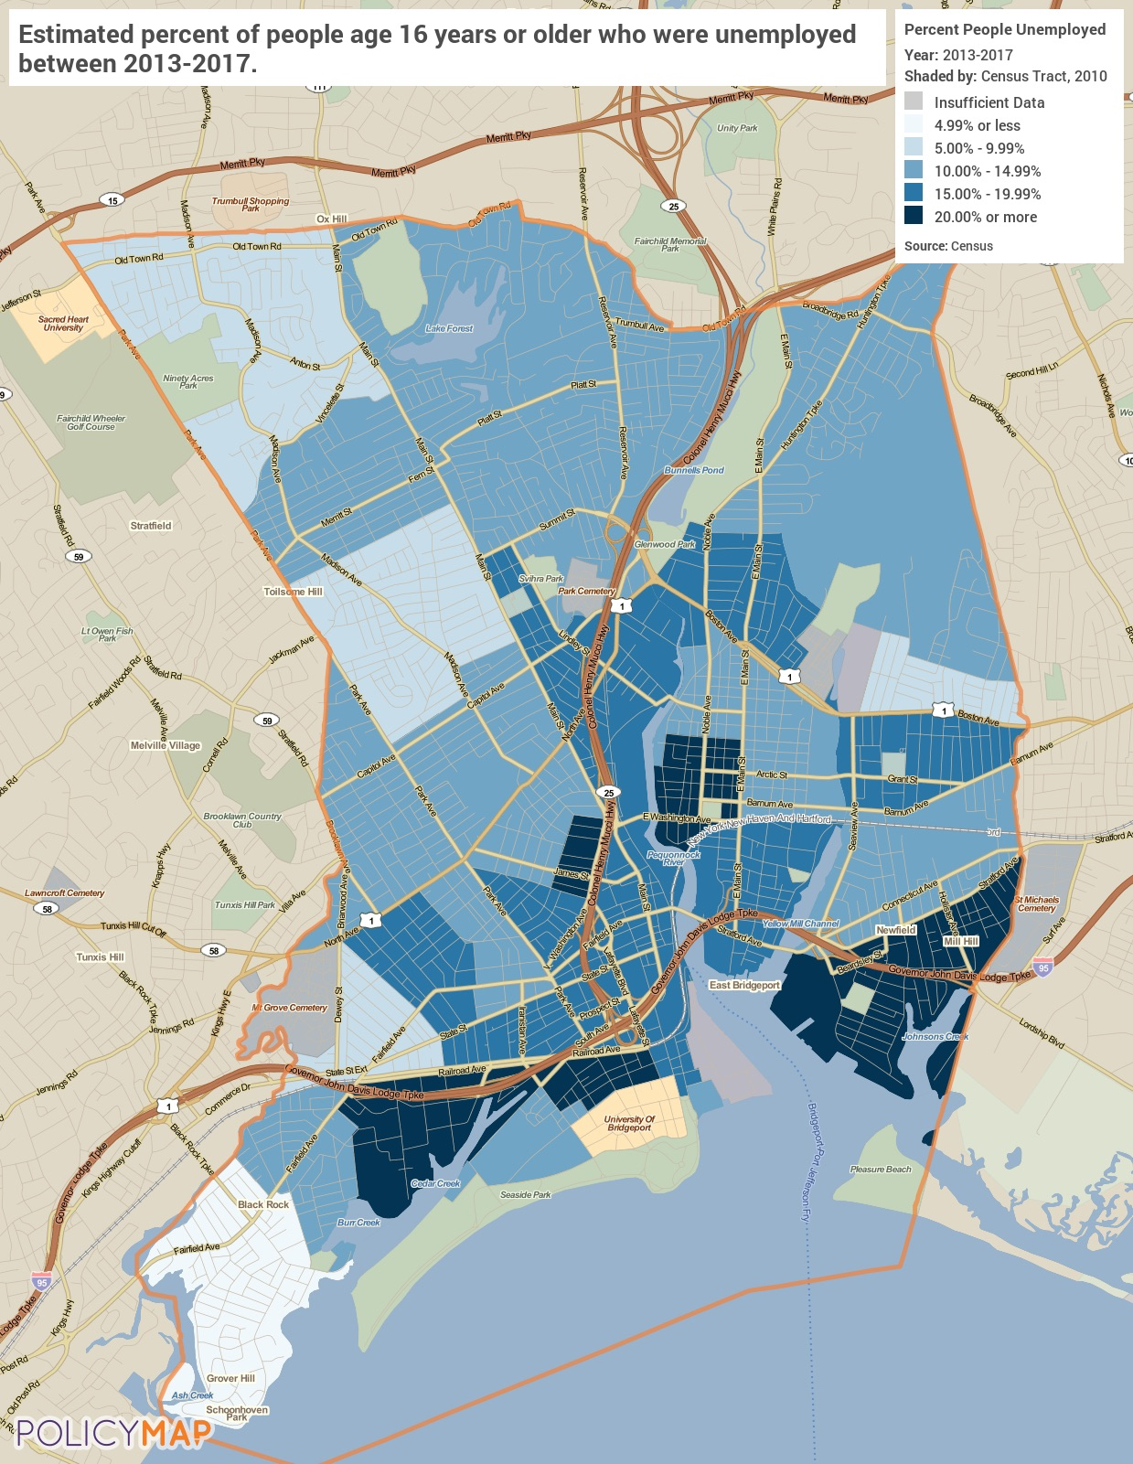
Unemployment

Occupations by Sector | Number of People
Management, business and financial | 16,850
Farming, fisheries and forestry occupations | 70
Service | 20,539
Sales and office | 14,413
Construction, extraction, maintenance and repair | 6,850
Production, transportation and material moving | 9,265
Table 47 – Occupations by Sector

Alternate Data Source Name:
2013-2017 ACS 5-Yr Estimates

Occupations by Sector
According to the ACS data, the largest employment sector is the Service sector with 20,539 employees. The second largest sector is Management, Business, and Financial with 16,850 and the third largest is Sales and Office with 14,413.
Travel Time
Travel Time | Number | Percentage
< 30 Minutes | 39,928 | 60%
30-59 Minutes | 17,768 | 27%
60 or More Minutes | 8,784 | 13%
Total | 66,480 | 100%
Table 48 - Travel Time

Alternate Data Source Name:
2013-2017 ACS 5-Yr Estimates

Commute Travel Time
Long commutes are not a significant issue for most residents of Bridgeport. Approximately 60% of all persons commuting to work have a commute of less than 30 minutes each way. Only 13% have a commute that is an hour or longer.
Source: 2013-2017 American Community Survey 5-Year Estimates
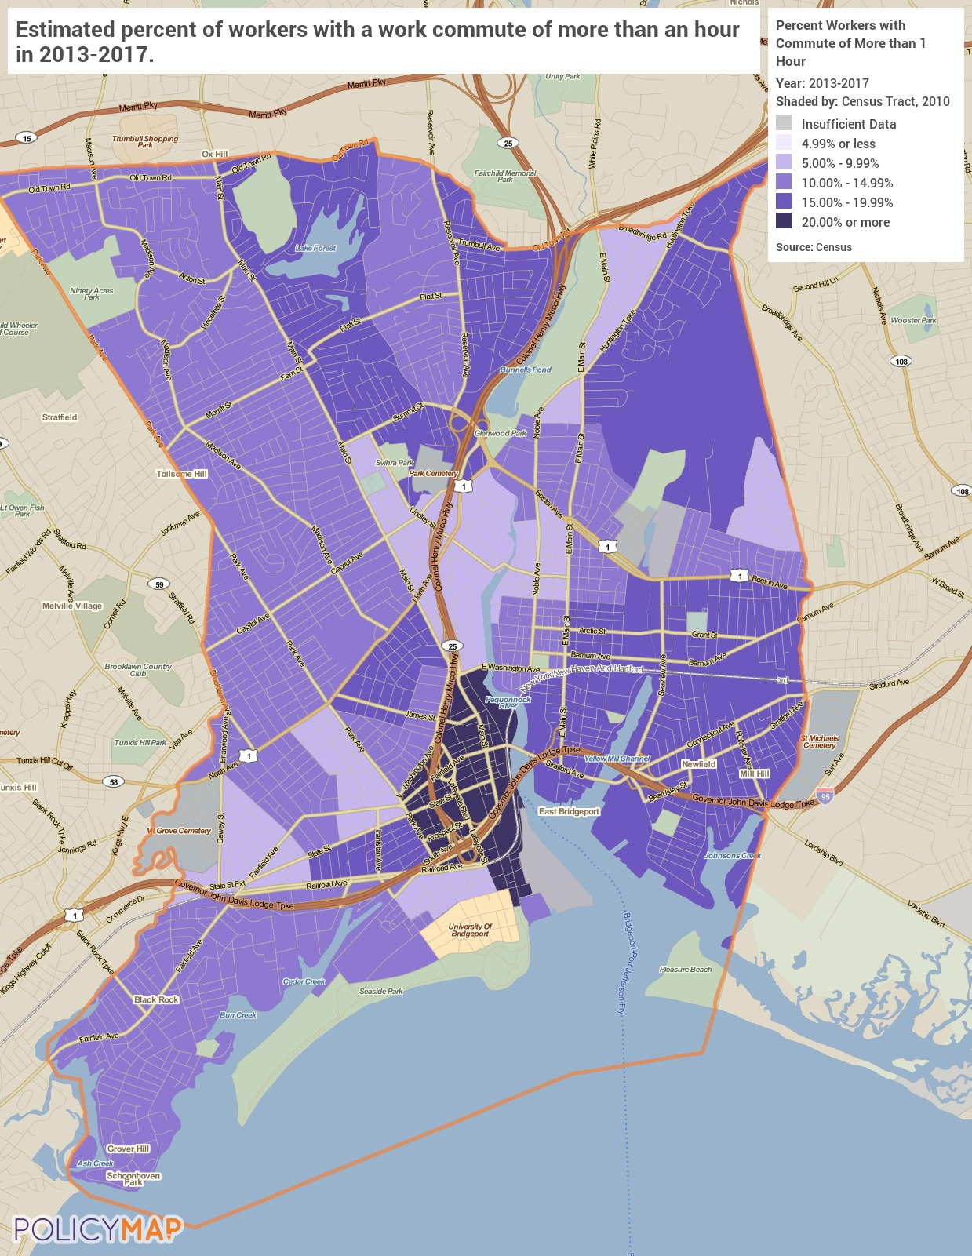
Commute Travel Time Greater Than One Hour

Education:
Educational Attainment by Employment Status (Population 16 and Older)
Educational Attainment | In Labor Force
 | Civilian Employed | Unemployed | Not in Labor Force
Less than high school graduate | 9,703 | 2,682 | 5,586
High school graduate (includes equivalency) | 18,043 | 3,375 | 5,244
Some college or Associate's degree | 15,956 | 2,404 | 3,726
Bachelor's degree or higher | 11,889 | 728 | 2,348
Table 49 - Educational Attainment by Employment Status

Alternate Data Source Name:
2013-2017 ACS 5-Yr Estimates

Educational Attainment by Age
 | Age
 | 18–24 yrs | 25–34 yrs | 35–44 yrs | 45–65 yrs | 65+ yrs
Less than 9th grade | 668 | 1,747 | 2,099 | 4,280 | 3,909
9th to 12th grade, no diploma | 2,371 | 2,406 | 2,687 | 3,863 | 2,173
High school graduate, GED, or alternative | 5,294 | 7,498 | 6,337 | 12,126 | 4,782
Some college, no degree | 6,890 | 5,571 | 4,053 | 6,644 | 1,982
Associate's degree | 683 | 1,583 | 1,265 | 2,158 | 624
Bachelor's degree | 1,613 | 3,431 | 2,461 | 3,924 | 1,069
Graduate or professional degree | 138 | 1,710 | 1,302 | 2,033 | 1,218
Table 50 - Educational Attainment by Age

Alternate Data Source Name:
2013-2017 ACS 5-Yr Estimates

Educational Attainment – Median Earnings in the Past 12 Months
Educational Attainment | Median Earnings in the Past 12 Months
Less than high school graduate | 21,871
High school graduate (includes equivalency) | 27,520
Some college or Associate's degree | 31,534
Bachelor's degree | 43,525
Graduate or professional degree | 55,310
Table 51 – Median Earnings in the Past 12 Months

Alternate Data Source Name:
2013-2017 ACS 5-Yr Estimates

Median Earnings by Educational Attainment
In general, the median earnings of individuals in the City are closely tied to educational attainment. Median earnings increase as individuals attain higher education. A person with a bachelor’s degree generally earns over $20,000 more than of a person without a high school degree. A person with a graduate or professional degree can expect to earn nearly $30,000 more than somebody with only a high school degree.
Based on the Business Activity table above, what are the major employment sectors within your jurisdiction?
In Bridgeport, the most prominent employment sector is Education and Health Care Services, by far. This sector also has the largest gap between jobs and workers. The sector makes up 26% of the workers but 43% of the jobs. However, the actual number of jobs and workers in this sector is very similar, 17,927and 18,735, respectively. This is due to the discrepancy between the total workers and total jobs in the City. There are nearly 68,000 workers and only 43,758 jobs.
There are three other sectors that are relatively major in the City. The Arts, Entertainment, and Accommodations sector makes up 11% of the workers and 7% of the jobs. The Manufacturing sector has 9% of the workers and 8% of the jobs. Finally, the Retail Trade sector includes 13% of the city’s workers and 7% of the jobs.
Describe the workforce and infrastructure needs of the business community:
Currently, there is a need to coordinate between local governments, businesses, and educational institutions to utilize exiting and establish new programs for the work force. There are immediate workforce needs as identified in the Business Activity table above, as well as the needs that come from future retirements and overall growth.
For more see the SP-25 Priority Needs for a description of the infrastructure needs of the community in priority need: Expand/Improve Public Infrastructure & Facilities.
Describe any major changes that may have an economic impact, such as planned local or regional public or private sector investments or initiatives that have affected or may affect job and business growth opportunities during the planning period. Describe any needs for workforce development, business support or infrastructure these changes may create.
The City's BGreen 2020 initiative has identified strategies to address environmental and economic concerns that affect the City, and in addressing these issues, create jobs, improve the environment and create a new path to prosperity for the City and its residents. Projects and actions include the creation of an Energy Improvement District that will make the government and businesses more energy efficient, improved streets and transit systems to reduce the need for autos, development of a Green Collar Institute to help train individuals for new green oriented jobs, and an increased use of recycling and composting to reduce the cost of disposal of materials and to create new jobs.
Aligned with this effort is the City's participation in the Sustainable Communities Consortium. Bridgeport is working with other communities in the New York-Connecticut area to develop livable communities and growth centers around existing and planned transportation to enhance affordable housing efforts, reduce congestion, and expand economic opportunities. Bridgeport's part of this program is the development of a new multi-modal transportation center at the core of the City. Nearly 10,000 people now live within walking distance of the proposed facility and the Bridgeport Hospital, with over 2,500 employees is only two blocks from this site. This project will demonstrate the benefits of site remediation, redevelopment and improved transit options as ways to eliminate blight, improve neighborhoods, create jobs, and reduce carbon emissions.
The City also received Brownfields Revolving Loan Funds from the U.S. Environmental Protection Agency, and these funds are being made available to developers to encourage the redevelopment of contaminated sites across the City. Other grants include the US DOT TIGER II grant for the Steele Point Project, the Water Street Dock and Terminal Project with FHWA Ferry Boat Grant Program funds, and the development of recreational areas and the restoration of ferry boat service for the Pleasure Beach Water Taxi Service Project.
How do the skills and education of the current workforce correspond to employment opportunities in the jurisdiction?
Higher education is a key economic driver in the region, and it is important to develop new programs that align education with job growth. Currently, there is a need to coordinate between municipalities, businesses, and educational institutions to utilize exiting and establish new programs for the work force. There are immediate workforce needs, as well as the needs that come from future retirements and overall growth.
Describe any current workforce training initiatives, including those supported by Workforce Investment Boards, community colleges and other organizations. Describe how these efforts will support the jurisdiction's Consolidated Plan.
In Bridgeport, the Workplace, Inc. received a $4 million federal recovery act grant under the Pathways Out of Poverty program to fund new training programs. Green-Up Bridgeport is a skilled trade training program that trains people in occupations that have increased demand across a range of industries. Also, ABCD provides computer training to low- and moderate-income individuals to prepare them for a range of employment opportunities.
The City's Small and Minority Business Resource Office provides technical assistance and training to local businesses. The Office also provides training to local contractors on topics such as lead abatement, asbestos removal and trends in green industries.
CDBG funds will be used to support growth in green industry. Greater Bridgeport Community Enterprises (GBCE) is working on a Green Business Hub that will ideally create jobs for 100 people over the next five years. In 2012, GBCE used CDBG funding to establish a mattress recycling facility in Bridgeport that offered training and employment. Training for green jobs also occurs through the CDBG-funded Conservation Corps, as young Bridgeport residents learn about environmentally sustainable initiatives like rainwater runoff collection and solar energy installation.
Does your jurisdiction participate in a Comprehensive Economic Development Strategy (CEDS)?
No
If so, what economic development initiatives are you undertaking that may be coordinated with the Consolidated Plan? If not, describe other local/regional plans or initiatives that impact economic growth.
Local plans and programs are discussed above.
Discussion
N/A

MA-50 Needs and Market Analysis Discussion
Are there areas where households with multiple housing problems are concentrated? (include a definition of "concentration")
HUD identifies four specific data points that constitute "housing problems": cost burden, overcrowding, lack of complete plumbing facilities, and lack of complete kitchen facilities. Within the City, 0.8% of occupied units lack complete plumbing, 0.9% occupied units lack complete kitchen facilities, 5.6% are overcrowded, and 52.8% are cost burdened.
Areas of concentration are census tracts that have two or more housing problems that are substantially higher than the City average. For this analysis, “substantially higher” means a lack of complete plumbing over 10.8%, a lack of complete kitchen facilities over 10.9%, overcrowding over 15.6%, or cost burden over 62.8%. There are no areas in the City of Bridgeport with concentrated housing problems.
Are there any areas in the jurisdiction where racial or ethnic minorities or low-income families are concentrated? (include a definition of "concentration")
Yes, there are several areas with a concentration of racial minorities, ethnic minorities, or low-income families. For the purposes of this analysis a “concentration” is any census tract where the minority population makes up 10% more than the citywide average or is low-income. Maps of these concentrations follow this section.
Black Households: In Bridgeport, 35.26% of the population is Black. There are four tracts with a concentration (greater than 45.26%) of Black households.
- 72800 – 55.64%
- 72900 – 52.09%
- 74300 – 49.44%
- 74400 – 48.81%
- 70200 – 50.35%
Asian Households: Approximately 3.1% of the City’s households are Asian. There are three tracts with a concentration (greater than 13.1%) of Asian households.
- 70400 – 15.09%
- 70500 – 13.53%
- 73200 – 13.8%
Hispanic: Hispanic residents make up 39.24% of the population in Bridgeport. There are multiple tracts with a concentration (greater than 49.24%) of Hispanic households.
- 70300 – 69.30%
- 70900 – 55.99%
- 72400 – 50.38%
- 73500 – 57.05%
- 73600 – 68.34%
- 73700 – 50.55%
- 73800 – 60.87%
- 74000 – 60.88%
- 73900 – 57.84%
- 71600 – 55.75%
Low-Income Households: The Median Household Income in the City is $44,841. Any household making 80% or less ($35,873) is considered “low-income” concentration. As visualized in the map below, the tracts in the central part of the city tend to have concentrations of low-income households.
See maps below: Concentration of Black Population, Concentration of Asian Population, Concentration of Hispanic Population and Concentration of LMI Households
What are the characteristics of the market in these areas/neighborhoods?
Based on data collected in the NA and MA, these areas share many of the same areas where there is higher poverty, a higher concentration of multi-family units, older housing units and higher vacancy rates.
Are there any community assets in these areas/neighborhoods?
As mentioned earlier, these areas are higher in concentration of multi-family development units. Public housing is also available in many of these areas.
Are there other strategic opportunities in any of these areas?
Strategic opportunities such as vital public services that improve the quality of life of residents in these areas are shared with stakeholder organizations. These stakeholders are part of the system of delivery the City coordinates to improve the lives of its citizens.
As well, the City of Bridgeport works closely with Opening Doors of Fairfield County in planning and coordination with homeless needs. The City also works with the New York-Connecticut Sustainable Communities which coordinate and implement transit-oriented development and sustainability projects, as well as steps to address housing equity issues in these areas in Bridgeport and across the region the region.
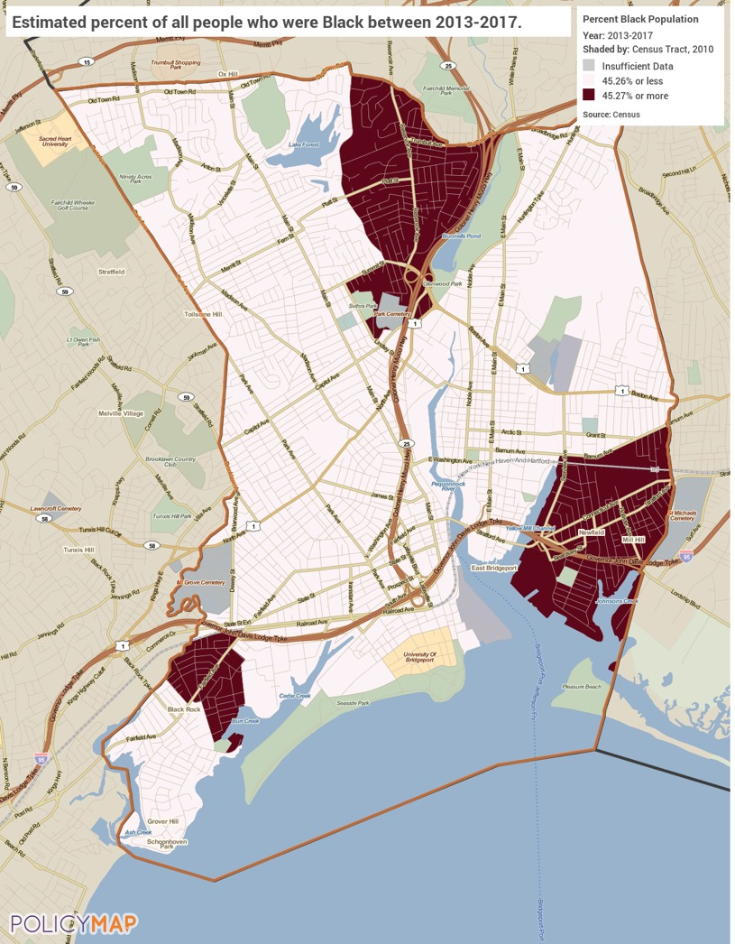
Concentration of Black Population
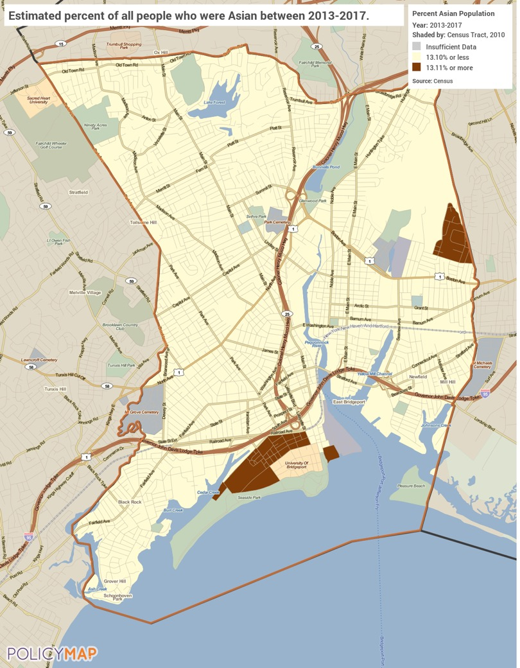
Concentration of Asian Population
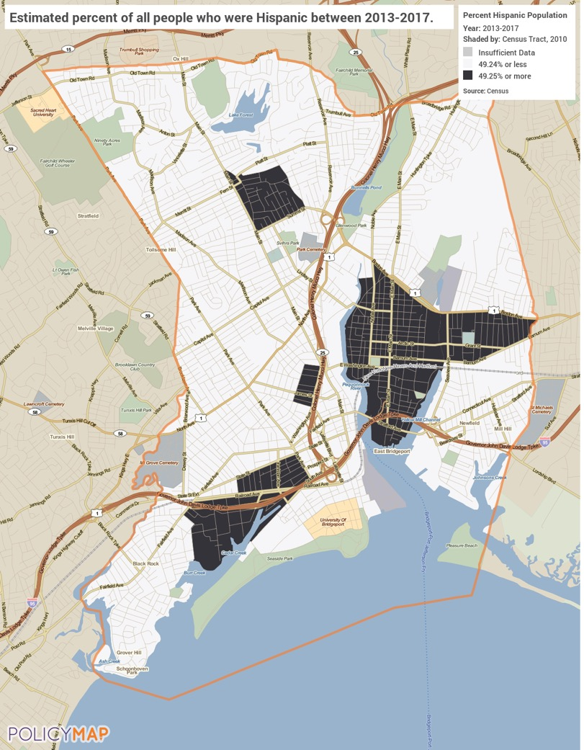
Concentration of Hispanic Population
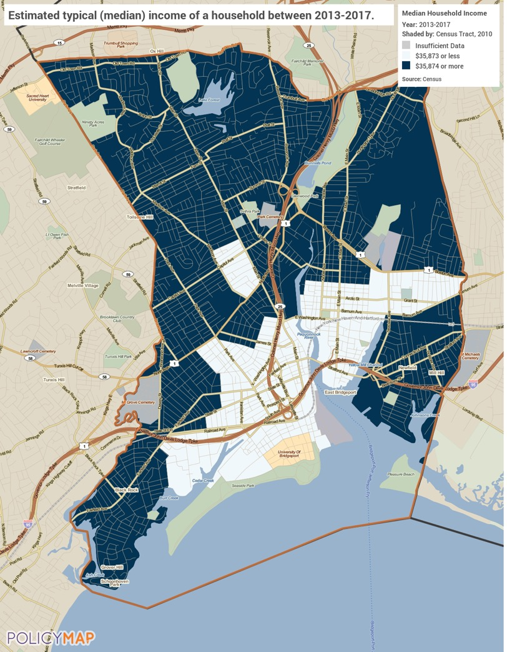
Concentration of LMI Households

MA-60 Broadband Needs of Housing occupied by Low- and Moderate-Income Households - 91.210(a)(4), 91.310(a)(2)
Describe the need for broadband wiring and connections for households, including low- and moderate-income households and neighborhoods.
Internet is an essential communications and information platform that allows users to take advantage of the increased interconnectedness of business, education, commerce, and day to day utility. Reliable access to the internet is becoming a necessity to thrive in the modern economic environment. Communities that lack broadband access struggle to keep pace with the country. Locations without broadband access impedes its population’s ability to take advantage of the educational and entrepreneurial opportunities available online. This is particularly problematic for LMI areas where economic opportunities are already often lacking. Studies suggest a strong correlation between increased high-speed internet access and increased education and employment opportunities, especially in small cities and rural areas.
Bridgeport does not have significant gaps in broadband coverage. Most of the city has more than one option of internet providers, to include LMI areas. The average Bridgeport household has two (2) options for broadband-quality Internet service; however, an estimated three percent (3%) of locals still don't have access to more than one provider and may have to rely on low-grade wireless.
The following map shows broadband access throughout the City. Broadband access is defined as advertised internet speeds of 768 kilobits per second or higher. FCC data shows two major infrastructure options within Bridgeport: cable and DSL.
See map below: Broadband Access
Describe the need for increased competition by having more than one broadband Internet service provider serve the jurisdiction.
Once broadband access has been obtained, it is important to ensure there is competition among service providers. Any resource that has a de facto monopoly on an area may not be incentivized to provide standard and consistent services. Bridgeport has a total of five (5) Internet providers offering residential service. Frontier Communications and Optimum by Altice are the strongest providers in Bridgeport so far as coverage. The average Bridgeport household has two (2) options for broadband-quality Internet service. These providers frequently overlap around the city:
Frontier Communications (DSL)
Spectrum (Cable)
Optimum by Altice (Cable)
Viasat Internet (formerly Exede)(Satellite)
HughesNet (Satellite)
The following map shows the number of broadband service providers by census tract. Most of the city has at least two options of high-speed internet with competitive providers, though there are some tracts with lower populations that only have access to one provider.
See map below: Highspeed Internet Providers
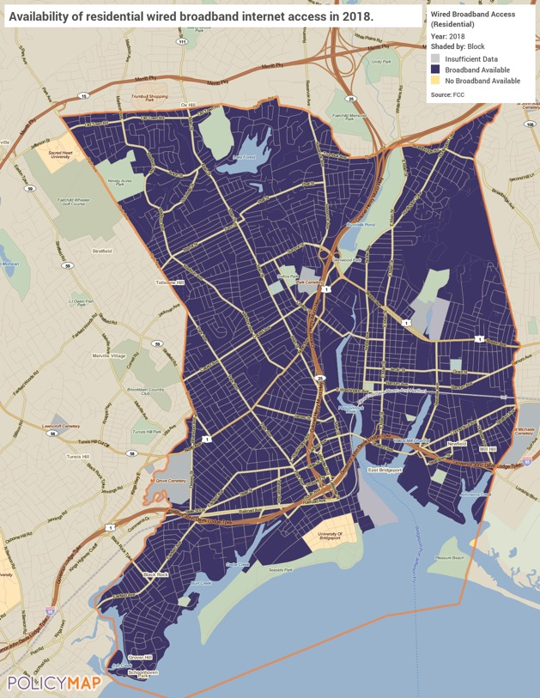
Broadband Access
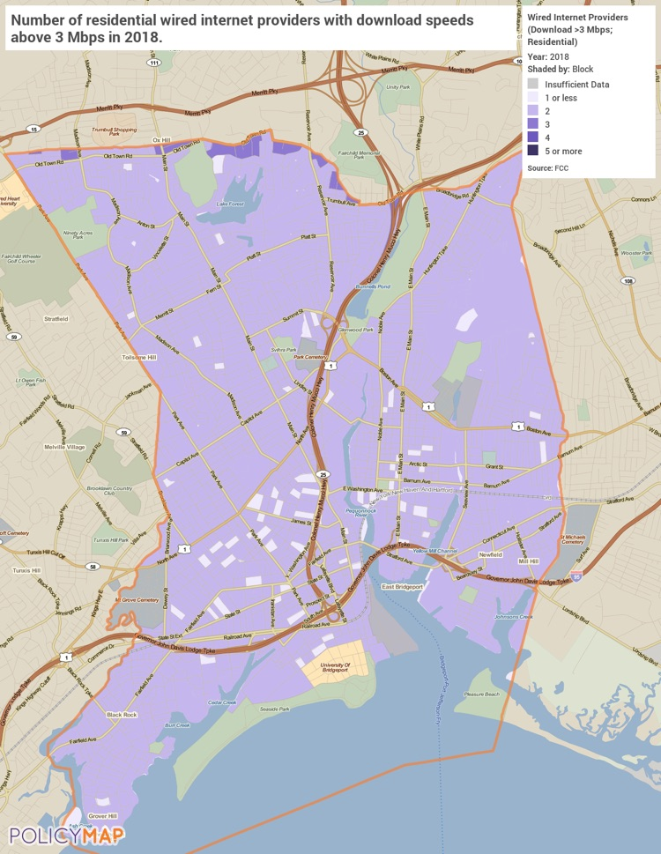
Highspeed Internet Providers

MA-65 Hazard Mitigation - 91.210(a)(5), 91.310(a)(3)
Describe the jurisdiction’s increased natural hazard risks associated with climate change.
Bridgeport has historically been prone to various natural hazard events including flooding, hail, thunderstorm winds, heavy snow, and others. The potential impacts of climate change—including an increase in prolonged periods of excessively low temperatures, more heavy precipitation, or more severe storms—are often most significant for vulnerable communities. The City is located near the coast, and likely experiences primary effects. By the middle of the century the average summer temperature is expected to rise four degrees. This rise in temperature could lead to altered weather and precipitation patterns, a rise in severe storms, an increased risk of catastrophic floods, increased electricity costs, and ruined crops. Additionally, any increase in the ocean levels or increased storm activity will lead to people moving away from the coast. A decrease of people could occur in the City which may cause labor shortages, decrease in competition for services, driving up costs and reducing quality, and reduced resources for locals.
Describe the vulnerability to these risks of housing occupied by low- and moderate-income households based on an analysis of data, findings, and methods.
Low- and moderate-income residents are at particular risk due to having less available resources to combat the impacts of natural disasters. A dramatic rise in electricity or housing costs could put them at imminent risk of homelessness or living in substandard conditions. Residents in rural communities will have less access to public support in case of emergencies and will have fewer resources to repair or prevent damage to their homes.
The City of Bridgeport strives to inform and prepare the general public for multi-hazard mitigation. There are online venues (including the city website and social media pages, the Connecticut State Division of Emergency Management and Homeland Security website and Twitter page, and the Connecticut Voluntary Organizations Active in Disasters (VOAD) website and Facebook page) that disseminate numerous informational guidebooks, videos, and emergency resources to build disaster resiliency in the community.

Strategic Plan

SP-05 Overview
Strategic Plan Overview
The Strategic Plan outlines the City of Bridgeport’s overall vision for housing and community development and addresses the City’s response to identified priority needs and targeted geographic areas over the next 5 years. The Plan specifically addresses how the City of Bridgeport intends to use HUD entitlement grants CDBG, HOME, ESG and HOPWA funds toward furthering HUD’s statutory goals of providing for suitable living environments and providing safe, decent and affordable housing especially for low- to moderate-income households and the special needs population in the City of Bridgeport.

SP-10 Geographic Priorities – 91.215 (a)(1)
Geographic Area
Table 52 - Geographic Priority Areas
1 | Area Name: | LOW MODERATE INCOME AREAS
 | Area Type: | Local Target area
 | Other Target Area Description:
 | HUD Approval Date:
 | % of Low/ Mod:
 | Revital Type: | Housing
 | Other Revital Description:
 | Identify the neighborhood boundaries for this target area. | Area Name: The target neighborhoods are in the low/mod neighborhoods in the City, especially those with the highest rates of poverty and crime, the poorest school performance ratings, and poorest housing characteristics as identified by the University of Connecticut’s Connecticut Center for Economic Analysis (CCEA) study. These neighborhoods with the highest concentrations of economically distressed families and minority populations are: Boston Avenue/Mill Hill; Downtown; East End, East Side; Enterprise Zone; the Hollow, South End and West Side/West End.
 | Include specific housing and commercial characteristics of this target area. | In each of these neighborhoods the housing stock is typically older, often in need of repair or renovation. In general, there are few businesses or amenities, and in particular, there are limited opportunities for food shopping.
 | How did your consultation and citizen participation process help you to identify this neighborhood as a target area? | These neighborhoods were frequently mentioned in the course of focus group and Public Hearing discussions. These discussions confirmed the already known needs of these areas, complementing the data provided by the HUD data and the CCEA study.
 | Identify the needs in this target area. | The needs in these target areas are numerous and varied. The principal needs are: 1) housing rehabilitation for both owner and renter units, 2) rental assistance for extremely low-income households threatened with homelessness, 3) new affordable rental construction, 4) public improvements to improve/revitalize neighborhoods, 5) small business assistance (loans, facades, training) 6) programs for youth, 7) job training and education, and 8) assisting the homeless.
 | What are the opportunities for improvement in this target area? | The opportunities are significant. First, the City can keep residents in safe, affordable housing and prevent additional persons and families from becoming  homeless. Second, the City can improve the quality of life by revitalizing these neighborhoods economically and in their appearance. Third, the City can assist the residents of these areas in obtaining good jobs.
 | Are there barriers to improvement in this target area? | The barriers are significant because of the amount of effort and resources needed to provide the necessary assistance. As described elsewhere the needs are great after fifty years of economic decline and neglect.

General Allocation Priorities
Describe the basis for allocating investments geographically within the jurisdiction (or within the EMSA for HOPWA)
There is an ongoing need in Bridgeport for all forms of assistance (public facilities, affordable housing, lead prevention/remediation, homelessness prevention, etc.). As the largest city in the state, situated in the wealthiest county, Bridgeport is the urban center of the region. Bridgeport provides many regional services to those who are not always able to care for themselves. Bridgeport’s unemployment rate is higher than that of the State. Bridgeport continues to be a city of poor and disadvantaged people. As mentioned earlier, the resources available from HUD do not come close to what is needed or requested to provide for all residents in need. Therefore, no one area can be targeted for the investment of HUD grant funds. The City will continue to work closely with the public through civic leaders, the Citizens Union and Neighborhood Revitalization Zone leadership to determine priority needs within the targeted neighborhoods.
LMI Census Block Group Tracts
090010726002, 090010726005, 090010725001, 090010725003, 090010722001, 090010722002,
090010722003, 090010720001, 090010714002, 090010720002, 090010721002, 090010712001,
090010712002, 090010714004, 090010714003, 090010713001, 090010711001, 090010710002,
090010711002, 090010712003, 090010712004, 090010709001, 090010703001, 090010702002,
090010702001, 090010701004, 090010704001, 090010705001, 090010705002, 090010709002,
090010706001, 090010713002, 090010716001, 090010706002, 090010744003, 090010740001,
090010744002, 090010744004, 090010744001, 090010743001, 090010743002, 090010743003,
090010743004, 090010743005, 090010740002, 090010743006, 090010737005, 090010737004,
090010737003, 090010737002, 090010737001, 090010738001, 090010738002, 090010738003,
090010739002, 090010739003, 090010739004, 090010714001, 090010719002, 090010719001,
090012572004, 090012572001, 090010724001, 090010724002, 090010728002, 090010729002,
090010730001, 090010731002, 090010731003, 090010732002, 090010732001, 090010733002,
090010734001, 090010734002, 090010734003, 090012572002, 090012572003, 090010735003,
090010735001, 090010736001, 090010736002, 090010735002, and 090010739001.
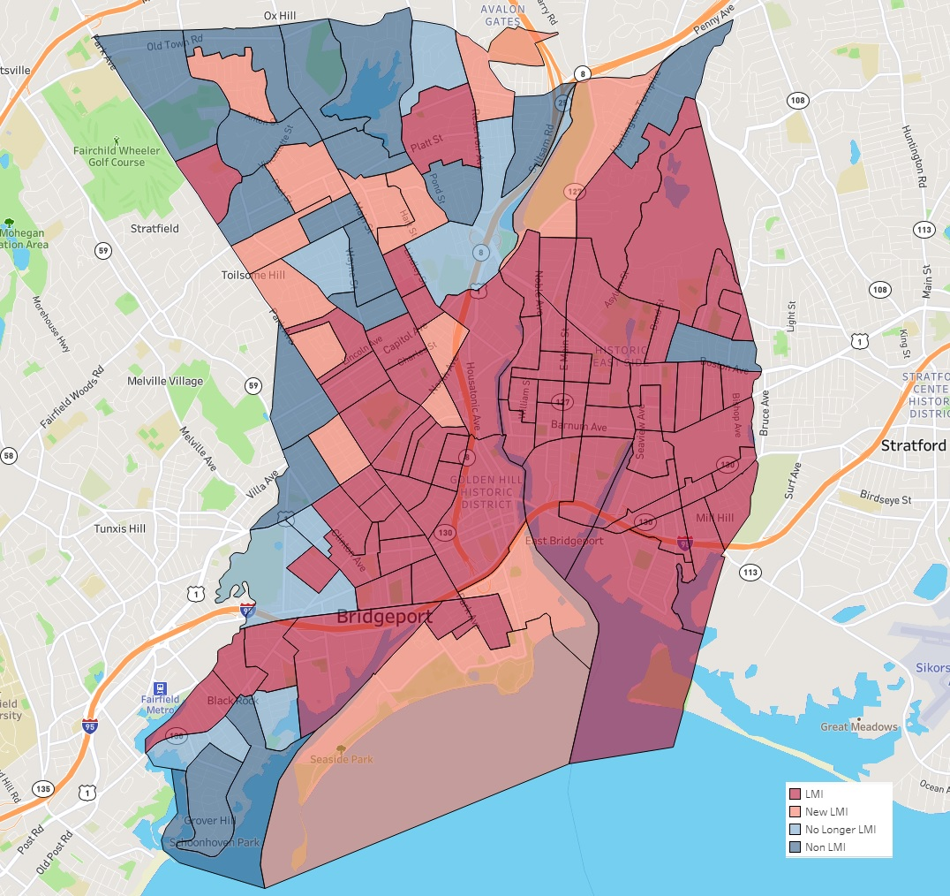
2020 LMI Census Tract Block Group

SP-25 Priority Needs - 91.215(a)(2)
Priority Needs
Table 53 – Priority Needs Summary
1 | Priority Need Name | Expand/Improve Public Infrastructure & Facilities
 | Priority Level | High
 | Population | Extremely Low  Low  Moderate  Non-housing Community Development
 | Geographic Areas Affected | LOW MODERATE INCOME AREAS
 | Associated Goals | 1A Expand Public Infrastructure  1B Improve Public Infrastructure Capacity  1C Improve Access to Public Facilities
 | Description | Expand and improve public infrastructure through activities for LMI persons and households. Improve access to public facilities that will benefit LMI persons and households. Funds will be used to improve public facilities such as recreational parks and community centers.
 | Basis for Relative Priority | Through community participation and consultation of local stakeholder partners and organizations the need to Expand/Improve Public Infrastructure & Facilities was identified. Adequate public facilities and infrastructure improvements are essential to addressing the needs of the LMI population, including the homeless, elderly and disabled. Facilities and improvements include neighborhood/community centers, improved road infrastructure and the installation of ADA curb cuts and sidewalks for safety in LMI areas.
2 | Priority Need Name | Preserve & Develop Affordable Housing
 | Priority Level | High
 | Population | Extremely Low  Low  Moderate
 | Geographic Areas Affected | LOW MODERATE INCOME AREAS
 | Associated Goals | 2A Increase Homeownership Opportunities  2B Increase Affordable Rental Hsg Opportunities  2C. Provide Code Enforcement in LMI Neighborhoods  2D. Provide Removal of Slum/Blight in ResidentArea  2E. Provide for Owner Occupied Housing Rehab
 | Description | Preserving housing and developing affordable housing, including Homeowner Rehabilitation, Rental Rehabilitation, and Increased Homeownership Opportunities remains one of the highest priorities in the jurisdiction.
 | Basis for Relative Priority | Through community participation and consultation of local stakeholder partners and organizations the need to Preserve & Develop Affordable Housing was identified. Through the needs assessment housing cost burden is by far the largest housing problem in the jurisdiction.
3 | Priority Need Name | Public Services & Quality of Life Improvements
 | Priority Level | High
 | Population | Extremely Low  Low  Moderate  Elderly  Frail Elderly  Persons with Mental Disabilities  Persons with Physical Disabilities  Persons with Developmental Disabilities  Persons with Alcohol or Other Addictions  Non-housing Community Development
 | Geographic Areas Affected | LOW MODERATE INCOME AREAS
 | Associated Goals | 3A Provide Supportive Services for Special Needs  3B Provide Vital Services for LMI Households
 | Description | Provide supportive services for LMI households and also the special needs populations in the jurisdiction. Public services will target LMI citizens and may include services to address homelessness, persons with physical and mental health, seniors, and youth.
 | Basis for Relative Priority | Through community participation and consultation of local stakeholder partners and organizations the need for Public Services for LMI and Special Needs was identified. Public Services offered by the city and partner non-profit organizations provide for vital and essential services for LMI households and families throughout the jurisdiction. Public services will also help to enhance education and improve living situations of LMI individuals and households in the jurisdiction.
4 | Priority Need Name | Homelessness Housing and Support Services
 | Priority Level | High
 | Population | Extremely Low  Low  Moderate  Chronic Homelessness  Individuals  Families with Children  Mentally Ill  Chronic Substance Abuse  veterans  Victims of Domestic Violence  Unaccompanied Youth
 | Geographic Areas Affected | LOW MODERATE INCOME AREAS
 | Associated Goals | 4A Provide Homeless Rapid Re-Housing Assistance  4B Provide Assistance to Homeless Shelters  4C. Provide for Street Outreach & Homeless Prevent
 | Description | Provide for homeless activities and services, including Homeless Prevention, Shelters Services, and Rapid Re-Housing.
 | Basis for Relative Priority | Through community participation and consultation of local stakeholder partners and organizations the need for homeless activities such as shelter operations and homeless prevention services was identified. The local PIT count has also identified homeless adults and families as homeless that require assistance.
5 | Priority Need Name | Housing/Supportive Services for Persons w HIV/AIDS
 | Priority Level | High
 | Population | Extremely Low  Low  Moderate  Persons with HIV/AIDS and their Families  Non-housing Community Development
 | Geographic Areas Affected | LOW MODERATE INCOME AREAS
 | Associated Goals | 5A. Provide Hsg Opportunities Persons w HIV/AIDS  5B. Provide Medical & Supportive Services HIV/AIDS
 | Description | Provide for housing & supportive services persons with HIV/AIDS such as permanent housing placement and short-term rent, mortgage and utility assistance (STRMU).
 | Basis for Relative Priority | Through community participation and consultation of local stakeholder partners and organizations the need for Housing & Supportive Services Persons w HIV/AIDS was identified.

Narrative (Optional)
Through an in-depth assessment of the City in the needs assessment and housing market analysis as well as an extensive citizen participation process the City was able to identify the five (5) priority needs in the Bridgeport. These priority needs listed in the table above are:
- Expand/Improve Public Infrastructure & Facilities
- Preserve & Develop Affordable Housing
- Public Services & Quality of Life Improvements
- Homelessness Housing and Support Services
- Housing/Supportive Services for Persons w HIV/AIDS

SP-30 Influence of Market Conditions – 91.215 (b)
Influence of Market Conditions
Affordable Housing Type | Market Characteristics that will influence  the use of funds available for housing type
Tenant Based Rental Assistance (TBRA) | According to the Housing Needs Assessment and the Housing Market Study, the greatest housing problem in Bridgeport is cost burden, and many of the households in the lowest income categories are severely cost  burdened. Furthermore, rents continue to increase while household incomes stagnate, causing the number of cost burdened households to grow. Due to this, rental assistance ranks high among program strategies. The elderly and extremely low-income small households are the two groups that emerged as most vulnerable both from the analysis of data and from discussion in the public meetings. TBRA is provided through the Bridgeport Housing Authority.
TBRA for Non-Homeless Special Needs | Rental assistance for the non-homeless special needs group will focus on persons living with HIV/AIDS. The City will provide TBRA for non-homeless special needs persons through the HOPWA program.
New Unit Production | Because of the current number of homes available and the weak housing market in general, the City will allocate most its funds in other areas such as rental housing assistance, however as the population of the City is still growing slowly, Bridgeport will still continue to focus its new construction. Most of the new housing development will be toward rental housing.
Rehabilitation | Given the age and condition of the housing stock in Bridgeport, rehabilitation of both owner and renter units in the City’s low-income areas is a high priority. The City will aim to use rehabilitation funds in connection with greater neighborhood revitalization initiatives in order to have a more immediate and visible impact. Rehabilitation dollars will be targeted toward housing that is in violation of the City's housing code, and particularly for elderly and disabled individuals. Lead hazard funding will continue to be used to protect the most vulnerable populations – primarily families with children 6 years or younger and expectant mothers in the home.
Acquisition, including preservation | Because of the limited funds available, the City will focus affordable housing programs towards rental assistance, however the City recognizes that due to the age of housing in the City (over 80% of the housing in Bridgeport were built before 1980), the City will still fund activities that acquire properties and/or remove buildings for the purpose of developing affordable housing.
Table 54 – Influence of Market Conditions

SP-35 Anticipated Resources - 91.215(a)(4), 91.220(c)(1,2)
Introduction
The City of Bridgeport is a HUD entitlement city receiving funding for formula grants CDBG, HOME, ESG and HOPWA. As the lead agency administering federal HUD funds, the City is responsible for directing entitlement grant funds towards creating strong, sustainable and inclusive communities and safe, decent and affordable housing for all, especially concerning low- to moderate-income households and the special needs population. In PY 2020, the City expects to receive the following HUD allocations:
CDBG: $3,415,850
HOME: $1,207,857
HOPWA: $958,576
ESG: $284,467
Over the 5-Year Consolidated Plan the City expects to receive similar annual fund allocations, however the City will adjust accordingly to any changes in allocation and produce an Annual Action Plan reflective of anticipated funding for the respective year.

Anticipated Resources
Program | Source of Funds | Uses of Funds | Expected Amount Available Year 1 |  |  |  | Expected Amount Available Remainder of ConPlan  $ | Narrative Description
 |  |  | Annual Allocation: $ | Program Income: $ | Prior Year Resources: $ | Total:  $
CDBG | public - federal | Acquisition  Admin and Planning  Economic Development  Housing  Public Improvements  Public Services | 3,415,850 | 0 | 0 | 3,415,850 | 13,663,400 | Expected Amount Available Remainder of Con Plan is for 4 more years of the plan.
HOME | public - federal | Acquisition  Homebuyer assistance  Homeowner rehab  Multifamily rental new construction  Multifamily rental rehab  New construction for ownership  TBRA | 1,207,857 | 0 | 0 | 1,207,857 | 4,831,428 | Expected Amount Available Remainder of Con Plan is for 4 more years of the plan.
HOPWA | public - federal | Permanent housing in facilities  Permanent housing placement  Short term or transitional housing facilities  STRMU  Supportive services  TBRA | 958,576 | 0 | 0 | 958,576 | 3,834,304 | Expected Amount Available Remainder of Con Plan is for 4 more years of the plan.
ESG | public - federal | Conversion and rehab for transitional housing  Financial Assistance  Overnight shelter  Rapid re-housing (rental assistance)  Rental Assistance  Services  Transitional housing | 284,467 | 0 | 0 | 284,467 | 1,137,868 | Expected Amount Available Remainder of Con Plan is for 4 more years of the plan.
Table 55 - Anticipated Resources

Explain how federal funds will leverage those additional resources (private, state and local funds), including a description of how matching requirements will be satisfied
The City continues to cultivate funding partners who can match its investment of CDBG and HOME funds. The City administration recognizes that its annual entitlement and formula allocations are not sufficient to meet all requests. The approving authority is not able to nor does it expected to fund subrecipients of CDBG or HOME budgets in full. HOME funds are generally a small portion of multimillion dollar housing development projects. CDBG application budgets are reviewed in detail to determine eligible uses of federal funds. Non-eligible expenses require other funds. In these cases, funding for eligible expenses are considered. Additional funds are raised by the sub-recipients to cover the remaining costs, with CDBG and HOME as leverage.
As such, for specific projects, the City leveraged HOME funds are a first-in commitment to raise additional funds. The City’s HOME Program is exempt from match requirements due to nature of the projects. HOME investments leverage several million dollars in private and public funding annually. The City's HOME Investment Partnership capital is now structured as performing loans as we move from grants to debt funding.
Matching requirements have been satisfied with other eligible financial resources and/or in-kind services, and the City will continue to seek this type of matching as well as financial matches. CDBG funds have been utilized as a match for various grants identified through the Youth Service Bureau and the Department of Health and Social Services.
If appropriate, describe publically owned land or property located within the jurisdiction that may be used to address the needs identified in the plan
The City, acting through its Office of Planning and Economic Development, works to transfer City-owned parcels - where/when appropriate - to developers and/or property abutters looking to provide economic development, neighborhood revitalization and affordable housing and or neighborhood stabilization opportunities for Bridgeport residents. Decisions are made on a project-by-project basis and will occasionally incorporate HOME/CDBG funds to leverage additional investment. Many current and pending HOME projects have used HUD funding as part of a larger redevelopment project on formerly City-owned parcels and buildings. In some cases of properties being sold to abutters, federal funds are not used.
Discussion
N/A

SP-40 Institutional Delivery Structure – 91.215(k)
Explain the institutional structure through which the jurisdiction will carry out its consolidated plan including private industry, non-profit organizations, and public institutions.
Responsible Entity | Responsible Entity Type | Role | Geographic Area Served
Bridgeport Housing and Community Development Department | Government | Rental  public facilities  public services | Jurisdiction
Park City Communities | PHA | Rental | Region
Bridgeport Office of Planning & Economic Development | Government | Non-homeless special needs | Jurisdiction
Bridgeport Health and Social Services Department | Government | Non-homeless special needs  public services | Jurisdiction
Bridgeport Chief Administrative Office | Government | public services | Jurisdiction
Mayors Initiative for Reentry Affairs | Government | public services | Jurisdiction
CT-503 CoC, Opening Doors of Fairfield County | Continuum of care | Homelessness  Non-homeless special needs | Region
Recovery Network of Programs | Other | Non-homeless special needs  Rental | Jurisdiction
Chemical Abuse Services Agency | Other | Non-homeless special needs  Rental | Jurisdiction
Inspirica, Inc. | Other | Non-homeless special needs  Rental | Jurisdiction
MID FAIRFIELD AIDS PROJECT | Other | Non-homeless special needs  Rental | Jurisdiction
APEX Community Care | Other | Non-homeless special needs  Rental | Jurisdiction
Catholic Charities |  | Non-homeless special needs  Rental | Jurisdiction
Table 56 - Institutional Delivery Structure

Assess of Strengths and Gaps in the Institutional Delivery System
As noted the Housing and Community Development Department (HCD) is the lead agency for Consolidated Plan activities. However, program delivery is conducted through government agencies and private sector organizations. HCD prepares and distributes the application for funding, conducts outreach efforts to the community about the programs, provides technical assistance to applicants in the competitive application process, and evaluates applications and makes recommendations for activity funding for City Council approval. The outreach efforts target both organizations and institutions that have previously received funding, and those that have not. HCD makes a conscious effort to avoid duplication of services and delivery systems. HCD seeks to strengthen its service providers and to build capacity so that these organizations can become more financially independent and better leverage and use resources.
One of the strengths of the delivery system is the City’s outreach and information efforts. The City works diligently to involve and inform as many agencies, organizations and institutions of the HUD programs, and has been successful in this regard. The program information that is disseminated is detailed and identifies the City’s priority areas and priority needs. The types of programs and activities that can be funded under each of HUD programs and those activities that are not eligible for funding are clearly defined and the City conducts multiple Technical Assistance Sessions to help grant applicants understand program requirements, the application and selection process, and the City’s expectations for program reporting. The staff also sits on many local boards/commissions and hold leadership positions in statewide organizations because of their knowledge and expertise.
Another strength is the wide range of services available to support low- and moderate-income households across the City. This is in part because many persons in the city have recognized the many needs and formed not-for-profit groups to address these needs. Further, HCD has observed, and to some degree facilitated, the coordination and cooperation among these groups in identifying new ways to meet needs.
The technical assistance sessions offered by the City are intended to address the gap that applicants and grantees have identified in recent meetings; that is, possessing detailed knowledge about program requirements and reporting requirements. These sessions provide the information needed for applicants to properly complete the application process and ensure that their programs or activities are appropriate for HUD funding. At the same time, applicants are made aware of the reporting requirements and measures that they must meet if awarded a grant. Feedback on the new information and training sessions has been positive.
The City has worked towards the selection process being made more transparent. This is being accomplished through providing more detailed information about the application process and requirements and through a better explanation of the selection criteria and program requirements.
Availability of services targeted to homeless persons and persons with HIV and mainstream services
Homelessness Prevention Services | Available in the Community | Targeted to Homeless | Targeted to People with HIV
Homelessness Prevention Services
Counseling/Advocacy | X | X
Legal Assistance | X
Mortgage Assistance | X
Rental Assistance | X | X | X
Utilities Assistance | X

Street Outreach Services
Law Enforcement | X
Mobile Clinics
Other Street Outreach Services | X | X | X

Supportive Services
Alcohol & Drug Abuse | X | X
Child Care | X | X
Education | X | X
Employment and Employment Training | X | X
Healthcare | X | X | X
HIV/AIDS | X | X | X
Life Skills | X | X | X
Mental Health Counseling | X | X | X
Transportation | X | X | X

Other
 | X | X | X
Table 57 - Homeless Prevention Services Summary

Describe how the service delivery system including, but not limited to, the services listed above meet the needs of homeless persons (particularly chronically homeless individuals and families, families with children, veterans and their families, and unaccompanied youth)
The City uses a variety of programs and partners to first prevent low-income persons from becoming homeless and, second, to support homeless persons and families in obtaining safe, affordable and sustainable housing. These efforts include a network of programs ranging from emergency shelters to transitional housing to permanent supportive housing services. The City works closely with the Continuum of Care to ensure that it is part of a broader discussion on homeless issues. The Continuum allows the City to be a part of a larger, comprehensive picture of homelessness in the Greater Bridgeport Area and focus its limited ESG/HOPWA resources on needed services like rental assistance, counselling and street outreach. The mission of the Continuum of Care is to help individuals and families who are hungry, homeless and at risk of becoming homeless, to achieve increased stability and self-sufficiency. Non-profit organizations based throughout Fairfield County provide services, emergency and supportive housing, homelessness prevention services and emergency food to those in need in the Greater Bridgeport Area. As well, local non-profit organizations such as Operation Hope and Catholic Charities strive to provide these services to the homeless or those at risk of becoming homeless.
Describe the strengths and gaps of the service delivery system for special needs population and persons experiencing homelessness, including, but not limited to, the services listed above
This delivery system includes a wide range of services for special needs populations and persons experiencing homelessness, and through the Continuum of Care, these programs are coordinated into a City-wide strategy to prevent homelessness and address it in a comprehensive manner where it occurs. The primary strength of addressing homelessness through participation in the Continuum of Care is that it allows continuum partners to focus resources on specific issues in order to avoid duplication of services. The Continuum also allows for a wider array of voices to be heard on what is a wide-ranging issue.
Still, the need exists to provide better and more information among housing providers, social service providers and case management agencies. The City plans to work with the Continuum of Care throughout the year to improve funding applications and best utilize ESG and HOPWA funds.
Provide a summary of the strategy for overcoming gaps in the institutional structure and service delivery system for carrying out a strategy to address priority needs
The strategy for overcoming any gaps in the service delivery system that works to address the priority needs identified in this plan will be the ongoing communication and training of the subrecipients and partners of the City that work towards accomplishing the goals established in the Strategic Plan and the one-year annual goals in the AAP. Activities throughout the year that are carried out to accomplish the goals of the Plan are completed by the City departments or nonprofits. These activities can viewed in the AP-35 Projects.

SP-45 Goals Summary – 91.215(a)(4)
Goals Summary Information
Sort Order | Goal Name | Start Year | End Year | Category | Geographic Area | Needs Addressed | Funding | Goal Outcome Indicator
1 | 1A Expand Public Infrastructure | 2020 | 2024 | Non-Housing Community Development | LOW MODERATE INCOME AREAS | Expand/Improve Public Infrastructure & Facilities | CDBG: $2,419,603 | Public Facility or Infrastructure Activities other than Low/Moderate Income Housing Benefit:  50000 Persons Assisted
2 | 1B Improve Public Infrastructure Capacity | 2020 | 2024 | Non-Housing Community Development | LOW MODERATE INCOME AREAS | Expand/Improve Public Infrastructure & Facilities | CDBG: $2,419,603 | Public Facility or Infrastructure Activities other than Low/Moderate Income Housing Benefit:  50000 Persons Assisted
3 | 1C Improve Access to Public Facilities | 2020 | 2024 | Non-Housing Community Development | LOW MODERATE INCOME AREAS | Expand/Improve Public Infrastructure & Facilities | CDBG: $2,419,603 | Public Facility or Infrastructure Activities other than Low/Moderate Income Housing Benefit:  50000 Persons Assisted
4 | 2A Increase Homeownership Opportunities | 2020 | 2024 | Affordable Housing | LOW MODERATE INCOME AREAS | Preserve & Develop Affordable Housing | HOME: $2,164,102 | Homeowner Housing Added:  10 Household Housing Unit
5 | 2B Increase Affordable Rental Hsg Opportunities | 2020 | 2024 | Affordable Housing | LOW MODERATE INCOME AREAS | Preserve & Develop Affordable Housing | HOME: $2,164,102 | Rental units constructed:  25 Household Housing Unit  Rental units rehabilitated:  50 Household Housing Unit
6 | 2C. Provide Code Enforcement in LMI Neighborhoods | 2020 | 2024 | Affordable Housing | LOW MODERATE INCOME AREAS | Preserve & Develop Affordable Housing | CDBG: $2,134,906 | Housing Code Enforcement/Foreclosed Property Care:  100 Household Housing Unit
7 | 2D. Provide Removal of Slum/Blight in ResidentArea | 2020 | 2024 | Affordable Housing | LOW MODERATE INCOME AREAS | Preserve & Develop Affordable Housing | CDBG: $2,134,906 | Buildings Demolished:  10 Buildings
8 | 2E. Provide for Owner Occupied Housing Rehab | 2020 | 2024 | Affordable Housing | LOW MODERATE INCOME AREAS | Preserve & Develop Affordable Housing | CDBG: $2,134,906  HOME: $1,711,082 | Homeowner Housing Rehabilitated:  50 Household Housing Unit
9 | 3A Provide Supportive Services for Special Needs | 2020 | 2024 | Non-Homeless Special Needs  Non-Housing Community Development | LOW MODERATE INCOME AREAS | Public Services & Quality of Life Improvements | CDBG: $1,707,862 | Public service activities other than Low/Moderate Income Housing Benefit:  50000 Persons Assisted
10 | 3B Provide Vital Services for LMI Households | 2020 | 2024 | Non-Housing Community Development | LOW MODERATE INCOME AREAS | Public Services & Quality of Life Improvements | CDBG: $1,707,862 | Public service activities other than Low/Moderate Income Housing Benefit:  50000 Persons Assisted
11 | 4A Provide Homeless Rapid Re-Housing Assistance | 2020 | 2024 | Homeless | LOW MODERATE INCOME AREAS | Homelessness Housing and Support Services | ESG: $402,995 | Tenant-based rental assistance / Rapid Rehousing:  250 Households Assisted
12 | 4B Provide Assistance to Homeless Shelters | 2020 | 2024 | Homeless | LOW MODERATE INCOME AREAS | Homelessness Housing and Support Services | ESG: $509,670 | Homeless Person Overnight Shelter:  125 Persons Assisted
13 | 4C. Provide for Street Outreach & Homeless Prevent | 2020 | 2024 | Homeless | LOW MODERATE INCOME AREAS | Homelessness Housing and Support Services | ESG: $509,670 | Homelessness Prevention:  1250 Persons Assisted
14 | 5A. Provide Hsg Opportunities Persons w HIV/AIDS | 2020 | 2024 | Non-Homeless Special Needs | LOW MODERATE INCOME AREAS | Housing/Supportive Services for Persons w HIV/AIDS | HOPWA: $2,396,440 | Tenant-based rental assistance / Rapid Rehousing:  600 Households Assisted  Housing for People with HIV/AIDS added:  180 Household Housing Unit
15 | 5B. Provide Medical & Supportive Services HIV/AIDS | 2020 | 2024 | Non-Homeless Special Needs | LOW MODERATE INCOME AREAS | Housing/Supportive Services for Persons w HIV/AIDS | HOPWA: $2,396,440 | HIV/AIDS Housing Operations:  540 Household Housing Unit
Table 58 – Goals Summary

Goal Descriptions
1 | Goal Name | 1A Expand Public Infrastructure
 | Goal Description | Expand public infrastructure through development activities for LMI persons and households. Activities can include adding ADA compliance for curb ramps and sidewalks and roadway expansion projects.
2 | Goal Name | 1B Improve Public Infrastructure Capacity
 | Goal Description | Improve access to public infrastructure through development activities for LMI persons and households. Public infrastructure activities include improvements to infrastructure in the jurisdiction such as roadway resurfacing and improvements to curbs and ramps on sidewalks for ADA compliance.
3 | Goal Name | 1C Improve Access to Public Facilities
 | Goal Description | Expand and improve access to public facilities through development activities for LMI persons and households and for special needs population (elderly, persons with a disability, victims of domestic abuse, etc.). Public facilities may include neighborhood facilities, community centers and parks and recreation facilities.
4 | Goal Name | 2A Increase Homeownership Opportunities
 | Goal Description | Increase homeownership opportunities for LMI households through homeowner housing added and direct financial assistance to homebuyers
5 | Goal Name | 2B Increase Affordable Rental Hsg Opportunities
 | Goal Description | Increase affordable rental housing opportunities for LMI households through rental units constructed and rental units rehabilitated.
6 | Goal Name | 2C. Provide Code Enforcement in LMI Neighborhoods
 | Goal Description | Provide for residential code enforcement activities in the jurisdiction for LMI households. These activities will help to maintain the housing in the community.
7 | Goal Name | 2D. Provide Removal of Slum/Blight in ResidentArea
 | Goal Description | Provide for neighborhood revitalization from activities that eliminate slum and blight and provide for better health and public safety.
8 | Goal Name | 2E. Provide for Owner Occupied Housing Rehab
 | Goal Description | Provide for owner occupied housing rehabilitation in target areas of the jurisdiction. These activities will benefit LMI households.
9 | Goal Name | 3A Provide Supportive Services for Special Needs
 | Goal Description | Provide supportive services for low income and special needs populations in the jurisdiction. Public services will target LMI citizens and may include services to address homelessness, persons with physical and mental health disabilities, the elderly, and the youth. Services may also include recreational programs for special needs populations, and education and health programs for special needs households.
10 | Goal Name | 3B Provide Vital Services for LMI Households
 | Goal Description | Provide supportive services for low- to moderate-income households in the jurisdiction. Public services will include: fair housing awareness, crime prevention programs, case management for emergency assistance, employment programs, and health programs.
11 | Goal Name | 4A Provide Homeless Rapid Re-Housing Assistance
 | Goal Description | Provide for rapid re-housing (RRH) assistance for the homeless population in the jurisdiction.
12 | Goal Name | 4B Provide Assistance to Homeless Shelters
 | Goal Description | Provide assistance to homeless shelters and support programs that offer overnight homeless services.
13 | Goal Name | 4C. Provide for Street Outreach & Homeless Prevent
 | Goal Description | Provide assistance to programs with street outreach services that reach out to the homeless population and homeless prevention services in the jurisdiction.
14 | Goal Name | 5A. Provide Hsg Opportunities Persons w HIV/AIDS
 | Goal Description | Provide for permanent housing placement assistance for persons with HIV/AIDS.
15 | Goal Name | 5B. Provide Medical & Supportive Services HIV/AIDS
 | Goal Description | Provide for medical and supportive services for persons with HIV/AIDS such as short-term rent, mortgage and utility assistance (STRMU), street outreach activities and homeless prevention.

Estimate the number of extremely low-income, low-income, and moderate-income families to whom the jurisdiction will provide affordable housing as defined by HOME 91.315(b)(2)
Over the 5-Year Consolidated Planning period the City estimates it will assist low- and moderate-income households with these affordable housing activities:
CDBG & HOME:
Homeowner Housing added: 10 Household Housing Unit
Homeowner Housing Rehabilitated: 50 Household Housing Unit
Rental units constructed: 25 Household Housing Unit
Rental units rehabilitated: 50 Household Housing Unit
ESG:
Tenant-based rental assistance / Rapid Rehousing: 250 Households Assisted
HOPWA:
Housing for People with HIV/AIDS added: 180 Household Housing Unit

SP-50 Public Housing Accessibility and Involvement – 91.215(c)
Need to Increase the Number of Accessible Units (if Required by a Section 504 Voluntary Compliance Agreement)
Park Cities Communities (PCC) continues to work towards increasing the available units for persons in need of publicly supported housing, including persons with a disability.
As a PHA receiving federal funding by HUD, PCC is by law, obligated to protect the rights of persons with disabilities. PCC is compliant with federal and state laws that provide protection to persons with disabilities, including Section 504 of the Rehabilitation Act of 1973 and in particular, 24 CFR Part 8 implementing Section 504, and 24 CFR Part 100 implementing the Fair Housing Act. Further, PCC will make any reasonable accommodation to its public housing apartments when it is necessary to allow for a person with any disability to live and enjoy housing through PCC. PCC will also make reasonable accommodations to its policies, programs and services, when they are necessary to allow persons with a disability to enjoy, participate or have access to the housing authority’s programs and services.
Activities to Increase Resident Involvements
The PCC will also pursue homeownership opportunities for residents through the continued leverage of partnerships with public and private enterprise. The components of this strategy were developed in consultation with the Resident Advisory Board (RAB) and other public/private for profit and non-profit housing agencies and reflect the mission of the PCC in utilizing all available resources as efficiently as possible to accomplish the overall goals and objectives established through the Five-Year Plan.
Is the public housing agency designated as troubled under 24 CFR part 902?
Yes
Plan to remove the ‘troubled’ designation
Park City Communities, the Bridgeport HA (PHA # CT001), is designated as troubled. The housing authority negotiated in November 2015, and then amended in 2018 a recovery plan to remove the “troubled” designation. The recovery plan set a number of measures to achieve desired outcomes as well as target accomplish dates. Measures to achieve outcomes include:
- Performance of staff (Executive Director, managers, and staff)
- Report on PASS and MASS
- Occupancy achievement and reporting
- Submission to HUD of Quality Control checks
- PIC reporting
- Achieve TAR not to exceed 10%
- REAC
- Waitlist: Clear Waitlist Policies for LIPH and HCV, and waitlist management
- LIHP measures
- HCV measures
- File documentation/maintenance, Quality Control and Reporting
- Portability measures (quality control and procedures)
- Project based units and Enhanced Vouchers
- Board and Staff training
- Financial measures (training, management, ensure proper financial accounts etc.)
- Maintain inventory of assets
- Other HUD requirements
The full recovery plan (amended 2018) has been uploaded into the Grantee Unique Appendices as a combined PDF in the AD-25.

SP-55 Barriers to affordable housing – 91.215(h)
Barriers to Affordable Housing
In 2019 the City of Bridgeport released, Plan Bridgeport, the City’s plan of conservation and development over the next 10 years. Plan Bridgeport provides an outline of the current realities of resources and constraints of the City and establishes a strategy for policy and funding decisions that will work to improve the quality of life for the City’s citizens through prioritization of resources towards the areas of waterfront, transit development, neighborhoods, and housing.
As documented in Plan Bridgeport, the housing situation is complex as there are contradicting policy problems. Housing is too expensive and not affordable for a large segment of the population. At the same time, housing is not expensive enough to generate a profit for real estate developers. The lack of profit incentive has led to an aging housing stock and overall shortage of housing in the City, which in turn is increasing demand for housing at all price points.
Plan Bridgeport also reports that older housing stock is more likely to have lead and asbestos hazards, more expensive to heat and cool and more prone to require costly repairs. Older housing is also generally less expensive to buy than newer housing, meaning that households with lower incomes tend to live in housing that has an increased risk of causing health problems and is more costly than newer housing to properly maintain. According to the ACS data in the MA-20 Year Unit Built table, 87% of homeowners and 85% of renters live in housing built before 1980 making it pertinent that the City address this issue. A full detailed strategy of the City is outlined in Plan Bridgeport.
Strategy to Remove or Ameliorate the Barriers to Affordable Housing
Despite higher residential taxes, homeownership in Bridgeport is still very achievable for low-income residents due to an average home sales price that is well below that of surrounding communities/suburbs. The City is also supportive of new affordable housing development, and has negotiated tax deals and payments in lieu of taxes, to make affordable housing development financially viable for interested developers. The Office of Planning and Economic Development is continually looking to improve and evaluate existing zoning and land use codes so that mixed-use and denser developments may be constructed where appropriate.
The Department of Housing and Community Development continues to seek, and provide technical assistance to, developers, property owners and service providers who are interested in providing/preserving affordable housing through CDBG, HOME, ESG and HOPWA funding. Greater focus will be place on low/mod income homeownership opportunities with developers for the upcoming years.
HCD will work closely with Park City Communities (Housing Authority) and other housing partners to carry out the development of a comprehensive Affirmatively Furthering Fair Housing Plan.

SP-60 Homelessness Strategy – 91.215(d)
Reaching out to homeless persons (especially unsheltered persons) and assessing their individual needs
Several activities and services are funded to help provide for the homeless and other special needs populations. Overall, these services address the high priority of reducing homelessness and the threat of becoming homeless. The allocations to alleviate homelessness include Emergency Shelter Grant(ESG) funds that provides stability to those that are transitioning from a shelter to their own apartment; energy assistance; and counseling. Other support services are in place to help homeless persons’ transition to permanent housing and independent living through the Continuum of Care are:
- Supportive housing programs that provide housing units and congregate living units which include supportive services.
- Shelter Plus Care Program provides grants for rental assistance for homeless individuals and families with disabilities through four components: Tenant, Sponsor, and Single Room Occupancy (SRO) rental assistance Single Room Occupancy provides rental assistance to homeless individuals in connection with moderate rehabilitation in SRO units.
- The Housing Opportunities for Persons with AIDS (HOPWA) provides individuals and families with permanent housing with supportive services for those that have been diagnosed with HIV/AIDS.
Addressing the emergency and transitional housing needs of homeless persons
Actions taken to address emergency shelter and transitional housing needs are listed below. The following actions are ongoing or have been completed by sub recipients, partners and/or stakeholders: Regular(quarterly) meetings and annual monitoring of all ESG sub-recipients; provide ongoing technical assistance to ensure proper documenting and spending of all ESG funding; help to market and making referrals to coordinated access using 211 has enabled customers to be linked to services meeting their homeless need. The 211 intake needs assessments allows for pinpointing services of the varying customers’ needs. Through the Standards and Evaluation committee, assess the capacity of area shelter and transitional housing programs and enforce those programs to prioritize and conform to rapid Re-housing and Housing First strategies specified in the plan; provide evaluation of transitional housing programs funded by ESG in the region; continue to add rigor to HUD program evaluation process; provide training to programs in preparation for evaluations; join with coalition of Ten Year Plan Municipalities to advocate for improved Discharge Planning protocols; assist in the completion of a listing of available buildings for development as permanent supportive housing; reestablish the work and focus of the Housing Committee on educating potential development partners regarding opportunities to create affordable and supportive housing, “match-making” between potential development and service teams, information sharing regarding traditional and non-traditional funding opportunities and advocacy on a local and state level for inclusionary zoning and fast track development; support the creation and implementation of a wrap-around service model to be provided to supportive housing tenants of units which are to be made available by Park City Communities; support the combining of a Safety net, Employment and Income and Consumer Forum into one committee with both ad-hoc and on-going subcommittee’s work on specific projects and areas of concern; formalize communication with Behavioral Health Subcommittee.
Helping homeless persons (especially chronically homeless individuals and families, families with children, veterans and their families, and unaccompanied youth) make the transition to permanent housing and independent living, including shortening the period of time that individuals and families experience homelessness, facilitating access for homeless individuals and families to affordable housing units, and preventing individuals and families who were recently homeless from becoming homeless again.
Emergency Shelter Grant funds have been used to alleviate homelessness by the following:
- Providing transitional housing for pregnant teens and women and children of domestic violence, social services to homeless or at risk of becoming homeless, providing utility payments for individuals and families who received shut off notices, providing rent and mortgage assistance for individuals and families that have received an eviction notice or those persons leaving the area shelter and transitioning into permanent housing, providing funding for emergency shelter buildings to assist with utility payments for the only family shelter in Bridgeport, and providing food provisions prep and nutrition guidance to individuals and families that require pantry services.
The City of Bridgeport and Opening Doors Fairfield County continue to work cohesively to meet, coordinate and identify the needs of the special needs population. The group also ensures there is sufficient transitional housing for men and women battling with substance abuse and mental health issues. City employees and area service agencies served on the “Ten Year Plan to End Homelessness". The Department of Health and Social Services continues to investigate, address and evaluate homeless needs throughout the city and region.
Help low-income individuals and families avoid becoming homeless, especially extremely low-income individuals and families who are likely to become homeless after being discharged from a publicly funded institution or system of care, or who are receiving assistance from public and private agencies that address housing, health, social services, employment, education or youth needs
A new recently funded initiative, Mayor Ganim’s Initiative for Reentry Affairs (MIRA), addresses the chronic issue of crime, homelessness and reincarceration, continues to gain momentum. This initiative provides linkage to community resources and pertinent information for the empowerment of convicted persons. MIRA strives to foster a productive and supportive environment where persons convicted of offenses may thrive, prosper and contribute to the social, political, and economic development of self, family, and community.
The City continues to monitor and support efforts to help extremely low-income households, and other “at risk” persons from becoming homeless. The Emergency Shelter Grant is designed to be the first step in a continuum of assistance to prevent homelessness and to enable homeless individuals and families to move forward toward independent living. Several of the programs and activities have been funded for PY 2020, continue to address the “high” priority assignment of reducing homelessness and the threat of homelessness. This included the allocation of ESG funds to emergency shelters within the city and the current allocation of HOPWA funds to providers throughout the Bridgeport EMSA. The allocation of CDBG funds also supports a variety of programs that are supported by Opening Doors of County Fairfield. We are also focusing a large portion of the funds towards the Rapid Re-Housing component to get individuals who are homelessness into their own units. Through collaborative efforts with the CoC, we continue our efforts to ensure individuals and families are housed in decent, safe and affordable housing and have access to the supportive services that are needed.
The City will work with stakeholders to support and call for a standard implementation and improvement of a minimum Discharge Coordination policy. The policy would ensure that Housing and Support Services will be coordinated and accessible for those being discharged from hospitals, prisons, and residential care facilities, eliminating the need for discharge into shelters and homelessness. The following are the specific measures and actions now in place and will be reviewed to address any major or minor unforeseen issues that may have come to view:
Measures:
- Implementation of zero tolerance policy by all local institutions for discharge into homeless shelter or homelessness.
- Reduction in number of individuals and families entering homeless service system who self-disclose hospital, residential healthcare facility, or prison as last address.
Actions:
- Add standards of service for discharge planning to system-wide standards for caregivers who serve the homeless in institutions.
- Coordinated Access and 211 assistance in the system-wide state program to assist this population.
- Establish additional supportive housing units for youth aging out of the foster care system; units to be funded by the CT Department of Children and Families.
- Create a Housing Specialist position to work in hospitals, prisons and courts.
- Establish a pilot project to provide supportive services to inmates at risk of homelessness utilizing funding from the Department of Corrections and/or other resources.

SP-65 Lead based paint Hazards – 91.215(i)
Actions to address LBP hazards and increase access to housing without LBP hazards
The department of HSS was successful in its bid to secure funding for the Bridgeport Lead Hazard Control Program, which provides clean and safe living environments for families with children under the age of six. These funds will be allocated to low/mod income property owners who rent to families with young children who are at risk of lead exposure or have elevated lead levels. These funds will allow the HSS to continue to abate homes. In addition, HSS will purchase carbon dioxide/smoke detectors that will further create safe living environments for low/moderate Bridgeport residents. The partnership with the department of HSS is an excellent example of developing a local coalition that works to mobilize support and leverage resources for preventing lead poisoning. This program is an intervention and preventive program aimed to reduce lead hazards for low and very low-income children age 6 and under in targeted neighborhoods throughout the City. Community outreach, widespread lead screenings, education to families and their landlords, risk assessment, and low-cost interim controls and abatement plans are used in eligible households in accordance with the HUD Lead-Safe Housing Rule. The program continues to targeted five (5) neighborhoods with high poverty rates, increased incidence of lead poisoning, and much of the housing stock built prior to 1980.
How are the actions listed above related to the extent of lead poisoning and hazards?
See above
How are the actions listed above integrated into housing policies and procedures?
The City of Bridgeport adheres closely to HUD’s policy of addressing lead-based paint hazards and to the Residential Lead-Based Paint Hazard Reduction Act of 1992, also known as Title X, to protect families from exposure to lead from paint, dust, and soil. Section 1018 of this law directed HUD and EPA to require the disclosure of known information on lead-based paint and lead-based paint hazards before the sale or lease of most housing built before 1978.

SP-70 Anti-Poverty Strategy – 91.215(j)
Jurisdiction Goals, Programs and Policies for reducing the number of Poverty-Level Families
The City’s anti-poverty strategy is part of a coordinated effort to create jobs and improve the local economy. The creation of economic opportunities is not the only solution to alleviating poverty, the City works with community partners to identify educational, life skills and training that provide opportunities for self-empowerment to enable low and moderate-income residents to become and continue to be self-sufficient and economically independent. These programs have an immediate impact on primary needs of the low-income population and the causes of poverty. CDBG provides the core funding for critical basic needs including health, social services, childcare, housing, and transportation. For example: CDBG funds in the program year will be used to expose at risk youth to college and career opportunities and support afterschool and weekend educational programs that promote Science, Technology, Engineering and Math programs. In many cases the participants will be the first in their families to attend college. Additionally, academic mentoring, tutoring and support programs funded by CDBG will ensure gifted students have the academic assistance they need to be successful in the academic areas of Science, Math, Engineering and Technology.
The planned renovation of a former firehouse into the new East End Senior Center, will give seniors a new place to call their own. The new center will provide more supportive services to the elderly for extended periods of time. Currently CDBG pays to rent a facility that provides only limited access for senior activities. The new center will be available to the seniors 24/7, allowing for extended programming.
How are the Jurisdiction poverty reducing goals, programs, and policies coordinated with this affordable housing plan
The goals in SP-45 directly work towards reducing poverty in the City over the next 5 years. Central to the anti-poverty plan is the preservation and development of affordable housing in the City.

SP-80 Monitoring – 91.230
Describe the standards and procedures that the jurisdiction will use to monitor activities carried out in furtherance of the plan and will use to ensure long-term compliance with requirements of the programs involved, including minority business outreach and the comprehensive planning requirements
The City of Bridgeport implements the following procedures to monitor all of its federal activities, programs, and projects and to ensure long-term compliance with applicable program requirements and comprehensive planning. The City will ensure that the CDBG, ESG, HOME and HOPWA Programs are carried out efficiently, effectively, and in compliance with applicable laws and regulations.
The Department of Housing and Community Development has developed procedures to ensure that approved projects will meet the purpose of the Consolidated Plan and that available funds will be distributed in a timely manner. Monitoring will include programs operated directly by the City and those carried out by any sub-recipients. The Sub-recipient Agreement is the contractual document between the City and the sub-recipient, which specifies the activities that are to be completed and the conditions which must be met, including compliance with the applicable laws and regulations. This agreement is the basis for monitoring all sub-recipients.
All monitoring provisions will include:
- Review and update all program policy and procedures
- Establish a program management plan for each program(CDBG, HOPWA, ESG, HOME)
- Conduct weekly staff meetings and collect weekly progress reports
- Ensure the timely and complete submission of quarterly reports
- Bi-annual on-site, monitoring visits to all fund recipients
- TA provided immediately to all recipients that fail to submit timely reports or meet quarterly goals
- Ensure quarterly report forms are clear and provide accurate data that is required in IDIS
- Ensure all recipients are submitting and following approved Program Management Plans(PMP)
- Ensure all recipients are spending within approved budget guidelines(Quarterly budget review)
- Ensure program data/accomplishments are entered into IDIS on a quarterly basis

Expected Resources

AP-15 Expected Resources – 91.220(c)(1,2)
Introduction
The City of Bridgeport is a HUD entitlement city receiving funding for formula grants CDBG, HOME, ESG and HOPWA. As the lead agency administering federal HUD funds, the City is responsible for directing entitlement grant funds towards creating strong, sustainable and inclusive communities and safe, decent and affordable housing for all, especially concerning low- to moderate-income households and the special needs population. In PY 2020, the City expects to receive the following HUD allocations:
CDBG: $3,415,850
HOME: $1,207,857
HOPWA: $958,576
ESG: $284,467
Over the 5-Year Consolidated Plan the City expects to receive similar annual fund allocations, however the City will adjust accordingly to any changes in allocation and produce an Annual Action Plan reflective of anticipated funding for the respective year.

Anticipated Resources
Program | Source of Funds | Uses of Funds | Expected Amount Available Year 1 |  |  |  | Expected Amount Available Remainder of ConPlan  $ | Narrative Description
 |  |  | Annual Allocation: $ | Program Income: $ | Prior Year Resources: $ | Total:  $
CDBG | public - federal | Acquisition  Admin and Planning  Economic Development  Housing  Public Improvements  Public Services | 3,415,850 | 0 | 0 | 3,415,850 | 13,663,400 | Expected Amount Available Remainder of Con Plan is for 4 more years of the plan.
HOME | public - federal | Acquisition  Homebuyer assistance  Homeowner rehab  Multifamily rental new construction  Multifamily rental rehab  New construction for ownership  TBRA | 1,207,857 | 0 | 0 | 1,207,857 | 4,831,428 | Expected Amount Available Remainder of Con Plan is for 4 more years of the plan.
HOPWA | public - federal | Permanent housing in facilities  Permanent housing placement  Short term or transitional housing facilities  STRMU  Supportive services  TBRA | 958,576 | 0 | 0 | 958,576 | 3,834,304 | Expected Amount Available Remainder of Con Plan is for 4 more years of the plan.
ESG | public - federal | Conversion and rehab for transitional housing  Financial Assistance  Overnight shelter  Rapid re-housing (rental assistance)  Rental Assistance  Services  Transitional housing | 284,467 | 0 | 0 | 284,467 | 1,137,868 | Expected Amount Available Remainder of Con Plan is for 4 more years of the plan.
Table 59 - Expected Resources – Priority Table

Explain how federal funds will leverage those additional resources (private, state and local funds), including a description of how matching requirements will be satisfied
The City continues to cultivate funding partners who can match its investment of CDBG and HOME funds. The City administration recognizes that its annual entitlement and formula allocations are not sufficient to meet all requests. The approving authority is not able to nor does it expected to fund subrecipients of CDBG or HOME budgets in full. HOME funds are generally a small portion of multimillion dollar housing development projects. CDBG application budgets are reviewed in detail to determine eligible uses of federal funds. Non-eligible expenses require other funds. In these cases, funding for eligible expenses are considered. Additional funds are raised by the sub-recipients to cover the remaining costs, with CDBG and HOME as leverage.
As such, for specific projects, the City leveraged HOME funds are a first-in commitment to raise additional funds. The City’s HOME Program is exempt from match requirements due to nature of the projects. HOME investments leverage several million dollars in private and public funding annually. The City's HOME Investment Partnership capital is now structured as performing loans as we move from grants to debt funding.
Matching requirements have been satisfied with other eligible financial resources and/or in-kind services, and the City will continue to seek this type of matching as well as financial matches. CDBG funds have been utilized as a match for various grants identified through the Youth Service Bureau and the Department of Health and Social Services.

If appropriate, describe publically owned land or property located within the jurisdiction that may be used to address the needs identified in the plan
The City, acting through its Office of Planning and Economic Development, works to transfer City-owned parcels - where/when appropriate - to developers and/or property abutters looking to provide economic development, neighborhood revitalization and affordable housing and or neighborhood stabilization opportunities for Bridgeport residents. Decisions are made on a project-by-project basis and will occasionally incorporate HOME/CDBG funds to leverage additional investment. Many current and pending HOME projects have used HUD funding as part of a larger redevelopment project on formerly City-owned parcels and buildings. In some cases of properties being sold to abutters, federal funds are not used.
Discussion
N/A

Annual Goals and Objectives

AP-20 Annual Goals and Objectives
Goals Summary Information
Sort Order | Goal Name | Start Year | End Year | Category | Geographic Area | Needs Addressed | Funding | Goal Outcome Indicator
1 | 1A Expand Public Infrastructure | 2020 | 2024 | Non-Housing Community Development | LOW MODERATE INCOME AREAS | Expand/Improve Public Infrastructure & Facilities | CDBG: $483,921 | Public Facility or Infrastructure Activities other than Low/Moderate Income Housing Benefit: 10000 Persons Assisted
2 | 1B Improve Public Infrastructure Capacity | 2020 | 2024 | Non-Housing Community Development | LOW MODERATE INCOME AREAS | Expand/Improve Public Infrastructure & Facilities | CDBG: $483,921 | Public Facility or Infrastructure Activities other than Low/Moderate Income Housing Benefit: 10000 Persons Assisted
3 | 1C Improve Access to Public Facilities | 2020 | 2024 | Non-Housing Community Development | LOW MODERATE INCOME AREAS | Expand/Improve Public Infrastructure & Facilities | CDBG: $483,921 | Public Facility or Infrastructure Activities other than Low/Moderate Income Housing Benefit: 10000 Persons Assisted
4 | 2A Increase Homeownership Opportunities | 2020 | 2024 | Affordable Housing | LOW MODERATE INCOME AREAS | Preserve & Develop Affordable Housing | HOME: $432,820 | Homeowner Housing Added: 2 Household Housing Unit
5 | 2B Increase Affordable Rental Hsg Opportunities | 2020 | 2024 | Affordable Housing | LOW MODERATE INCOME AREAS | Preserve & Develop Affordable Housing | HOME: $432,820 | Rental units constructed: 5 Household Housing Unit  Rental units rehabilitated: 10 Household Housing Unit
6 | 2C. Provide Code Enforcement in LMI Neighborhoods | 2020 | 2024 | Affordable Housing | LOW MODERATE INCOME AREAS | Preserve & Develop Affordable Housing | CDBG: $426,981 | Housing Code Enforcement/Foreclosed Property Care: 20 Household Housing Unit
7 | 2D. Provide Removal of Slum/Blight in ResidentArea | 2020 | 2024 | Affordable Housing | LOW MODERATE INCOME AREAS | Preserve & Develop Affordable Housing | CDBG: $426,981 | Buildings Demolished: 2 Buildings
8 | 2E. Provide for Owner Occupied Housing Rehab | 2020 | 2024 | Affordable Housing | LOW MODERATE INCOME AREAS | Preserve & Develop Affordable Housing | CDBG: $426,981  HOME: $342,216 | Homeowner Housing Rehabilitated: 10 Household Housing Unit
9 | 3A Provide Supportive Services for Special Needs | 2020 | 2024 | Non-Homeless Special Needs  Non-Housing Community Development | LOW MODERATE INCOME AREAS | Public Services & Quality of Life Improvements | CDBG: $341,572 | Public service activities other than Low/Moderate Income Housing Benefit: 10000 Persons Assisted
10 | 3B Provide Vital Services for LMI Households | 2020 | 2024 | Non-Housing Community Development | LOW MODERATE INCOME AREAS | Public Services & Quality of Life Improvements | CDBG: $341,572 | Public service activities other than Low/Moderate Income Housing Benefit: 10000 Persons Assisted
11 | 4A Provide Homeless Rapid Re-Housing Assistance | 2020 | 2024 | Homeless | LOW MODERATE INCOME AREAS | Homelessness Housing and Support Services | ESG: $80,599 | Tenant-based rental assistance / Rapid Rehousing: 50 Households Assisted
12 | 4B Provide Assistance to Homeless Shelters | 2020 | 2024 | Homeless | LOW MODERATE INCOME AREAS | Homelessness Housing and Support Services | ESG: $101,934 | Homeless Person Overnight Shelter: 25 Persons Assisted
13 | 4C. Provide for Street Outreach & Homeless Prevent | 2020 | 2024 | Homeless | LOW MODERATE INCOME AREAS | Homelessness Housing and Support Services | ESG: $101,934 | Homelessness Prevention: 250 Persons Assisted
14 | 5A. Provide Hsg Opportunities Persons w HIV/AIDS | 2020 | 2024 | Non-Homeless Special Needs | LOW MODERATE INCOME AREAS | Housing/Supportive Services for Persons w HIV/AIDS | HOPWA: $479,288 | Tenant-based rental assistance / Rapid Rehousing: 120 Households Assisted  Housing for People with HIV/AIDS added: 30 Household Housing Unit
15 | 5B. Provide Medical & Supportive Services HIV/AIDS | 2020 | 2024 | Non-Homeless Special Needs | LOW MODERATE INCOME AREAS | Housing/Supportive Services for Persons w HIV/AIDS | HOPWA: $479,288 | HIV/AIDS Housing Operations: 90 Household Housing Unit
Table 60 – Goals Summary

Goal Descriptions
1 | Goal Name | 1A Expand Public Infrastructure
 | Goal Description | Expand public infrastructure through development activities for LMI persons and households. Activities can include adding ADA compliance for curb ramps and sidewalks and roadway expansion projects.
2 | Goal Name | 1B Improve Public Infrastructure Capacity
 | Goal Description | Improve access to public infrastructure through development activities for LMI persons and households. Public infrastructure activities include improvements to infrastructure in the jurisdiction such as roadway resurfacing and improvements to curbs and ramps on sidewalks for ADA compliance.
3 | Goal Name | 1C Improve Access to Public Facilities
 | Goal Description | Expand and improve access to public facilities through development activities for LMI persons and households and for special needs population (elderly, persons with a disability, victims of domestic abuse, etc.). Public facilities may include neighborhood facilities, community centers and parks and recreation facilities.
4 | Goal Name | 2A Increase Homeownership Opportunities
 | Goal Description | Increase homeownership opportunities for LMI households through homeowner housing added and direct financial assistance to homebuyers
5 | Goal Name | 2B Increase Affordable Rental Hsg Opportunities
 | Goal Description | Increase affordable rental housing opportunities for LMI households through rental units constructed and rental units rehabilitated.
6 | Goal Name | 2C. Provide Code Enforcement in LMI Neighborhoods
 | Goal Description | Provide for residential code enforcement activities in the jurisdiction for LMI households. These activities will help to maintain the housing in the community.
7 | Goal Name | 2D. Provide Removal of Slum/Blight in ResidentArea
 | Goal Description | Provide for neighborhood revitalization from activities that eliminate slum and blight and provide for better health and public safety.
8 | Goal Name | 2E. Provide for Owner Occupied Housing Rehab
 | Goal Description | Provide for owner occupied housing rehabilitation in target areas of the jurisdiction. These activities will benefit LMI households.
9 | Goal Name | 3A Provide Supportive Services for Special Needs
 | Goal Description | Provide supportive services for low income and special needs populations in the jurisdiction. Public services will target LMI citizens and may include services to address homelessness, persons with physical and mental health disabilities, the elderly, and the youth. Services may also include recreational programs for special needs populations, and education and health programs for special needs households.
10 | Goal Name | 3B Provide Vital Services for LMI Households
 | Goal Description | Provide supportive services for low- to moderate-income households in the jurisdiction. Public services will include: fair housing awareness, crime prevention programs, case management for emergency assistance, employment programs, and health programs.
11 | Goal Name | 4A Provide Homeless Rapid Re-Housing Assistance
 | Goal Description | Provide for rapid re-housing (RRH) assistance for the homeless population in the jurisdiction.
12 | Goal Name | 4B Provide Assistance to Homeless Shelters
 | Goal Description | Provide assistance to homeless shelters and support programs that offer overnight homeless services.
13 | Goal Name | 4C. Provide for Street Outreach & Homeless Prevent
 | Goal Description | Provide assistance to programs with street outreach services that reach out to the homeless population and homeless prevention services in the jurisdiction.
14 | Goal Name | 5A. Provide Hsg Opportunities Persons w HIV/AIDS
 | Goal Description | Provide for permanent housing placement assistance for persons with HIV/AIDS.
15 | Goal Name | 5B. Provide Medical & Supportive Services HIV/AIDS
 | Goal Description | Provide for medical and supportive services for persons with HIV/AIDS such as short-term rent, mortgage and utility assistance (STRMU), street outreach activities and homeless prevention.

Projects

AP-35 Projects – 91.220(d)
Introduction
The development of the Annual Action Plan involved consultation the Bridgeport City Council, Citizens Union, the CoC and public/private agencies managing the delivery of housing, housing services, programs and service for the seniors and youth. Meetings and discussions were held between the staff of the Office of Housing and Community Development and other city departments, as well as meetings with appropriate housing and social service agencies regarding the changing needs of the community. Public input was also solicited through public hearings and the open-door policy of the Office of Housing and Community Development. All projects selected to receive funding in PY 2020 meet objective and goals set by the Consolidated Plan and input from the community overall. Special focus was placed on programs and services for seniors, youth, homeowners and homelessness prevention.
Projects
# | Project Name
1 | CDBG: Administration (20%)
2 | CDBG: Public Facilities & Infrastructure (35%)
3 | CDBG; Housing Programs (30%)
4 | CDBG: Public Services (15%)
5 | HOME: Administration (10%)
6 | HOME: CHDO Reserves (15%)
7 | HOME: Owner Occupied Rehab (30%)
8 | HOME: Non-CHDO Development Activities (45%)
9 | 2020-2023 CITY OF BRIDGEPORT CTH20F003 (BPT) (3.0%)
10 | 2020-2023 RECOVERY NETWORK OF PROGRAMS CTH20F003 (RNP)
11 | 2020-2023 CHEMICAL ABUSE AGENCY SERVICES CTH20F003 (CASA)
12 | 2020-2023 INSPIRICA CTH20F003 (INSPIR)
13 | 2020-2023 MID FAIRIFIELD AIDS PROJECT CTH20F003 (MFAP)
14 | 2020-2023 APEX COMMUNITY CARE CTH20F003 (APEX)
15 | 2020-2023 CATHOLIC CHARITIES CTH20F003 (CC)
16 | HESG20 BRIDGEPORT
Table 61 – Project Information

Describe the reasons for allocation priorities and any obstacles to addressing underserved needs
Allocation priorities are in line with the Consolidated Plan and the needs of the community. The City has five priority needs with associated goals that address the needs of the community and considers all identified needs as high priority. These needs were determined by the community and consultation of stakeholder organizations through a needs survey. The survey demonstrated a need for improvements to public infrastructure/facilities, affordable housing, and public services for LMI and special needs (including homeless and persons living with HIV/AIDS). Limited funding to address all of the needs identified is an obstacle to addressing underserved needs.
The priority needs are addressed by the activities carried out in the projects in this plan, and are summarized below. A detailed list of funding allocations has been attached to the Grantee Unique Appendices in the AD-25.
Priority Need #1: Expand/Improve Public Infrastructure & Facilities (High Priority)
This need will be addressed by project CDBG: Public Facilities & Infrastructure (35%). Activities include improvements across city public facilities such as the Bridgeport Fire Dept, Cardinal Shehan Center, Hall Neighborhood House, McGivney Community Center and more. Public infrastructure improvements include the concrete sidewalk installation at Roberto Clemente Redevelopment block.
Priority Need #2: Preserve & Develop Affordable Housing (High Priority)
This need will be addressed by projects: CDBG: Housing Programs (30%) and the HOME projects (CHDO Reserves, Owner Occupied Rehab, and Non-CHDO Development Activities). These activities will be administered and monitored by the City with the assistance of developers and service providers such as Stone Ridge Cooperative Corp.
Priority Need #3: Public Services & Quality of Life Improvements (High Priority)
This need will be addressed by project CDBG: Public Services (15%). Funding was allocated to a variety of vital and essential public services in the City. These activities include youth services, senior services, job skills training, social services and services that assist the special needs community. A list of funded programs is attached in the Grantee Unique Appendices in the AD-25.
Priority Need #4: Homelessness Housing and Support Services (High Priority)
This need will be addressed by project HESG: 2020 Activities (100%). Funding is provided to prevent homelessness with emergency homeless shelters such as the Central CT Coast YMCA and GBAPP Housing Plus. Homeless prevention service providers include the city Social Services Dept, Action for Bridgeport Community Dev, New Reach and Supportive Housing Works. RRH is provided by United Way.
Priority Need #5: Housing/Supportive Services for Persons w HIV/AIDS (High Priority)
Persons living with HIV/AIDS are one of the most vulnerable groups at risk of becoming homeless. This need is addressed through the HOPWA projects listed in this section, which lists 6 HOPWA sponsors and the City with administration. The HOPWA sponsors areRecovery Network Programs, Chemical Abuse Agency Services, Inspirica, Mid Fairfield AIDS Project, APEX Community Care, and Catholic Charities. The sponsors will provide for a variety of services including medical and supportive services, STRMU, street outreach, homeless prevention, and housing.

AP-38 Project Summary
Project Summary Information
(see following table)

1 | Project Name | CDBG: Administration (20%)
 | Target Area | LOW MODERATE INCOME AREAS
 | Goals Supported | 1A Expand Public Infrastructure  1B Improve Public Infrastructure Capacity  1C Improve Access to Public Facilities  2C. Provide Code Enforcement in LMI Neighborhoods  2D. Provide Removal of Slum/Blight in ResidentArea  2E. Provide for Owner Occupied Housing Rehab  3A Provide Supportive Services for Special Needs  3B Provide Vital Services for LMI Households
 | Needs Addressed | Expand/Improve Public Infrastructure & Facilities  Preserve & Develop Affordable Housing  Public Services & Quality of Life Improvements
 | Funding | CDBG: $682,759
 | Description | Citywide administration of the CDBG program in PY 2020.
 | Target Date | 6/30/2021
 | Estimate the number and type of families that will benefit from the proposed activities | N/A
 | Location Description | Citywide
 | Planned Activities | Staff salaries, planning, general admin
2 | Project Name | CDBG: Public Facilities & Infrastructure (35%)
 | Target Area | LOW MODERATE INCOME AREAS
 | Goals Supported | 1A Expand Public Infrastructure  1B Improve Public Infrastructure Capacity  1C Improve Access to Public Facilities
 | Needs Addressed | Expand/Improve Public Infrastructure & Facilities
 | Funding | CDBG: $1,195,727
 | Description | Expand & improve public infrastructure through development activities for LMI persons and households. Activities can include adding ADA compliance for curb ramps and sidewalks and roadway expansion projects. Expand and improve access to public facilities through development activities for LMI persons and households and for special needs population (elderly, persons with a disability, victims of domestic abuse, etc.).
 | Target Date | 6/30/2021
 | Estimate the number and type of families that will benefit from the proposed activities | Public Facility or Infrastructure Activities Housing Benefit:  30,000 LMI Persons Assisted
 | Location Description | Citywide
 | Planned Activities | Neighborhood facilities, public facilities, infrastructure.
3 | Project Name | CDBG; Housing Programs (30%)
 | Target Area | LOW MODERATE INCOME AREAS
 | Goals Supported | 2C. Provide Code Enforcement in LMI Neighborhoods  2D. Provide Removal of Slum/Blight in ResidentArea  2E. Provide for Owner Occupied Housing Rehab
 | Needs Addressed | Preserve & Develop Affordable Housing
 | Funding | CDBG: $1,024,909
 | Description | The city will increase homeownership opportunities for LMI households through homeowner housing added and direct financial assistance to homebuyers, increase affordable rental housing opportunities for LMI households through rental units constructed and rental units rehabilitated, and provide for residential code enforcement activities in the jurisdiction for LMI households. These activities will help to maintain the housing in the community. The city will also provide for neighborhood revitalization from activities that eliminate slum and blight and provide for better health and public safety and provide for owner occupied housing rehabilitation in target areas of the jurisdiction. These activities will benefit LMI households.
 | Target Date | 6/30/2021
 | Estimate the number and type of families that will benefit from the proposed activities | Homeowner Housing Rehabilitated: 10 Household Housing Unit  Housing Code Enforcement/Foreclosed Property Care: 20 Household Housing Unit  Buildings Demolished: 2 Buildings
 | Location Description | Citywide
 | Planned Activities | Code enforcement, removal of slum & blight & housing rehab.
4 | Project Name | CDBG: Public Services (15%)
 | Target Area | LOW MODERATE INCOME AREAS
 | Goals Supported | 3A Provide Supportive Services for Special Needs  3B Provide Vital Services for LMI Households
 | Needs Addressed | Public Services & Quality of Life Improvements
 | Funding | CDBG: $512,455
 | Description | The city will provide supportive services for low income and special needs populations in the jurisdiction. Public services will target LMI citizens and may include services to address homelessness, persons with physical and mental health disabilities, the elderly, and the youth. The city will also provide supportive services for low- to moderate-income households in the jurisdiction.
 | Target Date | 6/30/2021
 | Estimate the number and type of families that will benefit from the proposed activities | Public Service Benefit: 20,000 Persons Assisted
 | Location Description | Citywide
 | Planned Activities | Public service programs
5 | Project Name | HOME: Administration (10%)
 | Target Area | LOW MODERATE INCOME AREAS
 | Goals Supported | 2A Increase Homeownership Opportunities  2B Increase Affordable Rental Hsg Opportunities  2E. Provide for Owner Occupied Housing Rehab
 | Needs Addressed | Preserve & Develop Affordable Housing
 | Funding | HOME: $120,610
 | Description | Citywide administration of the HOME program in PY 2020.
 | Target Date | 6/30/2021
 | Estimate the number and type of families that will benefit from the proposed activities | N/A
 | Location Description | Citywide
 | Planned Activities | Staff salaries, planning and general admin
6 | Project Name | HOME: CHDO Reserves (15%)
 | Target Area | LOW MODERATE INCOME AREAS
 | Goals Supported | 2A Increase Homeownership Opportunities  2B Increase Affordable Rental Hsg Opportunities
 | Needs Addressed | Preserve & Develop Affordable Housing
 | Funding | HOME: $181,208
 | Description | The city will set-aside 15% of HOME program funds for CHDO affordable housing development.
 | Target Date | 6/30/2021
 | Estimate the number and type of families that will benefit from the proposed activities | Homeowner Housing Added: 1 Household Housing Unit  Rental units constructed: 2 Household Housing Unit
 | Location Description | Citywide
 | Planned Activities | Ownership and/or rental development w/ eligible CHDOs
7 | Project Name | HOME: Owner Occupied Rehab (30%)
 | Target Area | LOW MODERATE INCOME AREAS
 | Goals Supported | 2E. Provide for Owner Occupied Housing Rehab
 | Needs Addressed | Preserve & Develop Affordable Housing
 | Funding | HOME: $302,013
 | Description | The city will provide for owner occupied housing rehabilitation in target areas of the jurisdiction. These activities will benefit LMI households.
 | Target Date | 6/30/2021
 | Estimate the number and type of families that will benefit from the proposed activities | Homeowner Housing Rehabilitated:  10 Household Housing Unit
 | Location Description | Citywide
 | Planned Activities | Substantial owner-occupied housing rehab
8 | Project Name | HOME: Non-CHDO Development Activities (45%)
 | Target Area | LOW MODERATE INCOME AREAS
 | Goals Supported | 2A Increase Homeownership Opportunities  2B Increase Affordable Rental Hsg Opportunities
 | Needs Addressed | Preserve & Develop Affordable Housing
 | Funding | HOME: $604,026
 | Description | The city will provide non-CHDO affordable housing development through increased homeownership opportunities for LMI households through homeowner housing added and direct financial assistance to homebuyers and affordable rental housing opportunities for LMI households through rental units constructed and rental units rehabilitated.
 | Target Date | 6/30/2021
 | Estimate the number and type of families that will benefit from the proposed activities | Homeowner Housing Added: 1 Household Housing Unit  Rental units constructed: 3 Household Housing Unit  Rental units rehabilitated: 10 Household Housing Unit
 | Location Description | Citywide
 | Planned Activities | Rental and/or homeownership development activities
9 | Project Name | 2020-2023 CITY OF BRIDGEPORT CTH20F003 (BPT) (3.0%)
 | Target Area | LOW MODERATE INCOME AREAS
 | Goals Supported | 5A. Provide Hsg Opportunities Persons w HIV/AIDS  5B. Provide Medical & Supportive Services HIV/AIDS
 | Needs Addressed | Housing/Supportive Services for Persons w HIV/AIDS
 | Funding | HOPWA: $28,758
 | Description | Citywide HOPWA Admin (3%) in PY 2020.
 | Target Date | 6/30/2021
 | Estimate the number and type of families that will benefit from the proposed activities | N/A
 | Location Description | Citywide
 | Planned Activities | HOPWA Admin (3%)
10 | Project Name | 2020-2023 RECOVERY NETWORK OF PROGRAMS CTH20F003 (RNP)
 | Target Area | LOW MODERATE INCOME AREAS
 | Goals Supported | 5B. Provide Medical & Supportive Services HIV/AIDS
 | Needs Addressed | Housing/Supportive Services for Persons w HIV/AIDS
 | Funding | HOPWA: $153,372
 | Description | Recovery Network Programs will provide for medical and supportive services for persons with HIV/AIDS such as short-term rent, mortgage and utility assistance (STRMU), street outreach activities and homeless prevention.
 | Target Date | 6/30/2021
 | Estimate the number and type of families that will benefit from the proposed activities | HOPWA funding will provide TBRA rental assistance, permanent housing placement and supportive services and to approximately 40 low/mod income persons living with HIV/AIDS
 | Location Description | Citywide
 | Planned Activities | The City of Bridgeport is the regional administrator for HOPWA funds. This project will provide funding to organizations the aid residents living with HIV who are not able to care for themselves. Funding will be used for supportive services, tenant based rental assistance, administrative costs and facilities-based operations.
11 | Project Name | 2020-2023 CHEMICAL ABUSE AGENCY SERVICES CTH20F003 (CASA)
 | Target Area | LOW MODERATE INCOME AREAS
 | Goals Supported | 5B. Provide Medical & Supportive Services HIV/AIDS
 | Needs Addressed | Housing/Supportive Services for Persons w HIV/AIDS
 | Funding | HOPWA: $181,171
 | Description | Chemical Abuse Agency Services will provide for medical and supportive services for persons with HIV/AIDS such as short-term rent, mortgage and utility assistance (STRMU), street outreach activities and homeless prevention.
 | Target Date | 6/30/2021
 | Estimate the number and type of families that will benefit from the proposed activities | HOPWA funding will provide TBRA rental assistance, permanent housing placement and supportive services and to approximately 40 low/mod income persons living with HIV/AIDS
 | Location Description | Citywide
 | Planned Activities | The City of Bridgeport is the regional administrator for HOPWA funds. This project will provide funding to organizations the aid residents living with HIV who are not able to care for themselves. Funding will be used for supportive services, tenant based rental assistance, administrative costs and facilities-based operations.
12 | Project Name | 2020-2023 INSPIRICA CTH20F003 (INSPIR)
 | Target Area | LOW MODERATE INCOME AREAS
 | Goals Supported | 5B. Provide Medical & Supportive Services HIV/AIDS
 | Needs Addressed | Housing/Supportive Services for Persons w HIV/AIDS
 | Funding | HOPWA: $150,496
 | Description | Inspirica will provide for medical and supportive services for persons with HIV/AIDS such as short-term rent, mortgage and utility assistance (STRMU), street outreach activities and homeless prevention.
 | Target Date | 6/30/2021
 | Estimate the number and type of families that will benefit from the proposed activities | HOPWA funding will provide TBRA rental assistance, permanent housing placement and supportive services and to approximately 40 low/mod income persons living with HIV/AIDS
 | Location Description | Citywide
 | Planned Activities | The City of Bridgeport is the regional administrator for HOPWA funds. This project will provide funding to organizations the aid residents living with HIV who are not able to care for themselves. Funding will be used for supportive services, tenant based rental assistance, administrative costs and facilities-based operations.
13 | Project Name | 2020-2023 MID FAIRIFIELD AIDS PROJECT CTH20F003 (MFAP)
 | Target Area | LOW MODERATE INCOME AREAS
 | Goals Supported | 5A. Provide Hsg Opportunities Persons w HIV/AIDS  5B. Provide Medical & Supportive Services HIV/AIDS
 | Needs Addressed | Housing/Supportive Services for Persons w HIV/AIDS
 | Funding | HOPWA: $161,999
 | Description | Mid Fairfield AIDS Project will provide for permanent housing placement assistance for persons with HIV/AIDS. The organization will also provide for medical and supportive services for persons with HIV/AIDS such as short-term rent, mortgage and utility assistance (STRMU), street outreach activities and homeless prevention.
 | Target Date | 6/30/2021
 | Estimate the number and type of families that will benefit from the proposed activities | HOPWA funding will provide TBRA rental assistance, permanent housing placement and supportive services and to approximately 40 low/mod income persons living with HIV/AIDS
 | Location Description | Citywide
 | Planned Activities | The City of Bridgeport is the regional administrator for HOPWA funds. This project will provide funding to organizations the aid residents living with HIV who are not able to care for themselves. Funding will be used for supportive services, tenant based rental assistance, administrative costs and facilities-based operations.
14 | Project Name | 2020-2023 APEX COMMUNITY CARE CTH20F003 (APEX)
 | Target Area | LOW MODERATE INCOME AREAS
 | Goals Supported | 5A. Provide Hsg Opportunities Persons w HIV/AIDS  5B. Provide Medical & Supportive Services HIV/AIDS
 | Needs Addressed | Housing/Supportive Services for Persons w HIV/AIDS
 | Funding | HOPWA: $152,414
 | Description | APEX Community Care will provide for permanent housing placement assistance for persons with HIV/AIDS. The organization will also provide for medical and supportive services for persons with HIV/AIDS such as short-term rent, mortgage and utility assistance (STRMU), street outreach activities and homeless prevention.
 | Target Date | 6/30/2021
 | Estimate the number and type of families that will benefit from the proposed activities | HOPWA funding will provide TBRA rental assistance, permanent housing placement and supportive services and to approximately 40 low/mod income persons living with HIV/AIDS
 | Location Description | Citywide
 | Planned Activities | The City of Bridgeport is the regional administrator for HOPWA funds. This project will provide funding to organizations the aid residents living with HIV who are not able to care for themselves. Funding will be used for supportive services, tenant based rental assistance, administrative costs and facilities-based operations.
15 | Project Name | 2020-2023 CATHOLIC CHARITIES CTH20F003 (CC)
 | Target Area | LOW MODERATE INCOME AREAS
 | Goals Supported | 5A. Provide Hsg Opportunities Persons w HIV/AIDS  5B. Provide Medical & Supportive Services HIV/AIDS
 | Needs Addressed | Housing/Supportive Services for Persons w HIV/AIDS
 | Funding | HOPWA: $130,366
 | Description | Catholic Charities will provide for permanent housing placement assistance for persons with HIV/AIDS. The organization will also provide for medical and supportive services for persons with HIV/AIDS such as short-term rent, mortgage and utility assistance (STRMU), street outreach activities and homeless prevention.
 | Target Date | 6/30/2021
 | Estimate the number and type of families that will benefit from the proposed activities | HOPWA funding will provide TBRA rental assistance, permanent housing placement and supportive services and to approximately 40 low/mod income persons living with HIV/AIDS
 | Location Description | Citywide
 | Planned Activities | The City of Bridgeport is the regional administrator for HOPWA funds. This project will provide funding to organizations the aid residents living with HIV who are not able to care for themselves. Funding will be used for supportive services, tenant based rental assistance, administrative costs and facilities-based operations.
16 | Project Name | HESG20 BRIDGEPORT
 | Target Area | LOW MODERATE INCOME AREAS
 | Goals Supported | 4A Provide Homeless Rapid Re-Housing Assistance  4B Provide Assistance to Homeless Shelters  4C. Provide for Street Outreach & Homeless Prevent
 | Needs Addressed | Homelessness Housing and Support Services
 | Funding | ESG: $284,467
 | Description | ESG funds will be allocated as Admin (7.5%), HMIS (10%), Rapid Rehousing (22.5%), Shelter Support (30%), Prevention Services (30%) and provide for rapid re-housing (RRH) assistance for the homeless population in the jurisdiction, and assistance to programs with street outreach services that reach out to the homeless population and homeless prevention services in the jurisdiction.Additionally, the City will allocate ESG-CV funds to prepare, prevent and respond to COVID-19 in the areas of Homeless Prevention, Rapid Rehousing and Emergency Shelter agencies. For Homeless Prevention, funds will be used to assist with rental assistance due to loss of work/hours and/or lay offs. Rapid Rehousing funds will be used to assist the homeless population with permanent housing and the Emergency Shelter funds will be used for activities such as relocating due to quarantine or isolation, hotels stays, etc.
 | Target Date | 6/30/2021
 | Estimate the number and type of families that will benefit from the proposed activities | The City estimates it will provide for:  Tenant-based rental assistance / Rapid Rehousing: 50 Households Assisted  Homeless Person Overnight Shelter: 25 Persons Assisted  Homelessness Prevention: 250 Persons Assisted
 | Location Description | Citywide
 | Planned Activities | Admin (7.5%), HMIS (10%), Rapid Rehousing (22.5%), Shelter Support (30%), Prevention Services (30%)

AP-50 Geographic Distribution – 91.220(f)
Description of the geographic areas of the entitlement (including areas of low-income and minority concentration) where assistance will be directed
Geographic areas of entitlements continue to be the low/moderate-income census tracts throughout Bridgeport, especially those with the highest rates of poverty and crime, the poorest school performance ratings, and poorest housing characteristics as identified by the University of Connecticut’s, Connecticut Center for Economic Analysis (CCEA) study. These neighborhoods with the highest concentrations of economically distressed families and minority populations are: Boston Avenue/Mill Hill; Downtown; East End; East Side; Enterprise Zone; the Hollow, South End and West Side/West End.
Geographic Distribution
Target Area | Percentage of Funds
LOW MODERATE INCOME AREAS | 100
Table 62 - Geographic Distribution

Rationale for the priorities for allocating investments geographically
There is an ongoing need in Bridgeport for all forms of assistance (public facilities, affordable housing, lead prevention/remediation, homelessness prevention, etc.). As the largest city in the state, situated in the wealthiest county, Bridgeport is the urban center of the region. Bridgeport provides many regional services to those who are not always able to care for themselves. Bridgeport’s unemployment rate is higher than that of the State. Bridgeport continues to be a city of poor and disadvantaged people. As mentioned earlier, the resources available from HUD do not come close to what is needed or requested to provide for all residents in need. Therefore, no one area can be targeted for the investment of HUD grant funds. The City will continue to work closely with the public through civic leaders, the Citizens Union and Neighborhood Revitalization Zone leadership to determine priority needs within the targeted neighborhoods.
Discussion
LMI Census Tract Block Group:
090010726002, 090010726005, 090010725001, 090010725003, 090010722001, 090010722002,
090010722003, 090010720001, 090010714002, 090010720002, 090010721002, 090010712001,
090010712002, 090010714004, 090010714003, 090010713001, 090010711001, 090010710002,
090010711002, 090010712003, 090010712004, 090010709001, 090010703001, 090010702002,
090010702001, 090010701004, 090010704001, 090010705001, 090010705002, 090010709002,
090010706001, 090010713002, 090010716001, 090010706002, 090010744003, 090010740001,
090010744002, 090010744004, 090010744001, 090010743001, 090010743002, 090010743003,
090010743004, 090010743005, 090010740002, 090010743006, 090010737005, 090010737004,
090010737003, 090010737002, 090010737001, 090010738001, 090010738002, 090010738003,
090010739002, 090010739003, 090010739004, 090010714001, 090010719002, 090010719001,
090012572004, 090012572001, 090010724001, 090010724002, 090010728002, 090010729002,
090010730001, 090010731002, 090010731003, 090010732002, 090010732001, 090010733002,
090010734001, 090010734002, 090010734003, 090012572002, 090012572003, 090010735003,
090010735001, 090010736001, 090010736002, 090010735002, and 090010739001.

Affordable Housing

AP-55 Affordable Housing – 91.220(g)
Introduction
The Office of Housing and Community Development continues to seek and provide technical assistance to, developers, property owners and service providers who are interested in providing/preserving affordable housing through CDBG, HOME, ESG and HOPWA funding. Estimated activities by grant include:
HOME:
Homeowner Housing added: 2 Household Housing Unit
Rental units constructed: 5 Household Housing Unit
Rental units rehabilitated: 10 Household Housing Unit

CDBG & HOME:
Homeowner Housing Rehabilitated: 10 Household Housing Unit

ESG:
Tenant-based rental assistance / Rapid Rehousing: 50 Households Assisted

HOPWA:
Tenant-based rental assistance / Rapid Rehousing: 120 Households Assisted
Housing for People with HIV/AIDS added: 30 Household Housing Unit (Permanent housing placement)

One Year Goals for the Number of Households to be Supported
Homeless | 50
Non-Homeless | 27
Special-Needs | 150
Total | 227
Table 64 - One Year Goals for Affordable Housing by Support Requirement

One Year Goals for the Number of Households Supported Through
Rental Assistance | 200
The Production of New Units | 7
Rehab of Existing Units | 20
Acquisition of Existing Units | 0
Total | 227
Table 65 - One Year Goals for Affordable Housing by Support Type
Discussion
Due to its large population, lack of taxable commercial/industrial base, decades of disinvestment and relatively small developable land supply, the City of Bridgeport continues to face a high residential tax burden. Residential taxes are proportionately higher than those of other municipalities in the region, but current economic realities necessitate a higher tax rate to provide needed services to the residents of Bridgeport.
Despite higher residential taxes, homeownership in Bridgeport is still very achievable for low-income residents due to an average sale price that is well below that of surrounding communities/suburbs. The City is supportive of new affordable housing development and has negotiated tax deals and payments in lieu of taxes to make affordable housing development financially viable for interested developers.

AP-60 Public Housing – 91.220(h)
Introduction
The Housing Authority of the City of Bridgeport, d/b/a/ Park City Communities (PCC), works cooperatively with the community, public and private partners to provide quality housing opportunities and to promote and/or secure supportive services for eligible persons with limited incomes, through a variety of federal, state, local and private resources.
"Park City Communities mission is to serve families in Bridgeport by providing and develop high quality housing opportunities for all. We strive to strengthen our communities, enhance our partnerships and empower our families to succeed."
Actions planned during the next year to address the needs to public housing
Factors influencing the PCC’s selection of the referenced strategies it will pursue in the 2020 Annual Plan are varied and include:
- Funding and staffing constraints
- Limited availability of sites for assisted housing.
- Extent to which housing needs are met by other organizations in the community.
- Evidence of housing needs as demonstrated in the Consolidated Plan.
- Data-driven information available to the PCC.
- Influence of the current housing market on PCC programs.
- Community priorities regarding housing assistance.
- Results of consultation with local or state government.
- Results of consultation with residents and the Resident Advisory Board.
- Results of consultation with advocacy groups.
In summary, the PCC has outlined a very aggressive, strategic action plan for FY 2020 to assist with ensuring the Agency is operating as a viable and high-performing Housing Authority.
Actions to encourage public housing residents to become more involved in management and participate in homeownership
In FY 2020 the PCC will be directing its’ efforts to maximizing the number of affordable units available to the Agency and increasing the number of affordable housing units by (1) Leveraging affordable housing resources in the community through the creation of mixed-finance housing; (2) Applying for additional Housing Choice Vouchers should they become available and (3) Pursuing housing resources other than public housing or HCV tenant-based assistance.
The PCC will also pursue homeownership opportunities for residents through the continued leverage of partnerships with public and private enterprise. The components of this strategy were developed in consultation with the Resident Advisory Board (RAB) and other public/private for profit and non-profit housing agencies and reflect the mission of the PCC in utilizing all available resources as efficiently as possible to accomplish the overall goals and objectives established through the Five-Year Plan.
If the PHA is designated as troubled, describe the manner in which financial assistance will be provided or other assistance
Park City Communities, the Bridgeport HA (PHA # CT001), is designated as troubled. The housing authority negotiated in November 2015, and then amended in 2018 a recovery plan to remove the “troubled” designation. The recovery plan set a number of measures to achieve desired outcomes as well as target accomplish dates. Measures to achieve outcomes include:
- Performance of staff (Executive Director, managers, and staff)
- Report on PASS and MASS
- Occupancy achievement and reporting
- Submission to HUD of Quality Control checks
- PIC reporting
- Achieve TAR not to exceed 10%
- REAC
- Waitlist: Clear Waitlist Policies for LIPH and HCV, and waitlist management
- LIHP measures
- HCV measures
- File documentation/maintenance, Quality Control and Reporting
- Portability measures (quality control and procedures)
- Project based units and Enhanced Vouchers
- Board and Staff training
- Financial measures (training, management, ensure proper financial accounts etc.)
- Maintain inventory of assets
- Other HUD requirements
The full recovery plan (amended 2018) has been uploaded into the Grantee Unique Appendices as a combined PDF in the AD-25.
Discussion
N/A

AP-65 Homeless and Other Special Needs Activities – 91.220(i)
Introduction
The City’s strategy for implementing its homelessness program continues to be a multi-pronged approach, focusing first on the prevention of homelessness and second on the provision of emergency services and homeless persons and families. The City continues to work closely with the local Continuum of Care/Opening Doors Fairfield County by meeting quarterly, along with other partners to support, administer and monitor programs and coordinate data/outreach.
Describe the jurisdictions one-year goals and actions for reducing and ending homelessness including
Reaching out to homeless persons (especially unsheltered persons) and assessing their individual needs
Several activities and services are funded to help provide for the homeless and other special needs populations. Overall, these services address the high priority of reducing homelessness and the threat of becoming homeless. The allocations to alleviate homelessness include Emergency Shelter Grant(ESG) funds that provides stability to those that are transitioning from a shelter to their own apartment; energy assistance; and counseling. Other support services are in place to help homeless persons’ transition to permanent housing and independent living through the Continuum of Care are:
- Supportive housing programs that provide housing units and congregate living units which include supportive services.
- Shelter Plus Care Program provides grants for rental assistance for homeless individuals and families with disabilities through four components: Tenant, Sponsor, and Single Room Occupancy (SRO) rental assistance Single Room Occupancy provides rental assistance to homeless individuals in connection with moderate rehabilitation in SRO units.
- The Housing Opportunities for Persons with AIDS (HOPWA) provides individuals and families with permanent housing with supportive services for those that have been diagnosed with HIV/AIDS.
Addressing the emergency shelter and transitional housing needs of homeless persons
Actions taken to address emergency shelter and transitional housing needs are listed below. The following actions are ongoing or have been completed by sub recipients, partners and/or stakeholders: Regular(quarterly) meetings and annual monitoring of all ESG sub-recipients; provide ongoing technical assistance to ensure proper documenting and spending of all ESG funding; help to market and making referrals to coordinated access using 211 has enabled customers to be linked to services meeting their homeless need. The 211 intake needs assessments allows for pinpointing services of the varying customers’ needs. Through the Standards and Evaluation committee, assess the capacity of area shelter and transitional housing programs and enforce those programs to prioritize and conform to rapid Re-housing and Housing First strategies specified in the plan; provide evaluation of transitional housing programs funded by ESG in the region; continue to add rigor to HUD program evaluation process; provide training to programs in preparation for evaluations; join with coalition of Ten Year Plan Municipalities to advocate for improved Discharge Planning protocols; assist in the completion of a listing of available buildings for development as permanent supportive housing; reestablish the work and focus of the Housing Committee on educating potential development partners regarding opportunities to create affordable and supportive housing, “match-making” between potential development and service teams, information sharing regarding traditional and non-traditional funding opportunities and advocacy on a local and state level for inclusionary zoning and fast track development; support the creation and implementation of a wrap-around service model to be provided to supportive housing tenants of units which are to be made available by Park City Communities; support the combining of a Safety net, Employment and Income and Consumer Forum into one committee with both ad-hoc and on-going subcommittee’s work on specific projects and areas of concern; formalize communication with Behavioral Health Subcommittee.
Helping homeless persons (especially chronically homeless individuals and families, families with children, veterans and their families, and unaccompanied youth) make the transition to permanent housing and independent living, including shortening the period of time that individuals and families experience homelessness, facilitating access for homeless individuals and families to affordable housing units, and preventing individuals and families who were recently homeless from becoming homeless again
Emergency Shelter Grant funds have been used to alleviate homelessness by the following:
Providing transitional housing for pregnant teens and women and children of domestic violence, social services to homeless or at risk of becoming homeless, providing utility payments for individuals and families who received shut off notices, providing rent and mortgage assistance for individuals and families that have received an eviction notice or those persons leaving the area shelter and transitioning into permanent housing, providing funding for emergency shelter buildings to assist with utility payments for the only family shelter in Bridgeport, and providing food provisions prep and nutrition guidance to individuals and families that require pantry services.
The City of Bridgeport and Opening Doors Fairfield County continue to work cohesively to meet, coordinate and identify the needs of the special needs population. The group also ensures there is sufficient transitional housing for men and women battling with substance abuse and mental health issues. City employees and area service agencies served on the “Ten Year Plan to End Homelessness". The Department of Health and Social Services continues to investigate, address and evaluate homeless needs throughout the city and region.
Helping low-income individuals and families avoid becoming homeless, especially extremely low-income individuals and families and those who are: being discharged from publicly funded institutions and systems of care (such as health care facilities, mental health facilities, foster care and other youth facilities, and corrections programs and institutions); or, receiving assistance from public or private agencies that address housing, health, social services, employment, education, or youth needs
A new recently funded initiative, Mayor Ganim’s Initiative for Reentry Affairs (MIRA), addresses the chronic issue of crime, homelessness and reincarceration, continues to gain momentum. This initiative provides linkage to community resources and pertinent information for the empowerment of convicted persons. MIRA strives to foster a productive and supportive environment where persons convicted of offenses may thrive, prosper and contribute to the social, political, and economic development of self, family, and community.
The City continues to monitor and support efforts to help extremely low-income households, and other “at risk” persons from becoming homeless. The Emergency Shelter Grant is designed to be the first step in a continuum of assistance to prevent homelessness and to enable homeless individuals and families to move forward toward independent living. Several of the programs and activities have been funded for PY 2020, continue to address the “high” priority assignment of reducing homelessness and the threat of homelessness. This included the allocation of ESG funds to emergency shelters within the city and the current allocation of HOPWA funds to providers throughout the Bridgeport EMSA. The allocation of CDBG funds also supports a variety of programs that are supported by Opening Doors of County Fairfield. We are also focusing a large portion of the funds towards the Rapid Re-Housing component to get individuals who are homelessness into their own units. Through collaborative efforts with the CoC, we continue our efforts to ensure individuals and families are housed in decent, safe and affordable housing and have access to the supportive services that are needed.
The City will work with stakeholders to support and call for a standard implementation and improvement of a minimum Discharge Coordination policy. The policy would ensure that Housing and Support Services will be coordinated and accessible for those being discharged from hospitals, prisons, and residential care facilities, eliminating the need for discharge into shelters and homelessness. The following are the specific measures and actions now in place and will be reviewed to address any major or minor unforeseen issues that may have come to view:
Measures:
- Implementation of zero tolerance policy by all local institutions for discharge into homeless shelter or homelessness.
- Reduction in number of individuals and families entering homeless service system who self-disclose hospital, residential healthcare facility, or prison as last address.
Actions:
- Add standards of service for discharge planning to system-wide standards for caregivers who serve the homeless in institutions.
- Coordinated Access and 211 assistance in the system-wide state program to assist this population.
- Establish additional supportive housing units for youth aging out of the foster care system; units to be funded by the CT Department of Children and Families.
- Create a Housing Specialist position to work in hospitals, prisons and courts.
- Establish a pilot project to provide supportive services to inmates at risk of homelessness utilizing funding from the Department of Corrections and/or other resources.
Discussion
Pursuant to HUD's ongoing directive to target ESG funds toward rapid rehousing, as well as guidance received from the Continuum of Care/Opening Doors Fairfield County, the City intends to allocate its PY2020 ESG funds to: Admin (7.5%), HMIS (10%), Rapid Rehousing (22.5%), Shelter Support (30%), Prevention Services (30%).

AP-70 HOPWA Goals - 91.220 (l)(3)
One year goals for the number of households to be provided housing through the use of HOPWA for:
Short-term rent, mortgage, and utility assistance to prevent homelessness of the individual or family | 90
Tenant-based rental assistance | 120
Units provided in permanent housing facilities developed, leased, or operated with HOPWA funds | 30
Units provided in transitional short-term housing facilities developed, leased, or operated with HOPWA funds | 0
Total | 240

AP-75 Barriers to affordable housing – 91.220(j)
Introduction:
In 2019 the City of Bridgeport released, Plan Bridgeport, the City’s plan of conservation and development over the next 10 years. Plan Bridgeport provides an outline of the current realities of resources and constraints of the City and establishes a strategy for policy and funding decisions that will work to improve the quality of life for the City’s citizens through prioritization of resources towards the areas of waterfront, transit development, neighborhoods, and housing.
As documented in Plan Bridgeport, the housing situation is complex as there are contradicting policy problems. Housing is too expensive and not affordable for a large segment of the population. At the same time, housing is not expensive enough to generate a profit for real estate developers. The lack of profit incentive has led to an aging housing stock and overall shortage of housing in the City, which in turn is increasing demand for housing at all price points.
Plan Bridgeport also reports that older housing stock is more likely to have lead and asbestos hazards, more expensive to heat and cool and more prone to require costly repairs. Older housing is also generally less expensive to buy than newer housing, meaning that households with lower incomes tend to live in housing that has an increased risk of causing health problems and is more costly than newer housing to properly maintain. According to the ACS data in the MA-20 Year Unit Built table, 87% of homeowners and 85% of renters live in housing built before 1980 making it pertinent that the City address this issue. A full detailed strategy of the City is outlined in Plan Bridgeport.
Actions it planned to remove or ameliorate the negative effects of public policies that serve as barriers to affordable housing such as land use controls, tax policies affecting land, zoning ordinances, building codes, fees and charges, growth limitations, and policies affecting the return on residential investment
Despite higher residential taxes, homeownership in Bridgeport is still very achievable for low-income residents due to an average home sales price that is well below that of surrounding communities/suburbs. The City is also supportive of new affordable housing development, and has negotiated tax deals and payments in lieu of taxes, to make affordable housing development financially viable for interested developers. The Office of Planning and Economic Development is continually looking to improve and evaluate existing zoning and land use codes so that mixed-use and denser developments may be constructed where appropriate.
The Department of Housing and Community Development continues to seek, and provide technical assistance to, developers, property owners and service providers who are interested in providing/preserving affordable housing through CDBG, HOME, ESG and HOPWA funding. Greater focus will be place on low/mod income homeownership opportunities with developers for the upcoming years.
Discussion:
HCD will work closely with Park City Communities (Housing Authority) and other housing partners to carry out the development of a comprehensive Affirmatively Furthering Fair Housing Plan.
As well, due to its large population, lack of taxable commercial/industrial base, decades of disinvestment and relatively small developable land supply, the City of Bridgeport is faced with a high residential tax burden (54.37) * Residential taxes are proportionately higher than those of other municipalities in the region, but current economic realities necessitate a higher tax rate to provide needed services to the citizens of Bridgeport. (Fairfield, 26.36; Stratford,34.26; Trumbull, 34.02) *
(https://www.ct.gov/opm/lib/opm/igp/mill_rates/gl_2017_fy_2019_mill_rates.pdf)
The ability to stay in one’s home is a critical barrier to housing affordability in the City. The National Low-Income Housing Coalition’s 2018 “Out of Reach” report found that to pay fair market rent for a two-bedroom apartment in Connecticut, a household must earn an hourly housing wage of at least $24.90. Given the City’s aging housing stock and generally high rental housing costs in the region, decent, safe, affordable rental housing is not readily available.

AP-85 Other Actions – 91.220(k)
Introduction:
The City has several programs in place to address non-housing, CDBG-eligible community needs, including neighborhood beautifications, park improvements, conservation and sustainability, healthy eating, safe corridors, services for youth, seniors, veterans and those battling addiction.
Actions planned to address obstacles to meeting underserved needs
Each year it becomes more difficult to meet the growing requests for funding of programs and services through HUD entitlement funds. To overcome this significant, challenge the City will work with and provide technical assist to subrecipients to understanding alternate funding sources that could leverage funds. In addition, focus is placed on ensuring programs are operating at maximum efficiency and seeking greater levels of collaboration with partner organizations. The city will continue to seek out greater input from the Citizens Union, NRZ Leadership, City Council and other agencies and organizations. The City will rely on input it received throughout the planning process, including requests for youth services/programming and better coordination between different CDBG programs/activities to produce bigger "impact" projects that highlight CDBG/HOME/ESG/HOPWA funding partnered with private/community investment. Additional actions planned to address underserved needs are in the "Projects" section of this plan (AP-35).
Actions planned to foster and maintain affordable housing
The City places great emphasis on ensuring decent, safe affordable housing is available for low-income residents to the extent that is possible. HOME funds have focused on the development and construction of affordable rental housing. In the coming PYs, available HOME funds will be focused on creating low/mod income homeownership opportunities and/or rental house based on market need.
CDBG funds will provide resources for homeowner rehabilitation and will be marketed citywide. Priority will be given to the income eligible elderly, disabled, veterans and homeowners of the NRZ’s. Stabilizing existing homes, stabilizes communities and preventing homelessness allows seniors to “age in place”.
In addition to the city's Emergency Homeowner Rehabilitation Program (forgivable loans to make emergency home repairs), the city will partner with United Illuminating (UI) (Electric Utility) and Southern Connecticut Natural Gas (SCNG) (Gas Utility) to educate homeowners on energy saving and preventive measures that will ultimately save the homeowner money and provide protection of their investment. The UI and SCNG programs are free or at very low cost to eligible homeowners.
Similarly, homeless activities, ranging from providing emergency shelter to preventing homelessness receive a high priority. Thus, the City will focus on multiple efforts including rental assistance, rental acquisition and rehabilitation, new rental construction, as well as homeowner repair to provide affordable housing and in many instances, prevent homelessness.
Actions planned to reduce lead-based paint hazards
The department of HSS was successful in its bid to secure funding for the Bridgeport Lead Hazard Control Program formerly known as the Bridgeport Lead Free Family’s Program, which provides clean and safe living environments for families with children under the age of six. These funds will be allocated to low/mod income property owners who rent to families with young children who are at risk of lead exposure or have elevated lead levels. These funds will allow the HSS to continue to abate homes. In addition, HSS will purchase carbon dioxide/smoke detectors that will further create safe living environments for low/moderate Bridgeport residents. The partnership with the department of HSS is an excellent example of developing a local coalition that works to mobilize support and leverage resources for preventing lead poisoning. This program is an intervention and preventive program aimed to reduce lead hazards for low and very low-income children age 6 and under in targeted neighborhoods throughout the City. Community outreach, widespread lead screenings, education to families and their landlords, risk assessment, and low-cost interim controls and abatement plans are used in eligible households in accordance with the HUD Lead-Safe Housing Rule. The program continues to targeted five (5) neighborhoods with high poverty rates, increased incidence of lead poisoning, and much of the housing stock built prior to 1980.
Actions planned to reduce the number of poverty-level families
The City’s anti-poverty strategy is part of a coordinated effort to create jobs and improve the local economy. The creation of economic opportunities is not the only solution to alleviating poverty, the City works with community partners to identify educational, life skills and training that provide opportunities for self-empowerment to enable low and moderate-income residents to become and continue to be self-sufficient and economically independent. These programs have an immediate impact on primary needs of the low-income population and the causes of poverty. CDBG provides the core funding for critical basic needs including health, social services, childcare, housing, and transportation. For example: CDBG funds in the program year will be used to expose at risk youth to college and career opportunities and support afterschool and weekend educational programs that promote Science, Technology, Engineering and Math programs. In many cases the participants will be the first in their families to attend college. Additionally, academic mentoring, tutoring and support programs funded by CDBG will ensure gifted students have the academic assistance they need to be successful in the academic areas of Science, Math, Engineering and Technology.
The planned renovation of a former firehouse into the new East End Senior Center, will give seniors a new place to call their own. The new center will provide more supportive services to the elderly for extended periods of time. Currently CDBG pays to rent a facility that provides only limited access for senior activities. The new center will be available to the seniors 24/7, allowing for extended programming.
Actions planned to develop institutional structure
The City worked with consultants to assist with the development of the 2020-2024 Consolidated Plan. The goal of the contracted services is to develop a plan that improves and maximize performance and service of all HUD Programs and addresses the needs and wants of the residents. Each Program (CDBG, HOPWA, ESG) will be evaluated and revised to ensure the programs are operating in the most streamlined manner to maximize the grant performance period, and to ensure the office of Housing and Community Development’s aligned with the City’s Office of Planning and Economic Development and other relevant departments, including citywide and regional stakeholders. The plan will also examine and address the changes in the community and region since the development of the previous plan. Technical assistance will continue to be available for better integration of planned development projects and will allow the impact of HUD entitlement funds covered in this plan to be more noticeable and effective in the community.
Actions planned to enhance coordination between public and private housing and social service agencies
The City works closely with local non-profit organizations to actively encourage housing programs for low- and moderate-income persons. Also, the Office of Housing and Community Development maintains a positive relationship with the builders, developers, and financial institutions in the County and the region. This collaborative approach has resulted in the creation of affordable housing projects as well as homeownership.
Inadequacies in the institutional structure are primarily related to the lack of adequate funding to address local needs.

Program Specific Requirements
AP-90 Program Specific Requirements – 91.220(l)(1,2,4)
Introduction:
The following sections address the City's actions, programs and policies to meet program specific requirements for the CDBG, HOME, ESG, and HOPWA programs during Program Year 2020.
Community Development Block Grant Program (CDBG)
Reference 24 CFR 91.220(l)(1)

Projects planned with all CDBG funds expected to be available during the year are identified in the Projects Table. The following identifies program income that is available for use that is included in projects to be carried out.

1. The total amount of program income that will have been received before the start of the next program year and that has not yet been reprogrammed | 0
2. The amount of proceeds from section 108 loan guarantees that will be used during the year to address the priority needs and specific objectives identified in the grantee's strategic plan. | 0
3. The amount of surplus funds from urban renewal settlements | 0
4. The amount of any grant funds returned to the line of credit for which the planned use has not been included in a prior statement or plan | 0
5. The amount of income from float-funded activities | 0
Total Program Income: | 0

Other CDBG Requirements
1. The amount of urgent need activities | 0

2. The estimated percentage of CDBG funds that will be used for activities that benefit persons of low and moderate income. Overall Benefit - A consecutive period of one, two or three years may be used to determine that a minimum overall benefit of 70% of CDBG funds is used to benefit persons of low and moderate income. Specify the years covered that include this Annual Action Plan. | 100.00%

HOME Investment Partnership Program (HOME)
Reference 24 CFR 91.220(l)(2)

- A description of other forms of investment being used beyond those identified in Section 92.205 is as follows:
Not Applicable

- A description of the guidelines that will be used for resale or recapture of HOME funds when used for homebuyer activities as required in 92.254, is as follows:
The City of Bridgeport will use recapture provisions. If the HOME-assisted housing is transferred, whether voluntarily or involuntarily, during the affordability period, such sale or disposition of the property during the affordability period triggers repayment of the direct HOME subsidy the buyer received when first purchasing the property. Recapture is triggered even if the sale or transfer is to another income eligible household.
HOME-assisted units must meet the minimum affordability period that relate to the HOME-assisted units according to the following table:
Homeownership assistance HOME amount per-unit / Minimum period of affordability in years
Under $15,000 / 5 years
$15,000 to $40,000 / 10 years
Over $40,000 / 15 years

- A description of the guidelines for resale or recapture that ensures the affordability of units acquired with HOME funds? See 24 CFR 92.254(a)(4) are as follows:
The amount of the HOME assistance will be secured with a promissory note and mortgage.
The city will use a prorated recapture reduction amount during the affordability period. If the original homeowner sells or transfers their HOME-assisted housing during the affordability period, the amount of HOME assistance recaptured by the City will be based on a pro rata basis. calculated by the length of time the housing was occupied versus the length of the affordability period. The reduction in the amount due will occur annually on the anniversary of the closing of the loan. The annual reduction will be calculated by dividing 1 by the number of years in the affordability period and reducing the award amount by that amount every year for the term of the loan.

- Plans for using HOME funds to refinance existing debt secured by multifamily housing that is rehabilitated with HOME funds along with a description of the refinancing guidelines required that will be used under 24 CFR 92.206(b), are as follows:
Not Applicable

Emergency Solutions Grant (ESG)
Reference 91.220(l)(4)

- Include written standards for providing ESG assistance (may include as attachment)
See discussion session below.
- If the Continuum of Care has established centralized or coordinated assessment system that meets HUD requirements, describe that centralized or coordinated assessment system.
This City of Bridgeport and the Continuum of Care, are in renewed discussions regarding a more in-depth collaboration agreement among all stakeholders that include rating, ranking, monitoring. and recommending funding levels to the Citizen Union and City Council. It is extremely important that all activities funded with available ESG are properly distributed among subrecipients based on performance measures/criteria and need, with the goal of accommodating as many people as possible.
- Identify the process for making sub-awards and describe how the ESG allocation available to private nonprofit organizations (including community and faith-based organizations).
The ESG allocation process begins with the application for funding that the Department of Housing and Community Development announces in December and makes publicly available during the month of January after determining the level of funding to be expected in the coming Program Year. Applications are due thirty days from the date they are made available to the public. After submission to the City, applications are reviewed internally by a panel of Housing and Community Development staff. After review, the Department of Housing and Community Development makes determinations as to which applications are eligible for funding under the ESG regulations. ESG applications are also reviewed by a panel selected by the Continuum of Care to determine both eligibility and strength of proposal. Public hearing sessions for all applicants follow, at which applicants present their proposals to the Citizen’s Union Committee and a Special Committee on CDBG of the Bridgeport City Council. Both bodies make funding recommendations to the City Council to receive the entire ESG allocation, based on availability of funds, rating, ranking and past performance. The City Council makes final funding decisions at the completion of the Citizens participation process.
- If the jurisdiction is unable to meet the homeless participation requirement in 24 CFR 576.405(a), the jurisdiction must specify its plan for reaching out to and consulting with homeless or formerly homeless individuals in considering policies and funding decisions regarding facilities and services funded under ESG.
The City will collaborate with the Continuum of Care in order to meet the homeless participation requirement in 24 CFR 576.405(a), as many of the agencies have staff or volunteers that will assist in meeting this requirement.
- Describe performance standards for evaluating ESG.
POLICIES AND PROCEDURES FOR THE EMERGENCY SOLUTIONS GRANT (ESG)
The City has a complete policy and procedures statement on this topic that is available for public and/or HUD review at our offices M – F, our office hours are 9am – 5 pm. A sample is provided below. The full document is available upon request.
Notice of Funding Availability and Process Schedule.
The Department of Housing and Community Development (the “Department”) of the City of Bridgeport receives funding from the U.S. Department of Housing and Urban Development (“HUD”) to manage the Emergency Solutions Grant (“ESG”).
Upon notice of grant award funding availability for ESG, public notice of funding and application availability is made through advertisement(s) published in the Connecticut Post, or in another newspaper distributed in the City of Bridgeport. The funds under this program are intended to target two populations of persons facing homelessness: 1). Families and individuals who are currently in housing but, at risk of homelessness and need temporary assistance to prevent them from becoming homeless; 2). Families and individuals who are experiencing homelessness (residing in shelters or on the streets and need temporary assistance to obtain and retain their housing (rapid re-housing).
The Department offers a minimum of four (4) technical assistance sessions, including one-on-one sessions, prior to the application due date, at which potential applicants may work with Department staff to ensure that their application complies with City and HUD requirements. Applications must be returned to the Department no later than thirty (30) days after availability is noticed in the newspaper. Applications will be accepted, reviewed, rated and ranked by the CoC. In addition, the COC will make funding recommendations based on rating, ranking and program monitoring scores and goal achievements.
HOPWA information regarding method for selecting project sponsors:
The City of Bridgeport has formed a collaborative group of Professionals who rate, rank and make funding suggestions to the Citizens Union and the City Council. The Group of professionals include the COC. Applications are forwarded to committee members to review the applications. A date to discuss and deliberate on funding recommendations is set and the outcomes are then given to the Citizens Union and City Council.

